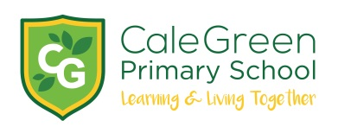

Friday 12th March 2021

Dear Parents / Carers

Thank you!

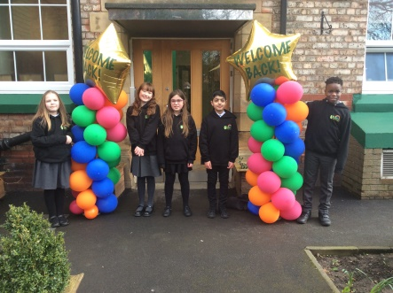

Just a quick update on the children’s return to school – in a word they have been magnificent! They have once again demonstrated such incredible resilience and have come back into school with such a positive desire to learn.

Our main aim over the next few weeks is to give the children the chance to reconnect with their friends, talk about their feelings and support them in embracing all that school life has to offer - so that they successfully and happily complete the rest of this school year. To do this we will make sure that the children’s well-being is at the heart of our work.

All the staff of the school would like to thank you so much for everything that you have had to do since January. As well as working from home, you have also had to be teachers as well. We know that can be tough – especially when the children might not want to do the learning!

We also know that many of you have enjoyed the challenge of supporting your children and sharing their learning journey with them. The quality of some of the children’s learning you have shared with us has just been amazing.

Our job now, is to build on what you have done with the children at home. We are all working to identify any gaps in children’s knowledge and skills so that we can support them throughout the rest of this year to rebuild and recover where needed. We can help the children to use their experiences to be even better learners.

As we start to get back to the ‘new’ normal, we start preparing for our Easter Raffle and our second Parent Consultation of the year. This will take place on Wednesday 14th / Thursday 15th / Friday 16th April. This will either be by telephone (as in the autumn term) or by ‘Google Meet’. Further details will follow before the Easter break.

Thank you again for everything that you have done since January. Once again, we have shown that we are all part of a wonderful school community ‘Learning and Living Together’.

Yours sincerely

D.Marshall
Headteacher

