Wednesday 21st February 2024

Dear Parents / Carers,

‘Seed to Loaf’ Workshops

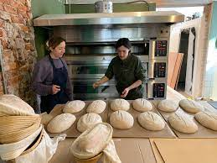

Your child has been chosen to join 14 other children in Year 5 to take part in an exciting project with the Michelin awarded restaurant, ‘Where the Light Gets in’ and their bakery, ‘Yellow Hammer’.

Over 3 days in March the children will get to follow the journey from ‘seed to a loaf of bread’. Some of the sessions will take place in school and one of them at ‘Where the Light Gets in’.

The children will get to try lots of different breads so please let school know of any food allergies that your child may have. Children should NOT fast on the dates listed below.

Electra and her team, will come to school on Wednesday 20th March and Thursday 21st March. On Friday 22nd March, the group will walk down to ‘Where the Light Gets in’ on Stockport Market. The group will set off at 9am and will be back in time for normal school dinner time. They will need full school uniform, sensible shoes and a waterproof jacket.

This promises to be an exciting opportunity, I’m sure you’ll agree!

If you have any queries please do not hesitate to contact school: schooladmin@calegreen.stockport.sch.uk

Yours sincerely,

Mrs Sarah McHugh

