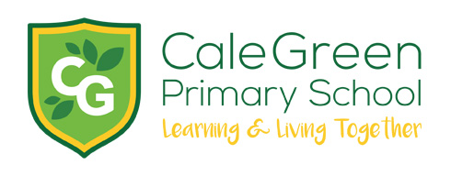

Wednesday 21st February 2024

Dear Parents / Carers,
World Book Day 2024-

Thursday 7th March
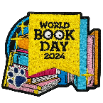

World Book Day is celebrating over 25 years and there has never been a greater time to get into reading. During the weeks before and after World Book Day, Thursday 7th March, we will be hosting all sorts of great activities to promote a love of reading, great books and inspiring authors.

Breakfast Club

Year 6 are invited to Breakfast Club on World Book Day for a free breakfast in return for them sharing and enjoying a book with a younger member of the Breakfast Club community.

Virtual Author visits

Reception, Year 1 and Year 2

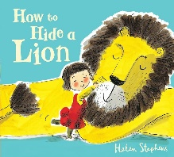

Award winning author and illustrator, Helen Stephens will share some stories and talk about how she writes and draws them. This will take place virtually during the morning on World Book Day.
Year 3, Year 4, Year 5 and Year 6

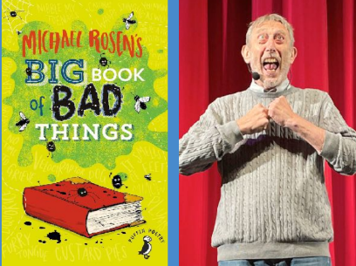

We will be joining schools across the country to watch Michael Rosen’s Big 50 Years Show which will be live streamed to our classes during the afternoon on World Book Day. This very special show will mark the 50th anniversary of the publication of Michael’s first book for children and 50 years of inspiring generations of children, teachers and families with his poetry.

Book Swap

We would like to invite everyone to bring in a book of good condition that they no longer want for a Whole School Book Swap. No money will be needed as it is a swapping event. These must be in a good condition to be enjoyed by a lucky new owner.

World Book Day Vouchers

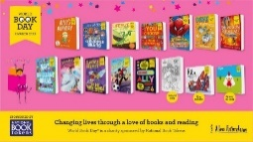
Each child will receive a World Book Day voucher which they can use towards a book of their choice or swap for one of the specially written World Book Day books. The vouchers can be used in book shops and most supermarkets.

A list of all the World Book Day books can be found here:

https://www.worldbookday.com/books/

A group of children in Key Stage 2 will also be walking down to Waterstones bookshop in Stockport to spend their vouchers.

Nursery visits to Bridgehall Library

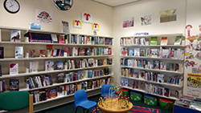

Our Nursery children enjoyed walking down to Bridgehall Library recently. They got to investigate the library, take part in some arts and crafts, as well as listening to Sara, the lovely librarian, read a great story. It’s a super and free for anybody to attend.

Kind regards,

Mrs Sarah McHugh
