Teaching and Learning Policy

‘Learning and Living Together’
RATIONALE

This policy is a statement of the aims, principles and strategies for developing quality first teaching and learning at Cale Green.

We have a teaching and learning policy so that all staff understand and achieve our shared standards of good practice. It provides an agreed framework for teaching and learning within our school, which secures a coherent and continuous education for our children and promotes quality teaching, equality and inclusion.

Teaching and learning are the core functions of our school. Effective teaching is the provision of high-quality experiences in a stimulating and supportive environment leading to good outcomes for pupils. The ability to establish and maintain good relationships is central to effective teaching - ‘learning and living together’ – so that we provide the best quality education for all the children of Cale Green.

OUR PHILOSOPHY

At Cale Green, we believe that our children will learn most effectively when they have access to a rich, deep and systematically planned curriculum that meets their diverse needs, academically, socially and culturally. To this aim, we have developed (and continue to develop) a curriculum where children gain knowledge and skills which are revisited over time so that they are firmly embedded. Our thematic approach provides opportunities for children to make links between different areas of the curriculum and apply their knowledge as skills.

We believe that children should be encouraged to learn in a variety of ways, that they should learn together and be given the opportunity for their voices to be heard and be actively involved in deciding what they need to do next in order to make further progress.

Teaching and learning at Cale Green reflects our children’s unique lived experience within their diverse local area and beyond.

Our approaches are rooted in the effective use of evidence-based research and our school-based practice experiences. We focus on what really matters for Cale Green.

QUALITY FIRST TEACHING

At Cale Green, we ‘leave no stone unturned’ in ensuring that each child reaches their full potential. One of the ways we do this is by ensuring that all our children receive Quality First Teaching. This means that our teaching uses high quality, inclusive methods and strategies that help all children to overcome barriers to their learning and provides opportunities for challenge and curiosity.

We have a ‘tiered’ approach to planning for the development of effective teaching so that there is a logical and well-sequenced plan to support and sustain the highest quality:

- Quality First Teaching
- Targeted Academic Support
- Wider Strategies

Professional development is focused on the development of the skills necessary for all teaching staff to deliver high quality teaching.

These skills are embedded, revisited and adapted where necessary, and include:

- developing an enabling environment including our classrooms being well organised and accessible with labelled resources to promote independence
- ensuring that lesson design has a clear structure where children are made aware of the learning objective at the start of the lesson
- staff planning together in phases to ensure continuity of experience for the children and workload reduction for the staff
- learning which is sequenced in small steps supported by the use of concrete and pictorial resources building towards abstract concepts
- explicitly teaching new vocabulary – often with the aid of visuals and displays
- children are asked to demonstrate and recall core knowledge in a variety of ways, e.g. drama, mind-mapping, drawing, digital literacy
- children are taught different strategies to remember important information and are encouraged to use the ways that work for them e.g. highlighting, steps to success, mnemonics, etc.
- making explicit links to prior and future learning to make connections across the curriculum - including future careers
- children work in flexible groups - mixed, pairs and individually and show their understanding in different ways
- children’s’ effort and achievement in their work is celebrated using a range of age appropriate strategies including ‘The Proud Cloud,’ ‘Class Dojo’, ‘Merit Certificates’, verbal and written praise etc.
- teachers ensure that learning is enjoyable (and therefore memorable) and that children are excited about what they are doing
- every teacher is a teacher of children with Special Educational Needs and Disabilities (SEND) and receives training to ensure they are using the appropriate techniques and resources to support any children with SEND
- use appropriate strategies such as ‘scaffolding’ and encouraging home language to support children with EAL
- staff carefully track each child’s progress to ensure that they are able to achieve their full potential
- staff meet regularly with parents and carers to discuss their children’s progress and keep them up to date with what their children are learning
- Metacognitive and self-regulation strategies are used to support pupils to think about their own learning more explicitly, using specific strategies for planning, monitoring, and evaluating their learning.
- In EYFS, teachers plan activities and experiences based on children’s interests and fascinations, ensuring the motivation to explore and learn is high.
- SEN support plans, one-page profiles and provision maps detail the strengths and needs of children with SEND. Clear, specific and measurable targets are set to ensure appropriate progress.

The guide found at the end of this policy details our current approaches. This guide is subject to constant revision.

QUALITY FIRST TEACHING – FROM THE CHILDREN’S PERSPECTIVE

The children have told us that their favourite lessons are when we:

- do practical lessons
- have trips and visits to help our learning
- learn interesting facts that we didn’t know before
- move about and work together
- do some something new
- learn new skills
- use technology
- learn new ways of doing things
- learn from experts
- create and make things
- are given responsibility for our own learning
- try something new for the first time

The children’s views inform our Challenge Curriculum (EYFS) and lesson design (KS1 and 2) – this also includes the key vocabulary children need and challenges for all children and those working at / towards greater depth standard.

THE MASTERY APPROACH AND ADAPTIVE TEACHING

Our approach to teaching and learning at Cale Green is a culmination of many years of intensive development as a school.

Mastery

The Education Endowment Foundation explain mastery:

“Mastery learning approaches aim to ensure that all pupils have mastered key concepts before moving on to the next topic – in contrast with traditional teaching methods in which pupils may be left behind, with gaps of misunderstanding widening. Mastery learning approaches could address these challenges by giving additional time and support to pupils who may have missed learning, or take longer to master new knowledge and skills.

In the ‘mastery learning’ approach, learning is broken down into discrete units and presented in logical order. Children are required to demonstrate mastery of the learning from each unit before being allowed to move on to the next, with the assumption that all pupils achieve this level of mastery if they are appropriately supported. Some may take longer and need more help, but the expectation is for all.

We focus on all children achieving what is expected of their age group and not going beyond this. Evidence shows that children need to be able to understand a concept, apply it in a range of situations and then be creative to really understand it. Simply going beyond their age group does not guarantee they understand something, it just means they have heard it.

At our school, no child will be taught content from the year group or phase above them, they will spend time becoming true masters of content, broadening their knowledge, applying and being creative with new knowledge and skills in multiple ways.

Adaptive Teaching

Adaptive teaching recognises that children are likely to learn at different rates and to require different levels and types of support from teachers to succeed.

This approach seeks to understand pupils’ differences, including their different levels of prior knowledge and potential barriers to learning and is an essential part of teaching. It means adapting teaching in a responsive way, including by providing targeted support to pupils who are struggling which is likely to increase pupil success.

Teachers will adapt lessons, whilst maintaining high expectations for all, so that all pupils have the opportunity to meet expectations. They will carefully balance input of new content so that pupils master important concepts.

At Cale Green, we believe it is our duty to ensure that children have a deep understanding of subject knowledge and skills so that they are ready for their next stage of learning.

Teachers plan and deliver lessons that meet the needs of their classes using the format and strategies that best suit the purpose of the learning:

- connect with prior learning – for example, a quick card sort game / think pair share activity
- share the big picture and outcomes – explain the format of the lesson (what and how), share the objectives (WALT – ‘To know that…), share the success criteria (by the end of this lesson you will be able to …).
All children must be clear about what they are learning and this should be recorded in child friendly language in any written work.
- explore and process the learning – pupils work independently, in pairs, in groups (with and without adult support) on tasks that allow them to practise the skills / process the knowledge in many ways (for example – drama, artwork, writing, digital learning)
- review and reflect – the children ‘show what they know’ – to what extent they have reached the success criteria and then think about what helped / hindered their progress/what they could do differently next time to improve.

Children are actively encouraged to participate in the assessment of their own learning and this is done in a variety of ways. In class we use a range of ‘assessment for learning’ strategies which are embedded throughout the learning cycle in each lesson. The following list highlights some of the techniques and strategies frequently used in lessons at Cale Green.

- ‘show of fingers’ – pupils show 5 fingers for 100% or fewer to respond to a statement like, ‘I am really good at using the grid method for multiplication’
- Self and peer assessment – pupils read their own, and each other’s work, and write a comment or complete a feedback sheet. They might evaluate a piece of music, PE sequence, drama presentation or art orally or using show of fingers / thumbs up to comment on the work of others – explaining what they liked (and why) and how it could be improved.

DEVELOPING VOCABULARY

The development of a rich vocabulary is important in helping children develop both the ability to understand spoken and written language and acquire a control of language that enables them to express their ideas and feelings clearly.

One key aspect of a child’s language development is the growth of their vocabulary – the words they understand and the words they use to communicate. There is a strong relationship between vocabulary and comprehension, where a broad vocabulary (knowing lots of words) and a deep vocabulary (knowing those words well) correlates with better understanding. Different ‘tiers’ of vocabulary are identified and this informs lesson planning and design.

When children write, a wider vocabulary gives children a rich palette with which to express their ideas, choosing a word to communicate with elegance and precision.

New vocabulary is identified at the planning stage of all subjects. Our lesson design approach highlights the new vocabulary necessary in a lesson or series of lessons. It is explicitly taught, using a variety of different strategies, and is on display in the classroom.

METACOGNTION (MCN) AND SELF-REGULATED LEARNING

Developing MCN approaches to teaching and learning leads to highly effective teaching and learning.

Children are taught to be able to monitor, direct and review their learning. Effective metacognitive strategies get children to think about their own learning more explicitly, often by teaching them specific strategies for planning, monitoring, and evaluating their learning.

At Cale Green we introduced MCN to lessons through a ‘lesson study’ project.

AIMS OF THE CALE GREEN APPROACH

In our strong commitment to effective and varied teaching strategies and our flexible approach to learning, we aim for children to:

- develop a responsible and independent attitude towards their work and towards their roles in society
- engage in learning in a positive way and to approach challenging tasks with confidence and enjoyment
- reach their full potential in terms of academic achievement and spiritual, moral, social and cultural development (SMSC)
- develop good behaviour and high levels of personal responsibility
- be tolerant, sensitive and understanding, showing respect for the rights, views and property of others

GENERAL PRINCIPLES TO SUPPORT OUR AIMS

In order to fulfil these aims for all pupils, at Cale Green we hold the expectation that everyone involved in the school, in any capacity, will adhere to the following principles:

All members of our school community can contribute to our aims by:

- using time and resources effectively
- developing a well ordered and high-quality learning environment
- promoting equality of opportunity in all aspects of school life
- working collaboratively with all members of the school community
- planning for, and presenting children with, a challenging curriculum that is adaptive and meets the needs of all groups and individuals
- Children who have English as an additional language and SEND are supported by teachers and bi-lingual support staff who have had regular CPD opportunities from the Ethnic Diversity Service and the Inclusion Team.

Teachers support these general principles by:

- establishing a challenging and stimulating programme of study, designed to enable all children to reach the highest standard of personal achievement following the ‘mastery approach’
- providing additional challenge for our most able learners as GRT challenges to ensure the number of children working within Greater Depth increases Not sure how to reword this but it sounds like we are focusing on numbers rather than the children themselves.
- planning a suitable programme of work to meet the needs of each individual child according to ability, aptitude and particular need
- ensuring that the acquisition of new knowledge is progressive and continuous, building on prior knowledge
- maintaining an up to date knowledge of the National Curriculum for Key Stages One and Two and The Early Years Foundation Stage
- ensuring that pupils, who are learning English as an additional language, have their home language and background valued and recognised. We are aware that bilingualism can be a useful learning tool and that all EAL pupils can make a valuable contribution to our school community
- using EAL strategies to support ALL learners including those with English as an additional language such as, using scaffolding including the Tower Hamlets materials and the EAL strategy placements
- displaying and celebrating the children's work effectively, using quality materials
- maintaining well-ordered and tidy classrooms
- ensuring teaching strategies, deployment of resources and classroom organisation supports children irrespective of background, promotes inclusion and reflects the diverse nature of Cale Green
- working collaboratively with other staff, with a shared philosophy and clearly defined goals
- developing their own expertise and showing flexibility within their working patterns
- being good role models through conduct and dress

Children support these general principles by:

- attending school regularly, punctually and with a positive attitude, being organised by bringing the correct kit and returning homework on time
- demonstrating outstanding behaviour in classrooms to support learning
- demonstrating outstanding behaviour at all other times - in line with the school's Behaviour Policy and the Cale Green Code which reflects credit on themselves and the school
- taking an increasing amount of responsibility for their own learning.

Parents support these general principles by:

- ensuring that children attend school regularly, punctually and in good health
- providing support for the good behaviour expected in school
- working with their child's teachers to maintain high standards of behaviour
- being realistic about their children's abilities and offering encouragement and praise
- giving support with homework, reading and encouraging their children to take an active interest in home learning
- ensuring early contact with school to discuss matters which may affect a child's happiness, progress and behaviour
- attending Parent Consultation to discuss their children's progress
- allowing their children to take an increasing responsibility as they progress through the school
- responding to letters and permissions in a timely manner

Mrs Sarah McHugh – Headteacher

spring / summer 2024

Review date: spring / summer 2025

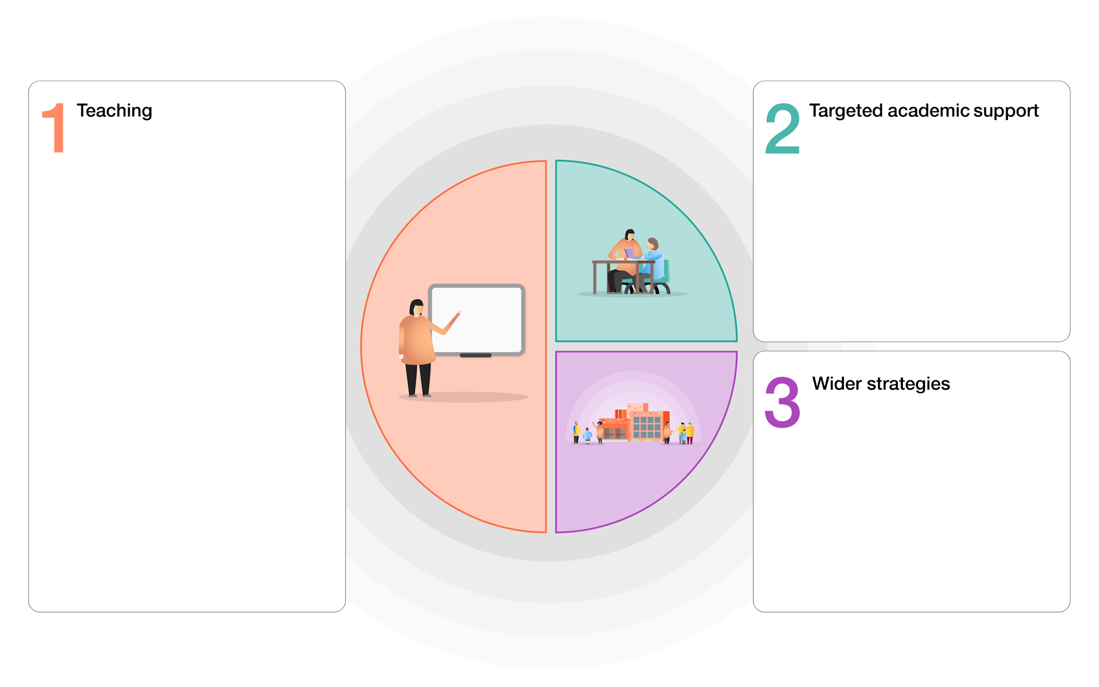
EEF GUIDE TO SUPPORTING SCHOOL PLANNING – TIERED MODEL – CALE GREEN PRIMARY SCHOOL

100+ devices and connections provided to ensure access to remote / home learning
Subsidised breakfast / after school provision
Outdoor learning provision extended in EYFS
Extensive trips, visits, curriculum visitors
Swimming for all children in KS2
Comprehensive PSHE curriculum given a high priority
Instrumental tuition funded for all KS2 children
School staff used to cover classes not supply
Child and Family Support Worker – provides 1:1 and group support for children and parents
3-year Career-Related Learning strategy to raise aspiration / opportunity with activities and visits subsidised / link with more able + greater depth
School Linking Network – broadening aspirations
Attendance monitored daily - awards
Poverty Proofing the school day – research and activities embedded into school life
Chameleon Project / Mouse Club transition projects
Tapestry / School Spider engaging parents
Parent support in school approaches eg phonics

Recovery + Premium Strategies closely aligned to classroom practice and driven by gaps identified through formative / summative assessment
1 x Academic mentors (January to July)
5 x graduate tutors (January 2021)
Intervention programmes led by Teachers and Teaching Assistants including LIP / NELI / WELLCOMM / Happy2BMe
Phonics in EYFS / KS1 taught in phases
Deployment of TAs and graduate TAs
Additional teacher 0.5. to target further support
Bilingual TA (0.6) focus on Early years support
Small group tuition - ongoing
Effective cycle of pupil progress meetings
Collaboration with professionals to create bespoke and targeted work for specific children, including those with SEN or EHCPs
Training in remote teaching and investment in digital devices to ensure access for all children
Effective TA support – project implemented
Extra-curricular activities – including academic support
Career Related Learning strategy – raise aspirations / link with Poverty Proofing / Greater Depth Standard

Quality First Teaching Programme supported by evidence-informed CPD / progress monitoring and appraisal process for teachers and support staff
‘Teams’ planning approach (collective efficacy)
Effective formative and summative diagnostic assessment integral to QFT and ensures teachers understand where learning gaps may exist and support recovery (termly assessment weeks)
Scaffolding and flexible grouping used as key high-quality teaching strategies
Talk 4 Writing embedded across the school
Maths mastery approach embedded across the school
A rich, broad and engaging curriculum that focus on knowledge and vocabulary acquisition – shared lesson design approach with GRT challenges embedded in each lesson
Homework set online that reinforces learning in core and theme areas
Whole -class guided reading approach underpinned by termly formative assessments and access to high-quality texts in independent reading and class texts
Regular subject and phases planning meetings to ensure consistency in approach, review and build on prior skills and knowledge
Core curriculum areas in reading, writing and maths are identified and taught / reinforced in learning across wider curriculum areas
Children to apply knowledge as skills through cross-curricular links
Additional staffing (0.5) KS1 supporting transition to Y1 (Language, phonics and communication) and phonics in Y2
‘Lesson Study’ research project focus on meta-cognition – research-based teaching strategies (EEF) 2020-2021 (EEF + 5 months progress)
Effective remote teaching - School able to provide immediate remote learning in event of class / school closures to ensure continuity of learning
All staff access regular CPD opportunities both in and beyond school
Staff / children - wellbeing and SEL including regular check-ins – embedded in school-life
High- quality CPD support for RQT to ensure all teaching across the school is of a high standard
All class teachers attend cluster writing moderation training to develop pedagogy and practice
Deliberate policy of recruiting QTS graduate TAs
Development of remote learning approach prioritised - immediate availability of support in case of school / bubble closure + self-isolation (includes ‘live’ lessons).

