Wednesday 25th April 2024
Dear Parents / Carers and Children
Year 6 Leavers Arrangements
Firstly, we are writing to let you know how proud we are of each and every child in Year 6. All the children are showing such a positive attitude, they are developing their independent learning skills and have shown tremendous resilience and determination to succeed throughout this year. They are now all preparing hard for their SATs and looking forward to an exciting transition to their high schools in September. The children are an absolute joy to work alongside and we are looking forward to making their last term at primary school one to remember!
We also recognise that this is an important and momentous time for you, as their families, to share with your child. The children’s wishes and ideas are at the heart of the discussions we have had in school and the activities we have planned. Please find below further details below.
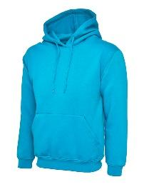

We are always determined that the children in Year 6 get the opportunity to celebrate and reflect on their time at Cale Green and are doing everything we can to make this happen. All children will receive their ‘Leaver’s Hoodie’ after they finish their SATs and will be given a ‘memory book’. We will ensure all children across the classes have the opportunity to leave messages for one another and have the opportunity to have their photographs taken together at the end of term.

The children will also shortly be starting their ‘Chameleon Project’ – a unique set of lessons designed to support your child manage the emotions and questions they have about the transition from primary to high school so that they see this as a positive change.

The project has 3 phases:

Phase 1 ‘Celebrating Success’.

The 1st phase is designed to build self-esteem, develop independence, reaffirm friendships, identify challenges and ensure children are aware of the support available to them. This is where we need families to get involved! Please help your child gather the following before Friday 17th May:
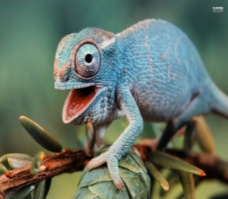
- A few original / copies of / scans of photographs of themselves / their family. (Children will be cutting up the photographs to create a collage so please do not send any original photos in unless you are happy for them to be used in this way).
- Pictures of images that represent them i.e. favourite foods / hobbies / places etc. These can be cut out from old magazines.
- (Optional) old school reports / certificates to be bound into the final project to keep safe.

Phase 2 ‘The Next Step’

In this phase, the children will have the opportunity to address hopes, worries and expectations about moving to high school. We will look at the skills needed to make new friends, how to become more organised, how to travel safely and what they will need to be able to become more independent. Children will have the opportunity to ask questions to past pupils and staff from the different Stockport high schools who are invited to Cale Green. During this phase, all children will have the opportunity to visit their high school for a transition day.

Phase 3 ‘Celebration and Moving On’

In July, children will be presented with their bound ‘Chameleon Project’ during a special assembly and during the Autumn term children in Year 6 are invited back to school for a ‘reunion’. We always look forward to this event as it is a pleasure to see how well children have adapted to their new schools and it provides staff at Cale Green with an extra opportunity to check everybody has settled well.

We believe that teaching children techniques of self-empowerment, providing opportunities to talk openly about their feelings and managing children’s expectations of high school provides them with the best possible foundation to enable our young people to adapt positively and thrive with the changes that lie ahead.

This year, children across Upper Key Stage 2 will be showcasing their singing and acting talents and perform in the large-scale show ‘Cinderella Rockefella’ on Wednesday 10th and Thursday 11th July. All Year 6 children will have speaking parts and rehearsals will begin after SATs. Further information regarding tickets and costumes will be sent out after the Whit holidays.

We are also very excited to be able to invite families into school on the morning of Thursday 25th July to share our Leaver’s assembly – an opportunity for the children to reflect on their time at primary school (get-your-tissues-ready!). The assembly will be followed by light refreshments and the ‘Chameleon Project’ presentation.

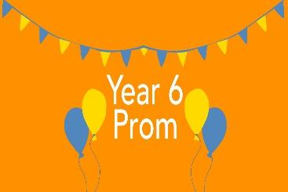
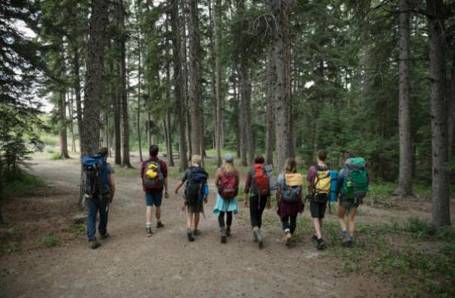

During the last few weeks of term, Year 6 children in school will be having a number of treats and ‘special activities’ and we cannot wait! These will include a pool party, a residential visit, sports day and of course – the end-of-year ‘leaver’s party’! The party will be held in the school hall on Tuesday 23rd July from 6:30 – 8:00pm and will involve food, a disco and lots of fun! Parents and carers are welcome to join us from 7:30pm.
We would like to thank you all so much for your continued support and we know the planned celebrations will provide you all with lasting memories of their time at primary school and opportunities to celebrate this very special time together.
Yours sincerely,
Mrs Lewis, Mrs Harding, Mrs Powell-Gill and Miss Foster
Monday 13th May – Thursday 16th May | Year 6 SATs week
Friday 17th May | Chameleon Project photos to be handed in by this date
Thursday 23rd May | Edgeley Football Tournament at Lark Hill Primary School
Tuesday 2nd and Wednesday 3rd July | Year 6 Residential
Thursday 4th July | Year 6 Transition to High School Day
Friday 5th July | Sports Day Stockport Cricket Club from 1:30pm
Wednesday 10th July 1:45pm | Cinderella Rockefella performance 1
Thursday 11th July 6:00pm | Cinderella Rockefella performance 2
Tuesday 16th July | Year 6 Pool Party
Tuesday 23rd July 6:30 – 8:00pm | Leavers’ Party – School Hall Parents / Carers are invited to join us from 7:30pm.
Thursday 25th July 9:15 – 11:15am | Leavers’ Assembly and Chameleon Project Presentation
Friday 26th July | Last day of Summer term. Children can bring in shirts to have signed by their friends.

