Tuesday 5th March 2019

Dear Parents/carers,
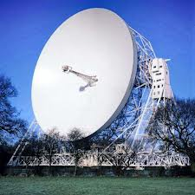

As part of our challenge ‘ Twinkle, twinkle little star, how I wonder what you are?’, the Reception classes will be going on a very exciting trip to Jodrell Bank to see the amazing Lovell telescope and take part in two workshops. The workshops are ‘The Inflatable Planetarium’ and the ‘Journey into Space’.

The trip will take place on Thursday 25th April 2019. We will travel by coach, leaving school at 9.00am, returning at 3:15pm. The children will need to wear their school uniform for the trip and will need sensible shoes to walk in and a coat.

If your child has a school meal they will be provided with a grab bag on that day. If your child usually has a lunch box please can they be provided with a lunch in a named disposable bag.

We are sure the trip will be a memorable day out and we are asking for each child to pay £12.00 toward the cost of transport and workshops. Please pay using Parent Pay.

If you have any queries please do not hesitate to contact us.

Mrs. Phillips and Mrs. Cartwright
Reception teachers

Child’s Name:

I give permission for my child to attend the visit Jodrell Bank on Thursday 25th April and will pay £12.00 to cover the cost of this trip on Parent Pay.

Any relevant medical information (including travel sickness):

Emergency Contact Numbers:

Signed: Parent / carer

