Thursday 7th February 2019

Dear Parents and Carers,

Young Carers – Board Games Event

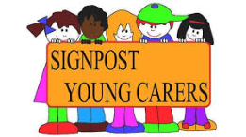

I have now taken over responsibility for our ‘Young Carers’ in school and have met with children to discuss the type of activities that they would like to have in school that are just for them.

On Monday 11th February, the first of these events, we will be playing board games together straight after school.

There will be lots of games, drinks and snacks!

Children should be collected from school at 5.00pm.

If you have questions about this activity, please feel free to contact me.

As a school we work closely with Hannah Thompson from an organisation called ‘Signpost Young Carers’. Hannah provides advice and support for children, families and schools. For further information please follow this link:

https://www.signpostforcarers.org.uk/young-carers

Kind regards,
Mrs. Carole Harding

Young Carers – Monday 11th February 2019

Name of Child:

I give permission for my child to attend the board games event. I will make arrangements for my child to be collected at 5.00pm.

Medical Conditions:

Emergency Contact details

Signed: Parent / Carer

