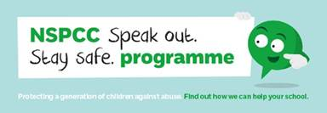

Free NSPCC online safety workshop

Monday 17th June 2.00pm – School Hall

The NSPCC are here to help you keep your child safe online!

No need to book. Tea and coffee will be available
