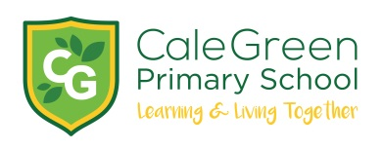
Wednesday 3rd July n2019
Dear Parents and Carers,
Stockport Children’s Book Award Presentation Evening,
Stockport Town Hall, Thursday 11th July 2019 – 7.00pm

Your child has been invited to attend this presentation evening on Thursday 11th July along with your family. Children will stay with their parents. They have been chosen for a number of reasons either:

- They have been chosen as Reader of the Year at our school - Dylan, Alex and Tilly
- They have a great attitude to reading and love reading!

Doors will open at 6.30pm for a prompt start at 7.00pm. The anticipated finish time will be 8.00pm. However, as this is a live event it is possible that it may over-run. You may also wish to factor in extra time for meeting authors/illustrators after the ceremony has ended.

There will be a bookshop so your child may wish to buy one of the winning titles, prices range from £5 - £9 (cash only). Winning authors and illustrators will be available to sign books/autographs at the end of the evening.

If you would like tickets for, which are free, please complete and return the slip below. We only have a limited amount of tickets so they will be allocated on a first come - first served basis. Please return by Friday 5th July.
This is a lovely event which really promotes reading and the love of a good book so we really look forward to seeing you there!
Kind regards,
Mrs. Sarah McHugh
English Subject Leader
Book Awards – Thursday 11th July – 6.30pm
I would like tickets for the Book Awards:
Name of child:
Adult tickets:
Child tickets:
Signed:
