Tuesday 9th July 2019

Dear Parents and Carers,

Year 5 / 6 Trip to Museum of Science and Industry

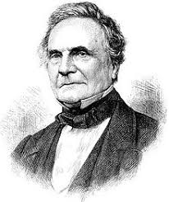
As part of the ‘STEAM’ theme, children in Years 5 and 6 have been working in school alongside artists from the Museum of Science and Industry to produce pieces of work that will contribute to a much larger ‘art installation’ celebrating the work of ‘Charles Babbage’ – a well-known mathematician, philosopher, inventor and mechanical engineer. The installation will also be a centrepiece at Manchester’s ‘International Festival of Arts’ this year.

We have been invited to view our contribution to the installation and for the classes to visit MOSI on Thursday 18th July as a ‘thank you’ for getting involved with the project.

The trip will be fully funded by sponsorship from the education department at MOSI.

On the day we will be leaving school by coach at 9:00am and will return by the end of the school day. Your child will need a packed lunch and drinks in a small rucksack and a waterproof coat. If your child usually has school dinners, a ‘grab bag’ lunch will be provided.

Kind regards,

Mrs Lewis and Mrs Harding

Name of Child:

I give permission for my child to attend the Museum of Science and Industry on Thursday, 18th July.

Emergency Contact Numbers:

Relevant Medical Details:

Signed: Parent / Carer

