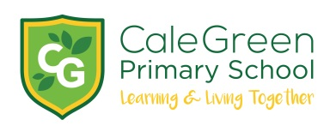

Thursday 5th December

Dear Parents and Carers,

**Christmas Dinner-**

**Friday 13th December**

**Sprouts Included!**

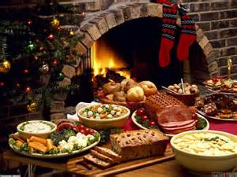

We will be having our school Christmas Dinner on Friday 13th December. If your child usually has a packed lunch and you would like them to have a Christmas Dinner on that day please could you complete and return the slip below. The cost of dinner is £2.20. Please ensure payment is made using Parent Pay selecting the school lunch payment item.

Your child will NOT have to pay if they normally have a school dinner OR if your child is in receipt of Free School Meals.

The closing date for ordering a dinner is Monday 9th December.

Kind regards,

Mrs. Sarah McHugh.

Deputy Head teacher

­­­­­­­­­­­­­­­­­­Christmas Dinner- Friday 13th December

I would like my child to have a Christmas dinner and I confirm that I have paid £2.20 on Parent pay.

Name of Child:

Class:

Food Allergies:

Signed: Parent / Carer