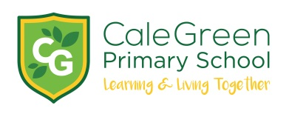
Friday 1st November 2019

Dear Families,
Real History Alive Workshop – Tuesday 19th November
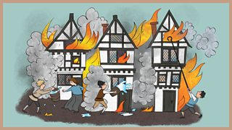
As part of our first theme, “How did the pesky rats stop the flickering flames?” Cedar, Cherry and Chestnut classes will enjoy a ‘hands-on’ workshop at school.
This educational historical morning has been arranged for Tuesday 19th November. The workshops will take place during the morning with all 3 classes taking part.
The activities will start with the children being whisked away on a historic adventure back to the year 1666 and they will experience a unique time-travelling history show with songs, live action and lots of fun!
The show is followed by hands on interactive workshops where the children will create scenes from the Great Fire of London and explore what it might have been like to part of this event.
The children will also get to bring historical figures back to life - going back in time to meet the characters who experienced the day.
This activity will bring our first theme to a fabulous finale. As a result, by the end of the morning the children will be able to demonstrate the vast array of their new knowledge, vocabulary and skills relating to the topic.
This visit will be funded by school, however if you would like to make a donation the cost per child is £3.00. If your child wants to they could also dress up as plague doctors, rats, flickering flames. This is optional though!
If you have any questions regarding this workshop please do not hesitant to come and speak to any member of the KS1 team.
Many thanks for your continued support.
Miss Best / Mrs Cronshaw / Miss Bayley
Real History Alive Workshop – Tuesday 19th November
Name of Child:

I enclose a donation of £3.00 towards the cost of the History Alive workshop (payment can also be made by ParentPay).

Signed: Parent / Carer

