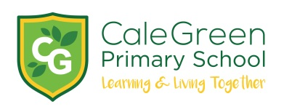
Friday 10th January 2020

Dear Parents and Carers,

Poetry Slam - Friday 28th February

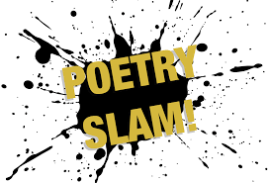

Do you remember learning a poem ‘off by heart’ at school? Perhaps you can still remember it? Well, on Friday 28th February we will be holding our first Poetry Slam in school where each class will be reciting a poem that they have learnt in class.

Individual children are also encouraged to learn their own favourite poem OR compose their own, which they will get a chance to perform - some of the teachers will also be taking part too!

Prizes will be awarded to those children who take part and perform their chosen poem. There will be one overall winner from each Key Stage.

Why should your child learn to write and perform a poem?

- It’s a great way to enrich your child's life!
- It’s fun and can open up new ways of understanding and expressing your own emotions and thoughts.
- Poems can communicate where prose struggles – like a funny nonsense poem or a sonnet filled with longing. Seeing a thought or emotional response on paper helps comprehension and the development of empathy.
- Poems can extend your child’s vocabulary, helping to build confidence and communication skills. Tongue-twisters and rhyming couplets encourage children to use their creativity and widen their vocabulary.

Poems can be fun to say and funny to read. Poems come in all shapes and sizes.
- Poetry is personal and there is no right or wrong answer!
- There may be rules to help but they are movable and open to expressive re-imagining.
Any child can be a poet!

This article gives you some ideas about why poetry is important and there are some links to poetry books which you might want to have a look at:

https://proudtobeprimary.com/reasons-teach-poetry-classroom/

Further details about the Poetry Slam will be sent out later this half-term but now is a good time to start writing / learning and practicing!

Kind regards,
Mrs Sarah McHugh

