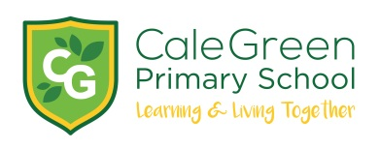
Monday 3rd February 2020

Dear Parents and Carers,
Ancient Greek Workshop

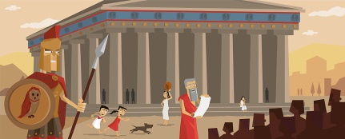

Holly, Hawthorn and Hazel classes will be taking part in an ‘Ancient Greek’ workshop in school on Wednesday 18th March. We will be visited for the day by a team of experts who run professional workshops for schools.

The children will take part in practical activities throughout the day which will cover everything from the warring city states, the birth of democracy and Greek legends to Alexander the Great and Greek culture. The visitors will act as warriors who will make learning about the Ancients Greeks a fun and inspiring experience!
The workshops consist of a short introduction to Greek life and culture, followed by four engaging activities:

A Greek quiz, with loads of fun Greek facts for the children to discover:

- Archimedes’ Stomachion – the oldest known mathematical puzzle
- Petteia, the Greek strategy game
- Myths and legends – the children are transported to a Greek theatre where they re-enact Greek myths and legends
- A Greek warrior will demonstrate his weapons and armour. Then the differences between the city states of Athens and Sparta are explored, the children take a lesson in democracy, which is followed by a mini Olympic Games. The great battle of Gaugamela between Alexander the Great and King Darius will round off an engaging and fun day.

Did you know…?

- The Greek Warriors are very much in demand for their depth of knowledge and enthusiasm for their subject. They have appeared in many films, historical documentaries and on the BBC’s “Horrible Histories”.

The cost of the workshop will be £5.00 per pupil which should be paid on Parent Pay. This cost has been subsidised by school.

If you have questions about this day please feel free to contact me or your child’s class teacher.

Kind regards,
Mrs. Sarah McHugh.
Deputy Head teacher

Ancient Greek Workshops – Wednesday 18th March

Name of Child:

I have paid £5.00 on Parent Pay _______

Signed: Parent / Carer

