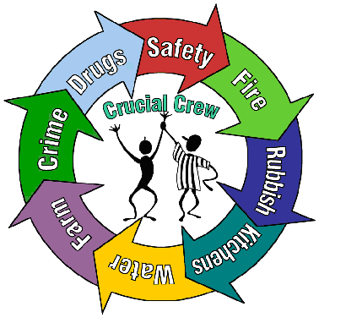
Friday 14th February 2020

Dear Parents / Carers,

Crucial Crew – Tuesday 3rd March

On the morning of Tuesday 3rd March we will be walking Year 6 to ‘The Armoury’ (Stockport Army Reserve Centre) to attend the annual ‘Crucial Crew’ event - a multi-agency safety event aimed at Year 6 children. The event has been designed to provide children with essential life skills that will enable them to keep themselves and others safe in the future.

It is generally accepted that children start to become more independent at this age and are often expected to cope increasingly on their own and deal with changes in their lives, such as a move to secondary school. The aim of the Crucial Crew event is to raise each participant’s awareness of the threats and dangers, in a fun and interactive way. Representatives from the Emergency Services and local agencies will be delivering a diverse range of scenarios to support the children’s developing independence and wellbeing. Example scenarios include: how to escape from a house fire, basic first aid training, exploring the effects of alcohol and smoking, dangers of the railway environment, awareness of domestic violence/abuse issues, cycling safely, personal safety in relation to street crime and cyber safety.

The cost of this trip has been subsidised significantly by the Pupil Premium for all children who means we can offer the trip at a cost of £2.00 per child (payable on ParentPay).
Please sign the permission slip below and return to school before Friday 29th February.

Many thanks

Mrs Nicola Lewis
Year 6 class teacher

Name of Child:

I give permission for my child to attend the Crucial Crew event at The Armoury, Stockport on Tuesday, 3rd March 2020 and will pay £2.00 via ParentPay.

Emergency Contact Number:

Medical Conditions:

Signed: Parent / Carer

