Thursday 13th February 2020

Dear Parents and Carers,

World Book Day – March 5th 2020

Reading Bingo!

It is World Book Day on Thursday 5th March and we will be using this day to relaunch our Reading Bingo!

Each child is encouraged to read or listen to being read the 20 books that have been carefully chosen to develop a breadth of authors and text type for each year group.

Each child will get a new copy of Reading Bingo sheet for their year group and they will be working on activities based on one of the books throughout the week. School have bought copies of all of the books which will be in each classroom.

World Book Day Vouchers

Each child will receive a World Book Day voucher which they can use towards a book of their choice or swap for one of the specially written World Book Day books. The vouchers can be used in book shops and most supermarkets.

Further details of World Book Day activities can be found at:
www.worldbookday.com

Poetry Slam – Wednesday 26th February – 9.00am

We start the celebrations on Wednesday 26th February when we hold our first ever ‘Poetry Slam’. Each class will have learnt a poem which they will be performing for everyone. In addition, children are invited to learn a poem to perform or write their own.

If any parents would like to join us for the ‘Poetry Slam’ you are more than welcome – perhaps you’d like to perform a poem you know or you can remember yourself from school!
Breakfast Club

Year 6 are invited to Breakfast Club on World Book Day for a free breakfast in return for them sharing and enjoying a book with a younger member of the Breakfast Club community.

‘The Day the Banana Went Bad’ – Michelle Robinson – Friday 28th February

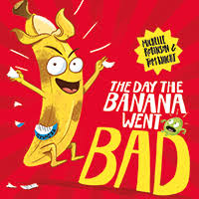

The excitement continues on Friday 28th February when we are visited by Michelle Robinson who will be talking about her new book, “The Day the Banana went Bad!”

A letter about this visit and how to order / buy a book was sent out in a letter earlier this week.

Learning to read is the most important skill we can support you with in teaching your child. We hope that these activities provide lots of fun opportunities to promote reading in your home and help to develop a lifelong love of reading!

Kind regards,

Mrs Sarah McHugh
Deputy Headteacher

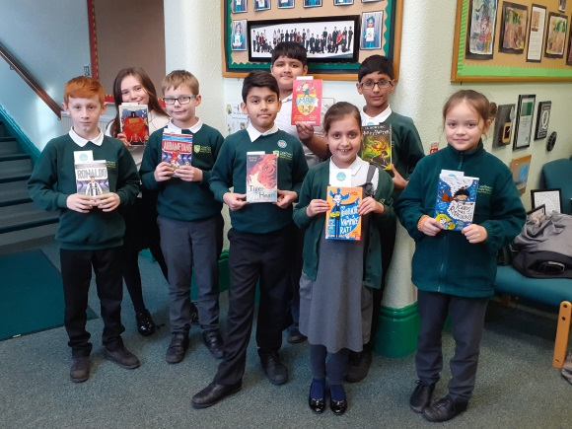

Children with their book prizes from for getting 50 stars on their Cale Green Achievement Charts

