S



**CV19 Schools Update 5 22nd March 2020**

If children can stay safely at home, they should, to limit the chance of the virus spreading.

That is why the government has asked parents to keep their children at home, wherever possible, and asked **schools to remain open only for those children who absolutely need to attend.**

We are currently **trusting** that families who are asking you to look after their children are doing so as we are their **ONLY** option.

<https://www.gov.uk/government/publications/closure-of-educational-settings-information-for-parents-and-carers/closure-of-educational-settings-information-for-parents-and-carers>

<https://www.gov.uk/government/publications/guidance-on-shielding-and-protecting-extremely-vulnerable-persons-from-covid-19/guidance-on-shielding-and-protecting-extremely-vulnerable-persons-from-covid-19>

**I am a critical worker or have a vulnerable child but I don’t want to send my child in to school or childcare, do I have to?**

Many parents working in these critical sectors may be able to ensure their child is kept at home. **Every child who can be safely cared for at home should be.**

This is an offer to parents and carers and there is no requirement for parents and carers to send their children to school if they do not need or wish to do so.

For vulnerable children, your child’s social worker will work with you to assess the best option for your child.

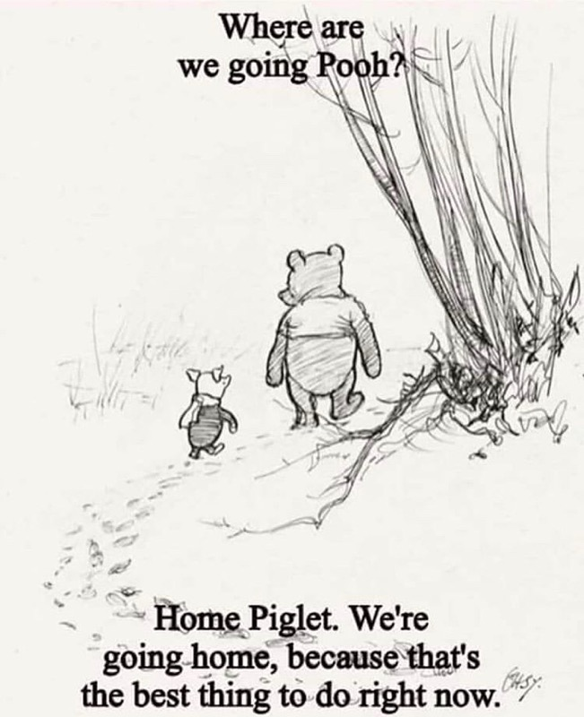

Special school

What do I do if my child has an EHC plan and I want them to stay at home?

Special schools, colleges and local authorities are advised to make case by case basis assessments of the health and safeguarding considerations of pupils and students on an education, health and care (EHC) plan. **For some, they will be safer in an education provision. For others, they will be safer at home.** We trust leaders and parents to make these decisions and will support them as required.

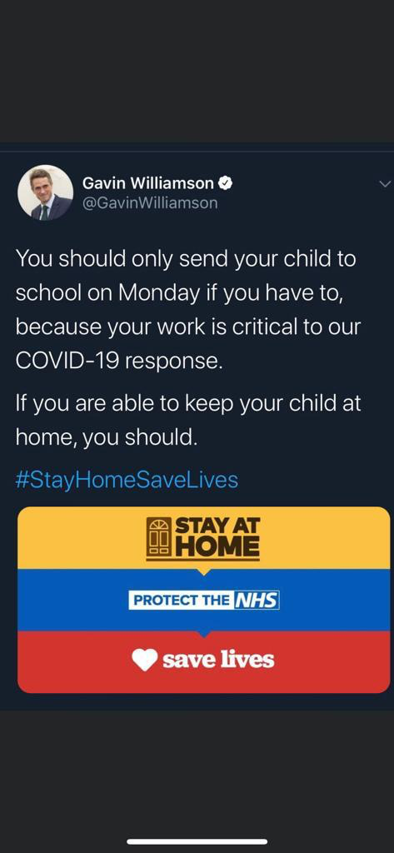

<https://www.gov.uk/government/publications/closure-of-educational-settings-information-for-parents-and-carers/closure-of-educational-settings-information-for-parents-and-carers>

### I am a critical worker or have a vulnerable child - can you guarantee that my child will attend their usual school or childcare provider?

We are expecting the majority of settings to stay open for the children of critical workers and vulnerable children so they can continue to attend their usual provider, but we acknowledge this will be impossible for some - such as small rural schools.

Where a setting is unable to stay open, we will work with the local educational authority, regional school commissioners and neighbouring providers to find an alternative setting for their pupils.

[school.enquiries@stockport.gov.uk](mailto:school.enquiries@stockport.gov.uk)

Stockport MBC are inviting parents to contact them where there are difficulties in accessing childcare for keyworkers.

We intend to work with everyone to ensure that we support our keyworker colleagues to allow them access to childcare.

Headteachers across the sector WILL be contacted and supported to enable them to provide provision.