Cale Green Primary School
Remote Learning Policy
Autumn 2020

This policy has been written by the school, building on national best practice, the EEF Stockport Local Authority, the National College and the Department for Education including information from the following websites:
https://educationendowmentfoundation.org.uk/covid-19-resources/best-evidence-on-supporting-students-to-learn-remotely/
https://educationendowmentfoundation.org.uk/tools/guidance-reports/using-digital-technology-to-improve-learning/
https://www.gov.uk/guidance/remote-education-during-coronavirus-covid-19
https://search3.openobjects.com/mediamanager/stockport/fsd/files/parent_and_carer_homeschool_toolkit.pdf
Rationale
In our truly comprehensive primary school, we have created an environment where we celebrate our diversity and actively promote it as a strength of the school.
In order to maintain our safe, calm and positive atmosphere, which permeates the day to day life of the school and which is sympathetic to pupils’ cultural, ethnic and social needs, we have created an orderly environment based on a sense of community and shared values where building and maintaining relationships is seen to be important – with ‘Living and Learning Together’ at the heart of our school ethos.
At Cale Green, we nurture every child’s unique talents to enable them to flourish in a climate of high expectations, innovation and creativity. If children are unable to attend school due to closures, we are committed to providing remote learning opportunities to deliver a coherent range of curricular experiences. The policy outlined here reflects a clear commitment to reinforce skills and give pupils access to remote learning activities which will meet their needs, building upon prior learning and referencing the work of John Hattie, understanding that the relationship between teachers, parents and chidlren can not be underestimated.
Aims
This Remote Learning policy for staff aims to:
- ensure consistency in the approach to remote learning for pupils who are not in school
- set out expectations for all members of the school community with regards to remote learning
- provide appropriate guidelines for data protection

This Remote Learning policy for pupils aims to:
- have structured daily opportunities to connect with learners across the school week
- provide continuity of learning and skills development
- ensure planning for opportunities for pupil achievement and attainment
- ensure we get it right for every child and that all children in our school are safe, healthy, achieving, nurtured, active, respected, responsible and included

Learning Outcomes:
- Developing an effective remote education programme that is aligned with in-school provision and curriculum planning.
- Recognising how remote education fits into school policies and legislative frameworks.
- Cultivating a whole school approach to remote education and understanding your safeguarding requirements.
- Recognising the importance of effective communication and consideration for wellbeing.
- Understanding the impact of technology for teaching and its effective use in remote education.

Roles and Responsibilities
The role of staff is to:
- provide a learning platform where all children have the opportunity to engage in learning
- promote an ethos of inclusion, respect, fairness and equality
- ensure that cyber resilience and internet safety is central to all digital technology use as set out in the Digital Learning and Teaching Policy
- observe and monitor children’s learning
- provide support and guidance for pupils
- keep abreast of research and national agenda and demonstrate an ongoing commitment to professional learning
- engage with effective learning and teaching resources

The role of the pupils is to:
- participate in online learning and activities as published by their teachers
- ensure everyone feels valued, respected and included
- promote respect in relation to the rights of others
- contribute their views through Tapestry and/or the school website
- offer peer support and guidance through shared learning

The role of parents is to:
- encourage pupils to access online learning and associated activities
- support the school values
- foster an open pathway of communication between the school and home where appropriate

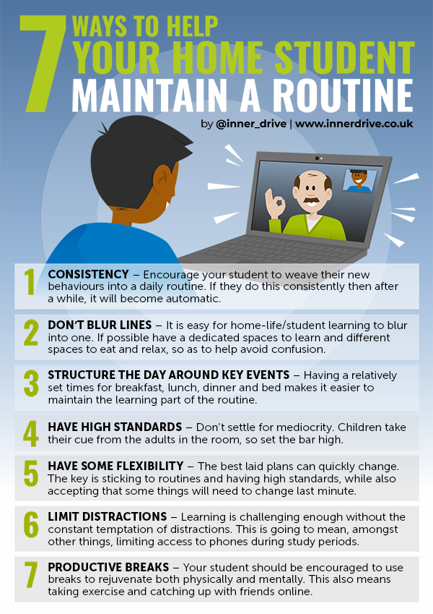
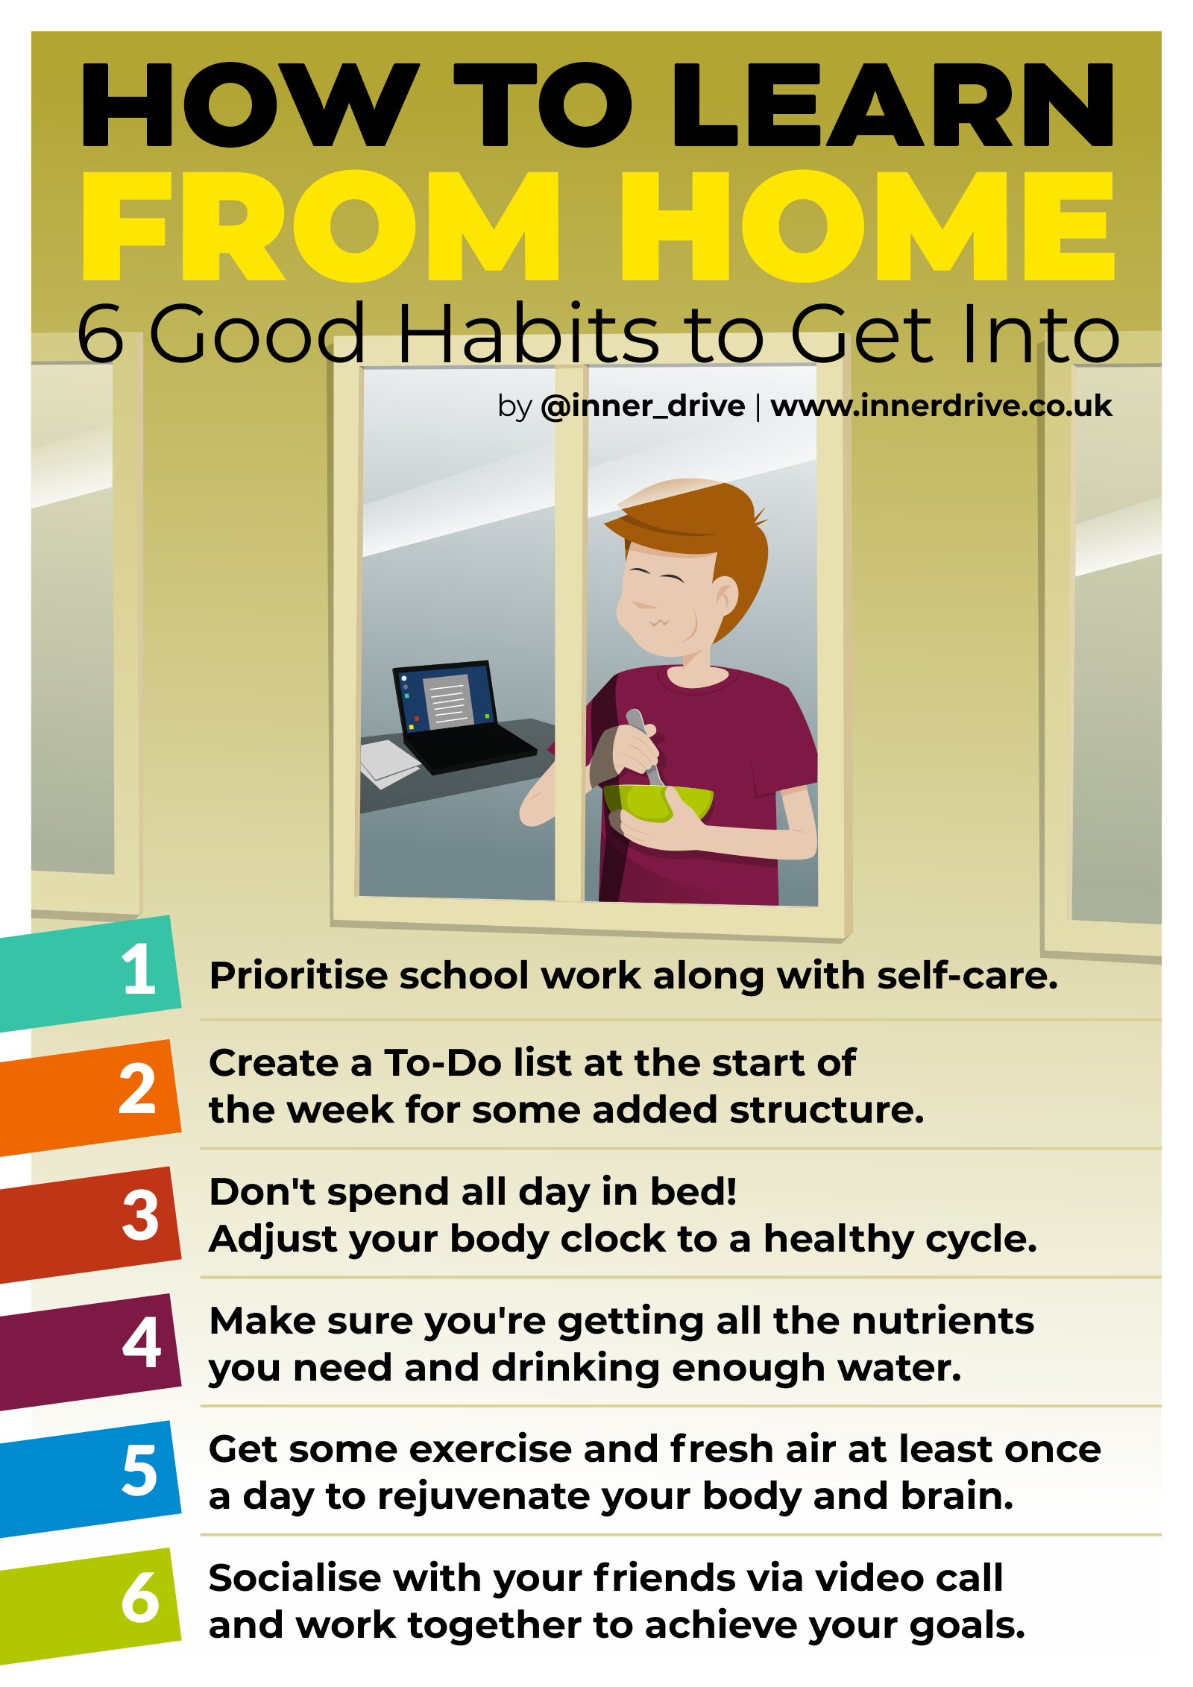
Two resources which will be useful for parents can be seen below and can be found on the school website:

Expectations for learning provision:
- teachers to follow class timetable as far as possible with reinforcement and consolidation of skills and concepts.
- all classes in Early Years to use Tapestry to provide regular learning opportunities and feedback
- all classes in Key Stage 1 and 2 to use the school website as a starting point for sharing work
- all teachers are responsible for planning, assessment and for meeting the needs of all children.

The following sets out criteria for remote learning. Teachers will provide:
- a daily literacy and/or English tasks
- daily maths and/or numeracy activity
- a weekly range of other curriculum areas including science, IT, art and PSHE
∙ pupil led learning with relevant contexts for skills development and independent research opportunities using the ‘Flipped Learning’ model
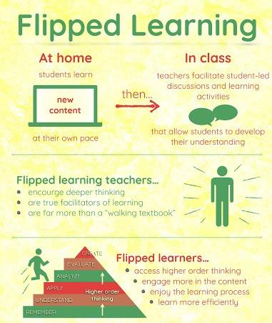
John Bergman’s model of ‘Flipped Learning’ is a teaching method that delivers learning content to children at home through electronic means and then uses class time for practical application activities such as low stake quizzes.

- a range of synchronous and asynchronous lessons in a blended format in the event of a class lockdown is the most beneficial
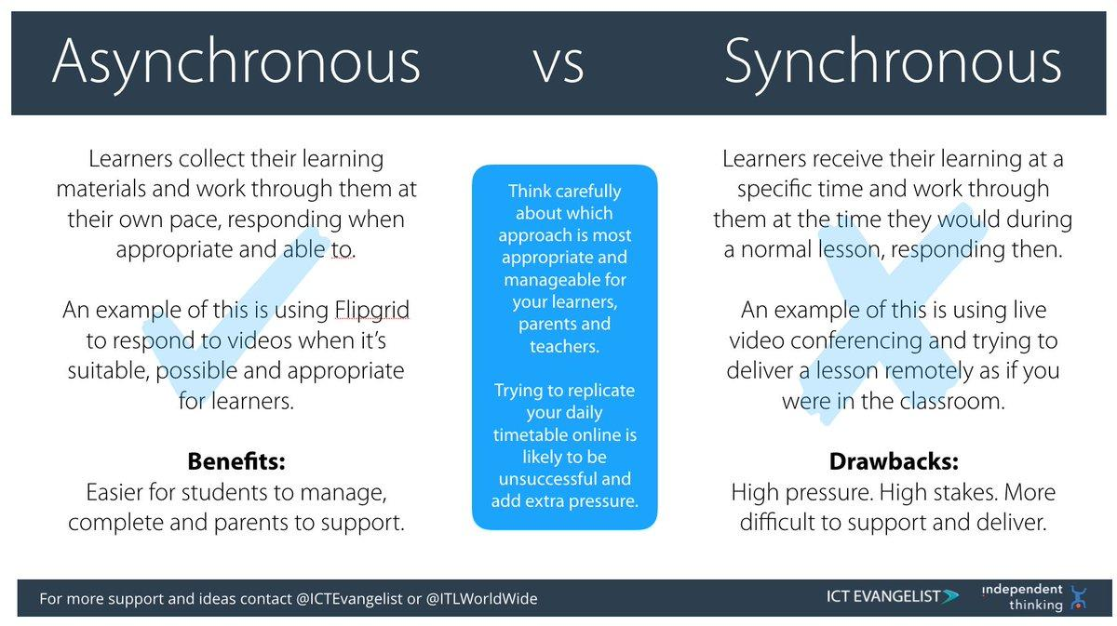

Practical Information
- Teachers should be available from 9am- 3.30pm. If a teacher is unable to provide learning for the day due to their own or a family member’s illness, another member from the phase will provide this. The teacher should report the illness to David Marshall, Headteacher; Sarah McHugh, Deputy Headteacher or Katherine Horrabin, Business Manager.
- The upload function on the school website and Tapestry can be used to enable pupils to submit evidence of their learning. Teachers are then able to assess and track all learning submissions.
- Where possible pupils should log in to their accounts to track progress.
- Where web-based activities do not offer a tracking/assessment function then pupils should record their progress and share with the teacher. This could be in a document or a screenshot of the result.
- There will be regular daily check-ins with pupils to provide direction, give feedback and provide an opportunity for pupils to ask questions. Feedback will be given on a daily basis.
- Remote learning should be available from 9am- 3.15pm.
- A number of well-established websites have been identified to use for remote learning:
- Oak National
- BBC Bitesize
- Spelling Shed
- Education City
- TT Rockstars
- My Maths
Teachers should ensure that children are accustomed to using these websites by providing them with opportunities in school to use them.
- Teachers and Teaching Assistants will keep in regular contact with children who are remote learning via Tapestry, the school website and phone calls to check-in. This may be useful for children who are not accessing remote learning.
- Teachers will ensure that IT is used to specifically enhance and develop the learning. The SAMR model (Dr Reuben r Puentedura) will be considered when designing tasks for our pupils. IT will have a strong presence in adding learning to Tapestry and the school website but it may not be used as the main learning tool.
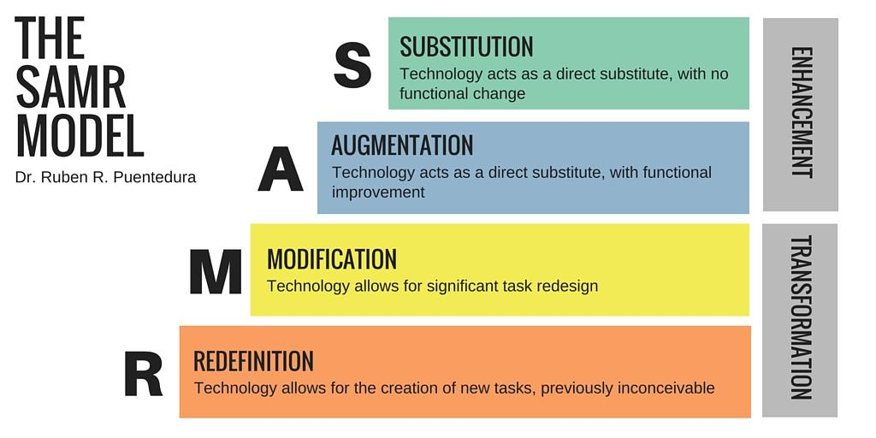

Top Tips for Remote Learning
Present new information in small chunks
Provide worked examples
Check for understanding using low stakes testing
Regular peer and teaching collaboration
Provide feedback to small groups or whole classes

Attending virtual meetings with staff, governors, parents and pupils
- Staff and children must be dressed appropriately during video calls.
- Avoid areas where there is a lot of noise, consider your background.
- There is an expectation that staff will attend staff meetings/ INSET as usual, staff will be invited via Google Meet.

Safeguarding children and their families
- Regularly identified vulnerable children and families will be contacted by a Pastoral team which include David Marshall, Headteacher; Sarah McHugh, Deputy Headteacher; Gill Rogers, Child and Family Support worker and Carole Harding, SENDCo by phone and/or by email on a regular basis.
- Support with food through food vouchers or food boxes via ‘Fairshare’ scheme will be used as a support.
- Serious concerns will be reported to Children’s services following the safeguarding policy and procedures.
- Half-termly vulnerable children meetings to take place to keep up to date and following this, half-termly Team around the School (TAS) meetings with school and a range of outside agencies invited: EWO, School Age plus worker, Social Worker and the School Nurse.

Guidance for Teaching Assistants
When assisting with remote learning, teaching assistants must be available during their normal working hours.
If they are unable to work for any reason during this time, for example due to sickness or caring for a dependent, they should report this using the normal absence procedure.
When assisting with remote learning, teaching assistants are responsible for:
- supporting pupils who aren’t in school with learning remotely
- posting work onto Tapestry/ the school website for specific children. For example a Leicester Inference reading text; ideas for Motor-skills activities; ideas/video links to physical activities like Joe Wickes.
- making resources that could be used with children once you return to school
- attending virtual meetings with staff, parents and pupils

Professional Development
During a longer period of lockdown it will be necessary to use this opportunity to develop your continued professional development by accessing courses and training relevant to your post and your own specific learning needs.
Some examples:
Staff could access professional development materials though platforms such as Learning Leads, Leicester Inference Project, EAL, White Rose training materials. The Subject Leaders for English and Maths will ensure that all staff know how to log in and access the training materials.

Subject Leaders
Alongside their teaching responsibilities, subject leads are responsible for:
- considering whether any aspects of the subject curriculum need to change to accommodate remote learning
- working with teachers teaching their subject remotely to make sure all work set is appropriate and consistent
- working with other subject leads and senior leaders to make sure work set remotely across all subjects is appropriate and consistent, and deadlines are being set an appropriate distance away from each other
- monitoring the remote work set by teachers in their subject by monitoring planning on the school website and Tapestry
- alerting teachers to resources they can use to teach their subject remotely

Senior leaders
Alongside any teaching responsibilities, members of the Senior Leadership team are responsible for:
- co-ordinating the remote learning approach across the school
- monitoring the effectiveness of remote learning – this will be by monitoring work set on the school website/Tapestry and monitoring the work that the children send into school as a weekly sample check.
- regular check-ins with teachers and subject leaders either by telephone, email and Google Meet.
- monitoring the security of remote learning systems, including data protection and safeguarding considerations

Designated safeguarding leads
The DSL is responsible for:
The Headteacher is the DSL and will undertake role of safeguarding lead (see job description) also refer to the safeguarding policy. In the event of her absence this role will be deputised by Sarah McHugh, Deputy headteacher; Katherine Horrabin, Business Manager; Carole Harding, SENDCo; Helen Cartwright, EY safeguarding lead and Gill Rogers, Child and Family Support worker.
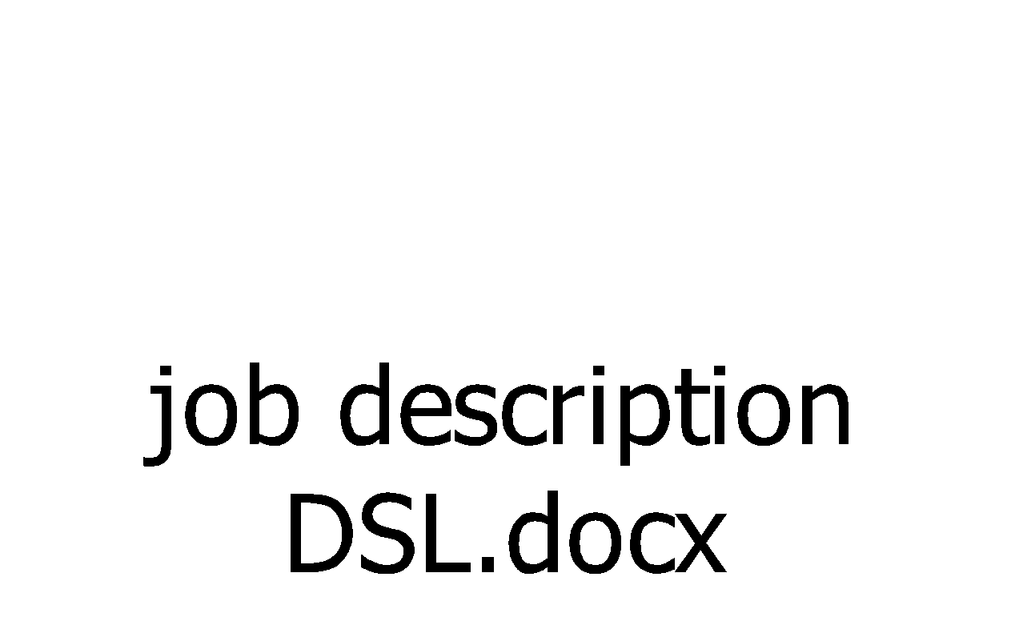
IT staff
School is supported by AVA, for internet problems they can be contacted by telephoning 0161 474 4100 or emailing ictschools.support@stockport.gov.uk : for email support they can be contacted by telephone on 0161 474 2239 or email support@ava.stockport.gov.uk
IT staff are responsible for:
- fixing issues with systems used to set and collect work
- helping staff with any technical issues they’re experiencing
- reviewing the security of remote learning systems and flagging any data protection breaches to the data protection officer
- Katherine Horrabin, Business Manager can be contacted during working hours to assist with in school issues

Governing board
The governing board is responsible for:
- monitoring the school’s approach to providing remote learning to ensure education remains as high quality as possible
- ensuring that staff are certain that remote learning systems are appropriately secure, for both data protection and safeguarding reasons

Data protection
Accessing personal data
When accessing personal data for remote learning purposes, all staff members will:
- use the school’s remote learning platforms: Tapestry and/or the school website. This will be used in-line with the school’s Safeguarding policy and Acceptable Use Policy.
- personal details of children must never be saved onto a pen drive or personal device.
- staff should use laptops or I-pads provided by school.
- personal details such as personal phone numbers must not be shared

Processing personal data
Staff members should not need to collect and/or share personal data such as names and addresses as these are available on SIMS, which can be accessed remotely.
Personal information may need to be shared with agencies such as Social Workers or health professionals.
Staff are reminded to collect and/or share as little personal data as possible online, all personal information must be password protected.

Keeping devices secure:
- all staff members will take appropriate steps to ensure their devices remain secure. This includes, but is not limited to:
- keeping the device password-protected – strong passwords are at least 8 characters, with a combination of upper and lower-case letters, numbers and special characters (e.g. asterisk or currency symbol)
- ensuring any portable storage devices such as a hard drive is encrypted – this means if the device is lost or stolen, no one can access the files stored on the hard drive by attaching it to a new device
- making sure the device locks if left inactive for a period of time
- not sharing the device among family or friends
- installing antivirus and anti-spyware software
- keeping operating systems up to date – always install the latest updates

Monitoring arrangements
This policy will be reviewed biannually by the Headteacher and Governing Body.

Links with other policies and documents:
Covid-19 Risk Assessment
Recovery Action Plan
Behaviour policy
Safeguarding policy
Data protection policy
Home-school agreement
Acceptable use policy

