Cale Green Primary School



Early Years Handbook

‘Pupils are happy in this school which sits at the heart of a close-knit, multicultural community. Pupils are kind, friendly and considerate towards each other. They feel safe because they are well looked after by a staff team that have high expectations for pupils’ behaviour and achievement. Pupils do their best each day to live up to the high standards that staff set for them.' Ofsted 2022



Dear Parents / Carers,
Learning and Living Together

Welcome to Cale Green Primary School. For those of you new to the school we will do everything possible to ensure your child will settle happily and enjoy their first experience of school. For those of you who have children that already attend our school we will continue to work hard to ensure that your child’s positive experiences are maintained!

As headteacher of the school I never forget the tremendous amount of trust you place in us to ensure that your child is safe and happy and that they make the best possible progress that they can. All the staff share my belief that if everything this school does isn’t good enough for our own children then it isn’t good enough for the children of Cale Green. We strive to build a school that we would want our own children to attend!

A key feature of our Early Year’s provision is that it is led by experienced teachers who are supported by knowledgeable and qualified teaching assistants. This ensures that all the children have an excellent start to their educational journey through school.

We believe every child deserves the best possible start in life to fulfill their potential and that a child’s experiences in the early years have a major impact on their future life chances. A secure, safe and happy childhood is a basic right and it provides the foundation for children to make the most of their abilities and talents as they grow up. We know that when parents choose our school they want to know that we will keep their children safe and encourage them to thrive.

In the Early Years, adults work with children to provide experiences which support the development of a positive sense of themselves, respect for others, social skills and a positive attitude towards learning.

The statutory Early Learning Goals establish the expectations for most children to reach by the end of the Early Years Foundation Stage (EYFS) and lay secure foundations for future learning. Teaching and learning activities in the Early Years are underpinned by sound educational theory and knowledge of how children learn and develop. We recognise that children learn in many different ways and we draw on a range of strategies to encourage the children to play, talk, observe, test, plan, question and reflect on their experiences. We are always happy to discuss your child’s progress with you.

Finally, thank you again for your interest in our school. We hope that this is the start of a long and happy association between us.

This booklet contains the answers to questions we are frequently asked when families visit us. If you require any further information, then please do not hesitate to contact the school.

Further information can be found on the school website:

www.calegreen.stockport.sch.uk

Yours sincerely,
Mrs Sarah McHugh Mrs Liz Adie
Headteacher Early Years Team Leader

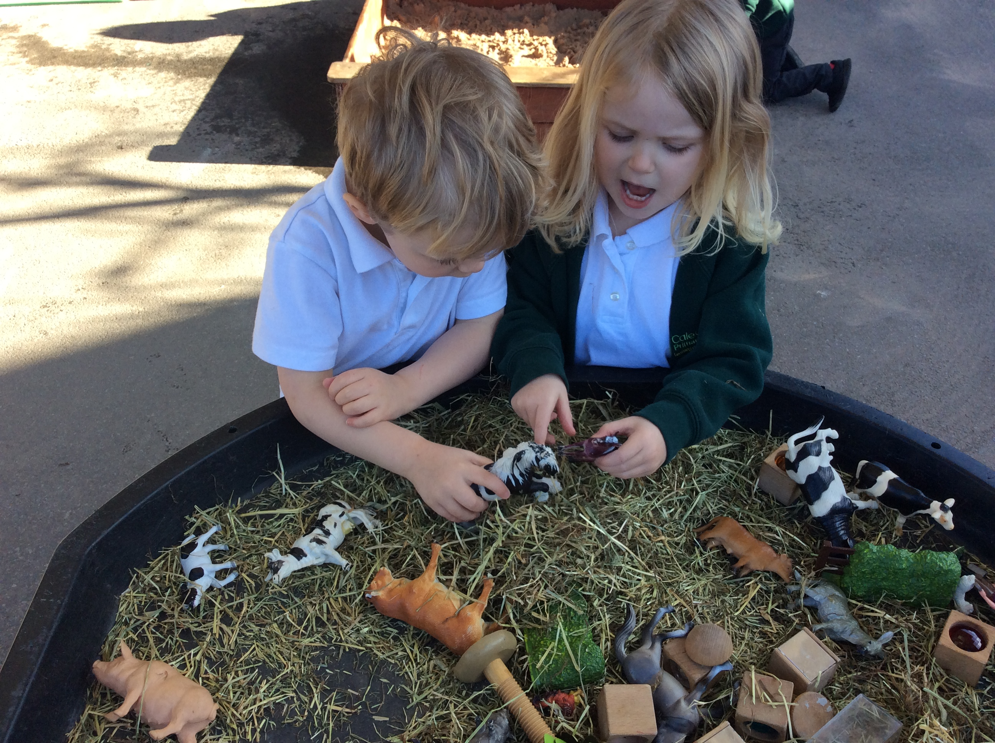

PURPOSE AND AIMS OF THE EARLY YEARS FOUNDATION STAGE

We have created a bespoke ‘curriculum’ for our youngest children, which reflects our community and prepares them for future learning. This is guided by the Department of Education’s Statutory Early Years Foundation Stage framework.

We are sensitive to the individual development of each child and ensure that the activities they undertake are suitable for their developmental stage and that their interests are considered. We recognise that children have to be challenged, but not pushed beyond their capabilities, so that they can continue to enjoy learning. We believe children’s experiences in the Early Years should be happy, active, hands-on, exciting and fun.

Ofsted commented in our most recent inspection, “Children in the early years quickly learn school routines and develop good learning behaviours. There is a strong focus on developing enthusiasm for reading from children’s very first days in the early years. Children are introduced to a wide range of books and stories. The songs that they learn and the games that they play help to develop their communication skills. They also learn about numbers and develop their understanding of the world around them.” (January 2022)

We offer your child an interesting and stimulating learning environment and the opportunity to play and explore alongside experienced and committed staff. We believe children should be presented with a beautiful and fascinating environment both indoors and outdoors, which gives them opportunities to revisit experiences to deepen their learning throughout their time with us.

We also believe children should be able to choose experiences which are rich in potential and we want your children to become lifelong learners who are willing to challenge themselves, take risks and be creative and confident.

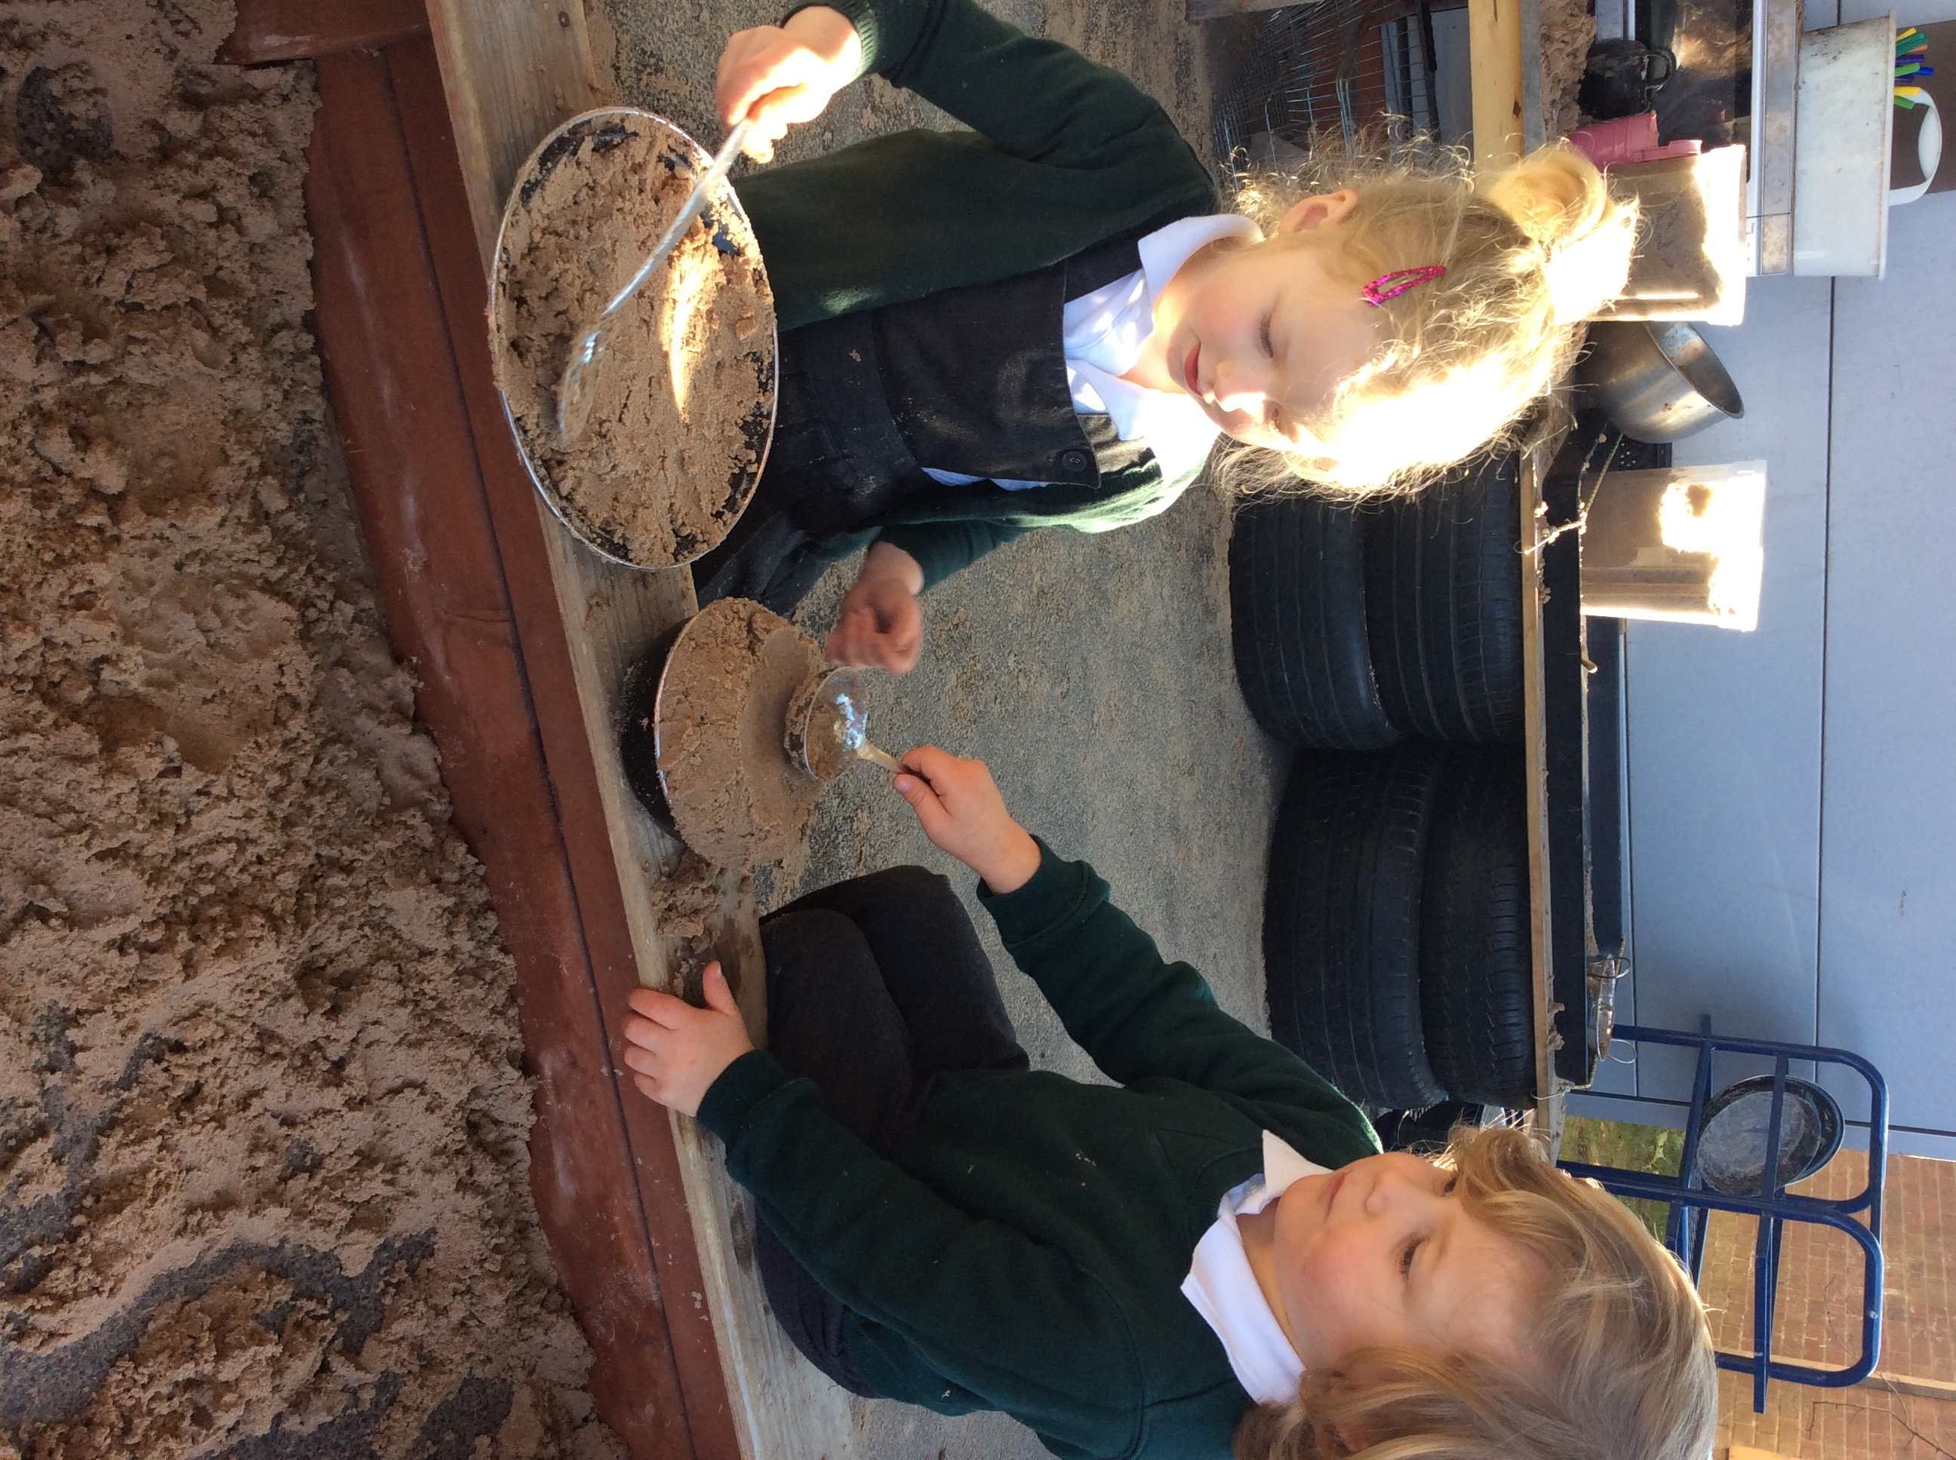

OUR CORE VALUES

The school community has created a set of core values by which we learn and live together.

‘We have more in common than that which divides us’-
We care about our world, where we live and our school.
We celebrate our diverse and inclusive community.

- We are a learning community where everyone has the highest aspirations for ALL of the children of Cale Green.
- We are a strong and resilient school community where kindness and thought for others is at the heart of everything we do.
- We are a school at the heart of its community with happy children ‘learning and living together’.

Created by children, families, teachers, teaching assistants and governors.
Autumn 2021

We have created 5 characters so that children understand the important values and can relate to them. Each animal has a cuddly toy and a special story about their special quality and we have now adopted one of each of these animals in zoos around the country.

Asha the aspirational aardvark
Raz the resilient rhinoceros
Kingy the kind kangaroo
Cohen the 'caring for the community' chimpanzee
Impy the inclusive iguana.

STARTING SCHOOL - INDUCTION

We believe children are competent learners from birth and we have an important role in working closely with families to nurture and support this. We have a carefully planned induction process to ensure a smooth transition into our school.

We work closely with parents, child minders and other settings to ensure that your child’s previous experiences are truly valued and built upon. We do this is a number of ways:

- We will welcome you to our school before you decide on which school you would like your child to go to
- We will meet with you at school in June to introduce our staff and provide you with a general ‘induction’ into school life
- We will visit you at home in June or July prior to joining our school to begin to build strong relationships and really get to know your child and their interests and needs
- We will meet with other settings and child minders your child might have been to, before your child starts at Cale Green, sharing assessment and other valuable information
- We will provide ‘Stay and Play’ sessions in July where staff will observe your child as they play, and plan adjustments to the provision to support your child’s learning when they start at Cale Green
- We will provide a gradual start, which builds up to full-time in September so children and staff really get to know each other well
- We will share your child’s learning and development with you through our online learning journal – ‘Tapestry’ and encourage you to share significant observations with us.
- We will have daily face-to-face contact with parents and carers.

We know that relationships are the foundation of children’s learning and development and that is why we do all we can to help your child feel emotionally secure with us. We are creating positive relationships between you home and school which will last for many years.

We will always welcome you to our Early Year’s department and we encourage you to let us know if you have any questions or queries. There will always be a member of the staff willing to talk to you should you have any worries about your child’s education or welfare.

MOUSE CLUB
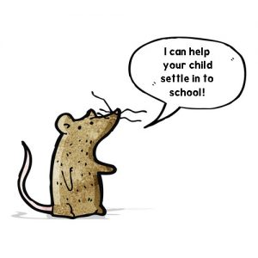

A very important part of our induction process is ‘Mouse Club’.

Mouse Club supports the development of positive partnerships for learning between families and our school. As part of our induction process, the project gives parents and carers an opportunity to meet school staff as partners in their child's development, sharing knowledge of their child’s strengths, aptitudes, likes and dislikes.

Our staff can support you further develop your understanding of how children learn and what they can do to provide a positive home learning environment. At stay and play sessions families are shown approaches to learning that they can support through fun activities both at home and in school.
The activities are designed to help your child be ‘school ready’. Before the children start school in September they will each be given their own special mouse who will share the child’s journey of getting ready for school. The main areas covered are gaining independence (getting used to putting on/ taking off their own coats and shoes, wiping their own nose) saying goodbye to the dummy, going on adventures outdoors, sharing books, singing together, developing healthy eating habits, establishing a bedtime routine and being toilet trained.

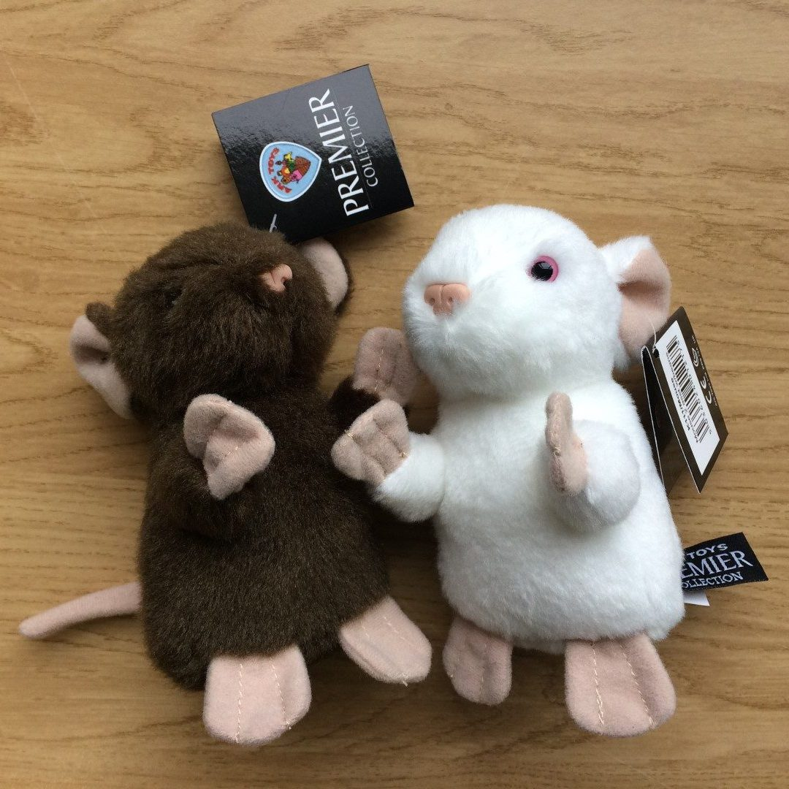

SESSION TIMES

Nursery aged children attend for 2 and a half days each week. Children are allocated a place in either the beginning or the end of the week class. They stay for lunch on full days.

Nursery

Monday / Tuesday: 8.50 – 3.05
Wednesday: 8.50 - 11.20

Or

Wednesday: 12.35 – 3.05
Thursday / Friday: 8.50 – 3.05

Some places for the ‘30 hours Offer’ are also available for families who are eligible. Please speak to Mrs Campbell or Mrs Crick in the school office if you are interested in taking this up.

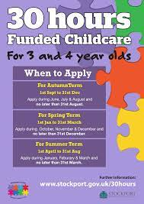

Reception / Key Stage 1

Morning: 8.40am – 11.30am
Afternoon: 12.30pm – 3.10pm

KEEPING IN TOUCH

We provide information about the school, events and activities to parents in many ways:

ParentPay: all payments for school activities are made through this service
Email: we email all letters to parents
Face-to-face: on the playground / during Family Assembly / etc.
Website: newsletters, recent letters, the school handbook and other important information is provided on the school website
Tapestry: Early Years online portal to share messages and children’s achievements
Twitter: We use this as a reminder to parents of activities and to celebrate specific activities which take place

Parent Pay



We use an online e-payment system 'ParentPay' for paying for school dinners, after-school club, trips, uniform etc. This is done online using a secure website called ParentPay or in cash at local stores where you see the PayPoint logo.

Downloading ParentPay to your phone or computer is very simple. If you need any assistance, please call into the school office. Further details about ParentPay can be found at:

https://www.parentpay.com/

SCHOOL UNIFORM

Please refer to the school website for specific information about uniform

https://www.calegreen.stockport.sch.uk/

All children are expected to wear school uniform, including those in Nursery.

White shirt or polo shirt
Grey / black trousers / skirt / pinafore dress (no jeans or tracksuits)
Green sweatshirt / cardigan / jumper
Sensible black shoes (no boots or training shoes please)

All these items are available at local supermarkets or can be ordered with a school logo via the school website.

Please note: we recommend children in Nursery wear leggings/ jogging bottoms instead of skirts or trousers if they are new to using the toilet. Clasps/ zips/ holding up a skirt can be tricky when you need the loo in a rush!

PLEASE LABEL EVERYTHING WITH YOUR CHILD’S NAME!

The school supplies embroidered polo shirts, fleeces, sweatshirts and T-shirts. We can also take orders for a shower proof jacket, homework / reading book bag, a school baseball cap and a ‘beanie’ hat. PE kit for Reception children consists of white t shirt, black short and black pumps. Our branded uniform is sourced locally which means that there are no postage costs and we support a local business.

Spare clothes

We ask parents and carers of Nursery children to provide several spare sets of clothes (these do not have to be uniform). Often, we take part in outdoor play, and creative activities which result in wet socks/ cuffs etc. We also require spare underwear and socks in case your child has a toilet accident.

Pre-loved clothing sale

We hold a pre-loved uniform (including shoes) sale on the playground on the last Friday of each month

Jewellery is not allowed. Only plain studs are allowed if a child’s ears are pierced.



LEARNING ENVIRONMENT

We have 4 classes in the Early Years –two, twenty place Nursery classes and two Reception classes (each of 22/23 children).

Children learn by playing and exploring both indoors and outdoors. We have two rooms - a Nursery room and a Reception room, joined by the toilets.
We also have a large outdoor area with some fixed climbing and balancing equipment.

Our environment is set up to appeal to the children’s interests and stages of development, and the resources available to your child are selected to support and promote your child’s learning and development.

No matter where your child chooses to play there will be opportunities to develop skills across the areas of learning. Indoors there is provision for looking at and sharing books, making marks, exploring making sounds, creating collages, painting and role play, using tools such as scissors, pencils and paintbrushes and time and space to share their ideas with others. Outside, the learning can take place on a larger scale. The children can experience nature first-hand in the garden and explore water and sand. They can create structures on a large scale, working with others to create using large crates, poles and planks and develop core strength by moving freely, balancing and climbing.

We are fully committed to ensuring that when the children leave the Early Years they have developed a real enjoyment of reading and have the necessary phonics knowledge and skills to access a range of books independently.

The children in the Early Years follow the ‘Statutory Framework for the Early Years Foundation Stage’. This framework enables children to learn and develop skills, attitudes and understanding in these areas of learning:

Prime Areas:

- Personal, Social and Emotional Development
- Communication and Language
- Physical development

Specific Areas:

- Mathematics
- Literacy
- Understanding the World
- Expressive Arts and Design

Teaching and learning takes place within the classrooms and outdoor areas, through a balance of adult-led and child-initiated activities within a carefully planned learning environment of continuous provision with enhancements related to specific interests and areas for development. Achievement of these prime and specific areas is achieved when children are:

- playing and exploring
- engaged in active learning
- provided with opportunities to be creative and think critically

Children access planned purposeful play opportunities through a balance of adult-led and self-initiated indoor and outdoor provision. This provision embraces every area of learning and is often enriched by visitors and trips.

Activities and experiences built around the interests of the children provide relevant and meaningful opportunities to develop children’s knowledge, skills and understanding in all aspects of their development. Please see a short video with images of our environments and activities on the school website under the ‘Early Years’ tab.

Jewellery is not allowed. Only plain studs are allowed if a child’s ears are pierced.

ASSESSMENT

Early Years record-keeping recognises children as individuals and reflect their whole development. Children arrive in school with differing levels of confidence and competence and the staff take note of this and work alongside your child’s needs. Assessment is continuous, ongoing and informal.
Supporting your child’s progress is an ongoing partnership between home and school. Your child will have an online Learning Journal (Tapestry) which both you and staff can access and add to:
www.tapestryjournal.com/
This will document the experiences your child has, and will help us to make decisions about how your child is developing. If either you, or we have any concerns about your child’s development we can meet and devise an additional support plan, making any referrals to other agencies such as Speech and Language Therapy and the Educational Psychology service.
We plan for each child’s individual learning requirements, including those children who need additional support or who have specific needs or disabilities. Any child who is identified as having special educational needs is supported, and time to work alongside parents is made available so that we can develop effective strategies to meet these needs.
Parent Consultations take place each term to discuss how your child has settled, how successfully they have built up relationships with their peers and the adults who care for them and the progress they are making with their learning. We also discuss how you can support your child’s learning and development.
Reports to parents are provided at the end of Nursery and Reception years. We add to your child’s online learning journal regularly, and encourage parents, carers, child minders and other setting to do the same.
Information regarding your child and his or her achievements, learning styles etc. is shared with their next teacher before they enter their next phase of learning in Key Stage 1.

At Cale Green we work hard to develop an effective partnership with parents as you are your children's first and most enduring educators. When parents and teachers work together, especially in the Early Years, this has a positive impact on the child's future learning and development. At the end of the Early Years the children are fully prepared for their next stage of education in Key Stage 1.

PHONICS, READING AND WRITING

All the children in school are taught to read and write following a scheme called ‘Unlocking Letters and Sounds.’ This is a detailed and systematic programme of teaching phonics skills with the aim of all children becoming fluent readers by the age of seven.

This begins in the Early Years. First, by developing phonological awareness through games, rhymes and songs and then by developing children’s ability to hear, identify and manipulate English phonemes (https://www.theschoolrun.com/what-is-a-phoneme) in order to teach the correspondence between these sounds and the spelling patterns that represent them. (https://www.bbc.co.uk/tiny-happy-people/what-is-phonological-awareness/znrk8hv)

The goal of phonics is to enable beginning readers to decode written words by sounding them out, (or in phonics terms, blending the sound-spelling patterns), and enable beginning writers to segment the sounds in words to write the graphemes (letters) which represent them. Children are taught in their class in the Early Years for daily phonics teaching. Further support is put in place if a child requires it.

In teaching reading, several approaches are used, as we find that this is more effective than focusing on one single aspect. Story-telling and shared reading help to develop letter sounds and knowledge and well as supporting comprehension. Singing and rhyming develops phonological awareness as well as counting and clapping syllables in a word. The exploration of different voice sounds during reading helps children to make different sounds, ready to learn phonemes and also help with understanding the text in terms of emotions, for example.

All children are all given a book bag which contains books from our reading scheme and our reading bingo initiative, and they are encouraged to share them with their family, regularly.

Studies demonstrate that one of the most important factors in children succeeding in children is that they read at home with parents and with parents who read aloud to them.



ATTENDANCE / ABSENCE FROM SCHOOL

We always reward good attendance and punctuality as these are crucial to a child’s success.

Please inform the school on the day of absence, by telephone or email, the reason for a child's absence. A member of staff will contact you on the first day of any absence if you have not contacted the school.

Government regulations require every absence to be explained, preferably through a direct conversation or an email or note. The Education Welfare Officer and our child and family Support Worker, regularly monitor attendance and will contact parents if necessary. Attendance below 90% triggers the involvement of Education Welfare Officer. Please be aware that persistent absence may result in fines and prosecution by the Local Authority.

No absence is authorised for holidays unless in exceptional circumstances. All other holidays are recorded as unauthorised and where appropriate Education Penalty Notices of £60 per parent per child may be issued by the Local Authority for children of compulsory school age.

Whenever possible, dental or medical appointments should be made outside school hours. In the event of continued medical absence, we will inform the School Nurse who may be able to offer support.

Children are not allowed to leave school during the day unless a parent / carer collects the child after seeing the head teacher or a member of staff.

Under no circumstances will a child be allowed to leave the school premises on the strength of a verbal request alone or with another minor.

Please inform us of anything which may be distressing your child,
for example, the illness or death of a relative, death of a pet or absence of a parent (hospital, working away, etc.).

PUNCTUALITY

If your child arrives, or is brought to school, after 8.50am, he/she is late and must be signed in at the school office on the ‘Inventory’ system by their parent / carer before going to the classroom. This is important so that the attendance registers are accurate.

A record is made of late arrival and if the problem persists then parents will be contacted by the head teacher or the Educational Welfare Officer. Regular ‘Late at the Gate’ sweeps are held by the Education Welfare Service to encourage good punctuality.
Awards are given in school for good punctuality.

UNAUTHORISED ABSENCE

As already stated the school should be informed, as soon as possible, of the reason for any absence. If no reason is given, the absence is classed as 'unauthorised'. In addition, certain absences may be classed as 'unauthorised', even if a message has been received. This is if the absence was not for an authorised or justifiable reason such as shopping or for a haircut!

HOLIDAYS TAKEN IN TERM-TIME

There are strict guidelines for holidays in term time. If your holidays do not coincide with the school's pattern, absence cannot be authorised only for exceptional circumstances.

After two weeks your child will be reported as ‘missing from education’ and after four weeks unauthorised absence the school will remove the child's name from the register. For example, home leave from the Armed Forces.

Apart from the legal requirement to complete a fixed minimum number of attendances, parents should bear in mind the disruptive effect the absence may have on their child's education. Parents are requested not to book holidays during the period of Key Stage 1 and 2 SAT testing.

Education Penalty Notices of £60.00 per parent per child will be sought when children are absent from school for longer than five days for a holiday.

CHILD PROTECTION – SAFEGUARDING

Our school is completely committed to safeguarding the children. We play an essential role in protecting children from abuse. As we are in regular contact with children and young people we are in a strong position to identify signs of abuse and neglect.

We safeguard children by:

- creating safe environments for children and young people through robust safeguarding practices
- ensuring that adults who work in the school, including volunteers, do not pose a risk to children
- making sure staff are trained, know how to respond to concerns and keep-up-to-date with policy and practice
- teaching children and young people about staying safe
- maintaining an environment where children feel confident to approach any member of staff if they have a worry or problem.

The school complies with all the requirements. These include Health and Safety, Safer Recruitment, Risk Assessments on trips and visits, Medicines in Schools, Fire Safety, Child Protection and Radicalisation and Extremism.

All staff receive the appropriate training in Child Protection. The two Designated Safeguarding Leads are:

Designated Safeguarding Lead – Mrs Sarah McHugh
Deputy Designated safeguarding – Ms Gill Rogers

Another 4 members of staff have completed Designated Safeguarding Lead training:

Mrs Carole Harding (SENCO / Deputy head)
Mrs Nicky Lewis (Deputy head)
Mrs Helen Cartwright (Key Stage 1)
Mrs Katherine Horrabin (Business Manager / Governor)

In cases of serious physical or sexual abuse disclosed by a child, the school is REQUIRED to report the matter to Social Care IMMEDIATELY. In these very serious situations, it is likely that a social worker will contact the parents, NOT the school. This requirement forms part of the Local Authority's procedures for dealing with child abuse and is not a matter for the discretion of individual headteacher's or members of the school staff.

In less clear cases of suspected physical abuse or emotional/psychological abuse, the school will often seek advice from Social Care before discussing the issue with parents. Further information about safeguarding in schools can be found at:
https://www.safeguardinginschools.co.uk/safeguarding-and-governors/what-is-safeguarding/
www.safeguardingchildreninstockport.org.uk/

Intimate Care

Sometimes the children in the Early Years require intimate care if they have had an ‘accident’ / soiled themselves. Staff will always change your child and if necessary will provide them with clean clothing. You will always be informed if this is necessary and every instance is recorded.

The school has a separate ‘Intimate Care policy which details the procedures staff must follow to safeguard the dignity, health and care of your child. This can be found on the school website.

Trips and Visits

All teachers are visit leader trained and risk assessments prior to each visit are written. During visits ‘dynamic’ risk assessments are constantly made to ensure the safety of the children. Written permission slips (not verbal permission) are required when the children are on an educational visit. The children usually wear ‘hi-vis’ jackets and a member of staff who is first aid trained accompanies the children on the visit.

INTERNET / E-MAIL

You can access information about the school through the following Internet address:

www.calegreen.stockport.sch.uk

The school’s email address is: Schooladmin@calegreen.stockport.sch.uk

Children do not have individual email accounts. Social networking sites are blocked. The school’s access to the Internet is also controlled by the Local Authority and all key strokes (any typing) is logged and monitored by Esafe.

The school does have an active Twitter account which can be found at:
@CaleGreenPS

CHILD AND FAMILY SUPPORT WORKER

We are very fortunate that we have Gill Rogers, our Child and Family Support Worker who helps the children to overcome any ‘barriers to learning’ that they may have during their time at the school. Gill works with families, individual children, small groups and whole classes and has developed a range of activities to support the mental health and the emotional health and well-being of all the children.

Child and family support is available before school, during playtimes and lunchtimes, after school and sometimes at the weekends and during the school holidays. The work of the school in this area has been recognised as ‘good practice’.

Work with parents and carers includes the ‘Friends of Cale Green’, ‘Family Learning’ and parenting courses as well as providing individual support and ‘signposting’ to other services. Another very important aspect of Gill’s work is to promote good attendance and punctuality.
We also have a Bilingual Community Learning Mentor, Tabassam Ijas, who works at the school on Wednesdays to help support parents and children where the family has English as an additional / second language.

BEHAVIOUR / PASTORAL CARE

At Cale Green we value and respect each unique individual. We constantly praise and reward good behaviour. We stress the qualities of kindness, thoughtfulness and gentleness. The school has a clear, simple code of conduct which was created by the children and which each child is expected to follow. This is known as ‘The Cale Green Code’.

The Cale Green Code

We will always do our best to:

- be safe and sensible
- treat everyone and everything with respect
- be responsible for our own actions
- listen and follow instructions carefully

When problems arise parents / carers are informed and involved. The Child and Family Support Worker may also be involved. We use ‘Restorative Approaches’ to resolve issues – working ‘with’ children and their families. Children and their families are also asked to sign the ‘Home / School Agreement’. This partnership agreement has been written by parents and the school working together.

Our approach is to work with and alongside children and their families, together in a strong and equal partnership.



THE CALE GREEN CHALLENGE

To promote our Core Values every child is challenged to complete a range of tasks throughout their time at Cale Green Primary School. This includes learning to tie your shoelaces to jumping in a muddy puddle. Lots of the tasks are designed to be able to complete at home whilst some will be completed in school time.

There is no rush to finish all the tasks - it's not a race!

When your child has completed 10 tasks they have completed Challenge 1. They will be awarded a Kingy 'the kind' kangaroo badge to wear on their school jumper.

To get Challenge 2, children must complete a further 10 tasks to get the Cohen 'caring for the community' chimpanzee badge.

Challenge 3 requires the children to complete another 15 tasks. This will get them an Impy 'the inclusive' iguana badge.

Challenge 4 requires the children to complete a further 20 tasks. This will get them an Asha 'the inspirational' aardvark badge.

Finally, to achieve Challenge 5 - the Raz 'the resilient' rhino badge, children must complete another 25 tasks.

SCHOOL TRAVEL – SUSTAINABLE SCHOOLS



The school is committed to encouraging walking, cycling or scooting to school as a safe means of transport. This has been recognised by achieving the SUSTRANs Gold Award. We were the first primary school in Greater Manchester to have achieved this!



We want to encourage sustainable, safe travel as part of our school culture. We encourage the children to cycle and scoot to school so that it becomes the norm for travel to Cale Green, creating a long lasting and durable cycling culture, quieter, safer roads and happy, healthy children.

Activities sometimes take place in lessons and at least once every half - term there is some form of activity related to walking, cycling, and scooting and road safety. We also encourage the children to consider these issues through their curriculum activities. The governors fully support these activities and we have a parent identified as a ‘Cycling Champion’.

We work closely with a range of partners such as BRAKE, the Local Authority and Sustrans to deliver the following activities:

Road Safety: Operation Eagle Eye / Step Outside / Headsmart / Crashed Vehicle Project / Child Speedwatch

Cycling and Scooting: Bike week / Bike It days / Dr. Bike / Bling Your Bike / Bike It Breakfast / cycle + scooter storage / ‘Bespoke Cycling’ (bike recycling charity / ‘Scooter Man’ – scooter park / Manchester Velodrome BMX course visits / Bruntwood Park BMX course / weekend adult cycling workshops / Sustrans ‘Superhero’ day.

We are active partners in the ‘Living Streets’ charity and take part in Walk to School activities wherever possible – regularly winning the Local Authority Award for the most journeys to school on foot, bike or scooter!

In addition, we have introduced ‘Balanceability’ to get every Reception child riding a bike without stabilizers and ‘Bikeability’ so that older children can ride their bikes safely.
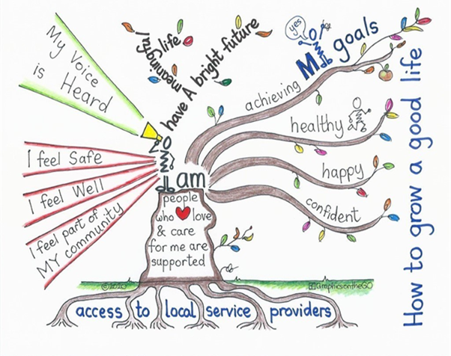

EQUALITY AND INCLUSION

We are proud that our truly comprehensive primary school serves to meet the needs of all children of the Cale Green area irrespective of their background or need.
At Cale Green we are committed to raising standards for all children, closing any gaps between different groups. We are also committed to tackling the barriers to equal opportunities which may prevent a child from achieving their full potential.
We have a rich and deep, balanced and appropriate curriculum which promotes British values and which provides equal opportunity for all pupils to maximise their potential regardless of age, sex, sexual orientation, race, colour, religion or disability.
We aim to promote equality and tackle any form of discrimination and actively promote harmonious relations in all areas of school life. We seek to remove any barriers to access, participation, progression, attainment and achievement. We take our contribution towards community cohesion seriously. Throughout everything we do we consider the wider impact of our actions.



We were proud to be awarded the Inclusion Quality Mark which recognises the work done in school to ensure that EVERY child, irrespective of home background and their unique needs, achieves to the very best of their potential. It is our duty to ensure that we do not discriminate against any children.

The school also publishes an Equality and Diversity policy which has a range of actions so that we can fulfil our general equality duty contained in the Equality Act (2010). This is published on our school website.

‘Pupils are happy in this school which sits at the heart of a close-knit, multicultural community. Pupils are kind, friendly and considerate towards each other. They feel safe because they are well looked after by a staff team that have high expectations for pupils’ behaviour and achievement. Pupils do their best each day to live up to the high standards that staff set for them.’ (Ofsted January 2022)

SPECIAL EDUCATIONAL NEEDS and DISABILITY

At Cale Green we are proud to hold the Local Authority Inclusion Quality Mark.

In the Early Years, we work with health visitors and Start Well Hub workers so are often aware of your child’s needs and support already being given before your child starts school.

At some time during their time at school many children will have special educational needs of different kinds. In fact, we feel that all our children's needs are special. Children’s needs are monitored and assessed during their school career. There is a teacher in school (SENCO), who has special responsibility for these children, Mrs Carole Harding. She is highly experienced and gets to know the children and their families very well.

Children experiencing difficulties are referred by the class teacher to the special educational need’s teacher. Any specific difficulties are then identified and assessed, responded to, monitored and evaluated. The school receives support from the Learning Support Service with specialist teaching, and from the Educational Psychology Service. Additional support is accessed from a wide range of other ‘providers’ such as the Speech and Language and the Occupational Therapy.

The SENCO is also responsible for liaison between parents, the school, governors, other professionals and the Local Authority and for ensuring that the requirements of the Local Authorities guidelines on Special Educational Needs are fulfilled.

More able children are tracked through the school with, where appropriate, special provision made to cater for their needs and to enrich and enhance their learning. The school website includes details of the support available to children in Stockport, the ‘Local Offer’ and also the support which is provided in school, the ‘School Offer’.

As a school we endeavour to meet all our children’s needs however we realise that we need to plan and implement plans for improving accessibility at Cale Green for disabled pupils. We regularly review our Accessibility Plan and identify any barriers to access which exist at the school.

As a school we plan for:

- increasing access for disabled pupils to the school curriculum
- improving access to the physical environment of the school
- improving the delivery of written information to disabled pupils.

As a two storey building arrangements are in place to move Key Stage 2 classes to the ground floor if the need arises. Additional adult support is also provided if required.

Our approach to special needs and disabilities is detailed on the school website under the ‘Our School / Special Needs’ tab.

FREE SCHOOL MEALS / PUPIL PREMIUM

Children from families in receipt of certain benefits may be eligible for free school meals. Please ask at the school office for details. Your child may be able to get free school meals if you get any of the following:
- Income Support
- income-based Jobseekers Allowance
- income-related Employment and Support Allowance
- support under Part VI of the Immigration and Asylum Act 1999
- the guaranteed element of State Pension Credit
- Child Tax Credit (provided you’re not also entitled to Working Tax Credit and have an annual gross income of no more than £16,190)
- Working Tax Credit run-on - paid for 4 weeks after you stop qualifying for Working Tax Credit
- Universal Credit
Children who get any of the above benefits in their own right (i.e. they get benefits payments directly, instead of through a parent or guardian) can also get free school meals.
Further details can also be found by contacting:
www.stockport.gov.uk/services/advicebenefitsgrants/benefits/freeschoolmeals
benefitsfsm@stockport.gov.uk

T: 0161 217 6015
Our school will receive an additional £1320 for each child registered as eligible for free school meals at any point in the last 6 years. Looked After Children, those in the care of the Local Authority, receive an additional £2300 which is ring-fenced to be spent on that child alone.
The more parents who claim Free School Meals (even if you do not use it because your child has a packed lunch,) the more Pupil Premium Grant money goes into the school budget.
Schools will also receive additional funds for each pupil who has left Local Authority care because of one of the following:
- adoption
- a special guardianship order
- a child arrangements order
- a residence order
We have a ‘tiered’ approach to our pupil Premium Strategy and currently use this money to employ extra staff to help with English and maths from the Early Years through to Year 6. Mrs. Nicola Lewis, our Year 5 / 6 teacher, is the ‘Pupil Premium Champion’ and she meets regularly with the governing board to discuss the impact of these additional funds.
This money is used to support the development of high quality ‘first’ teaching, additional staffing, access to subsidised activities, etc. So, you can see how important it is to the children that you claim your entitlement!
Details of how much Pupil Premium grant the school receives, what it spends it on and its impact are detailed on the school website.

Remember – if you claim just once the school will
receive at least £1320 a year for the next 7 years!

POVERTY PROOFING THE SCHOOL DAY

At Cale Green we work to identify and overcome the barriers to learning that children and young people from families with less financial resources face.

We have had an external audit of our school which looked at many different aspects of school life and involved children, parents, staff and governors.

We now have an action plan tailored to address any policies or practices. In this way we can also explore the most effective way to spend our pupil premium allocation.

For further details, please follow this link:

http://www.povertyproofing.co.uk/

COMPLAINTS PROCEDURE

The majority of concerns expressed by parents are dealt with on an informal basis within the school itself. Only when this avenue is exhausted would the complaints procedure established by the Local Authority come into effect. We aim to acknowledge complaints within 3 working days and respond to them in 10 working days.

The full details of the Complaints Procedure, including the scope of the arrangements and the rights and roles of all concerned, the role of the Governing Body, the Local Authority and the Secretary of State are available from school and ae on the school website under the ‘Parents’ tab.

All complaints will be taken seriously and treated with care and sensitivity.

CHARGING FOR SCHOOL ACTIVITIES

There is a small, voluntary, weekly charge for the Nursery Fund to pay for snacks and additional resources.

The Governing Board recognises the valuable contribution that the wide range of additional activities, including clubs, trips and residential experiences can make towards the children’s personal and social education. The Governing Board wish to see the curriculum enriched as far as possible for the benefit of all the children and aims to promote and provide such activities both as part of a broad and balanced curriculum for the children and as additional optional activities.

All school activities are subsidised and the school asks for a voluntary contribution towards the cost from parents. Any requests for contributions must make it clear that there is no obligation to contribute and that pupils will not be treated differently according to whether or not their parents have made any contribution in response to the request.

Charges may be made for the cost of repairing or replacing any damaged property or item resulting from a child's inappropriate behaviour or for replacing any non-returned property or an item that has been loaned or hired to a child. This is especially the case with lost reading and homework books. A charge of £5.00 will be made for each book lost.

The school’s Charging and Remissions policy is available on the school website under the ‘Our School’ tab.

ACCIDENTS, ILLNESS AND MEDICAL MATTERS

The majority of our Teaching Assistants are qualified in Paediatric First Aid and are able to deal with most of the minor injuries that occur in school. Sometimes we do have more serious accidents, for example, real or suspected fractures, eye injury, head injury, etc. and in these circumstances, we will make every effort to contact the parent/carer. However, the welfare of the child is our first concern and it may well be felt necessary to seek immediate hospital treatment, whilst at the same time, attempting to contact you.

Please inform the school immediately of any changes of emergency contact numbers, especially mobile phone numbers. Other up-to-date contact names and telephone numbers are also very important.

We have had instances where children are sent to school already feeling unwell. It is invariably the case that these children need to be sent home later in the day.

If there is any doubt in your mind about your child's health, it is far better to keep him/her at home for a while, or visit your doctor. It is sometimes the case that children return to school before they are really fully well and this can mean them having to have further time off, or even in some cases, passing the infection to others.

MEDICINES IN SCHOOL / MEDICAL CONDITIONS IN SCHOOL

As a general rule medicines are NOT administered to children on the school premises by the staff. This is in line with national and local guidelines.

If a child is prescribed a medicine 3 x a day then it can usually be administered before school, after school and before bedtime.

However, it is appreciated that sometimes a child is perfectly well enough to attend school but is following a course of medicine prescribed by a doctor that needs to be administered during the school day. If the school staff are to be asked to administer medicine, they are only allowed to do so with written authority from parents and the consent of the head teacher. This medicine must be in the original container with the original doctor / pharmacist instructions.

Forms for this purpose are available from the school office. As a school we follow the ‘Medical Conditions in School’ guidance from the Department for Education.

For children with serious medical needs a Health Care Plan may be drawn up.

Under no circumstances will children be allowed to take medicine by themselves without adult supervision.

ASTHMA AND INHALERS / EPILEPSY / SEVERVE ALLERGIC REACTION

It is recognised that children who suffer from asthma need ready access to their prescribed inhaler and spacer. The school's policy is that as soon as a child is able (old enough) he/she should keep a 'reliever' inhaler (usually in a blue container) with him/her at all times. Until such times that a child is able to take charge of his/her inhaler it will be kept in the classroom. All inhalers and spacers should be clearly marked with the child's name.

If your child is hospitalised with breathing difficulties / suspected asthma, then you must contact school and inform us on your child’s return to school.

In practice, inhalers are kept in a clear plastic container which is kept in the classroom during lessons, near to the child at playtime, assemblies and lunchtimes and which is taken on class visits / trips.

It should not be necessary for 'preventer' inhalers (brown) to be brought into school.

If your child has an asthma attack, then in an emergency another child’s blue inhaler / spacer may be used.

If your child has epilepsy / severe allergy (usually to nuts) then we will keep an ‘epi-pen’ in school and staff will be trained in its use. Please inform us of any intolerances/ allergies when your child develops them.

MEDICAL SCREENING PROGRAMME

Medical screening takes place for children in the Reception age group. Each child is routinely seen for a hearing test. In addition, some children may have their vision, height and weight checked at school if it is deemed necessary. The children are examined by the school doctor or the school nurse and parents are invited to be present.

Our school nurse, Liz Donegan, is based at Heaton Norris Health Centre, and carries out the Screening Programme. A dental inspection is also held annually. Parents are informed by the school dentist if any treatment is required.

HEAD LICE

If you find, or suspect that your child has head lice (or the eggs, often known as 'nits'), then please inform the school. Please be assured that anyone can catch head lice and it has nothing to do with 'dirty hair'. In fact, head lice prefer clean hair (but they don't like combs!).

FAMILY FORUM / COMMUNICATION

We have a weekly Family Assembly which all parents and carers are invited to attend either in person or online via a link that can be sent to you.

Every term there is at least one formal Family Forum. This is usually to discuss an issue raised by parents / carers or a priority the school is currently working on. Past topics for discussion have included becoming school ready, poverty proofing, attendance, free school meals, anti-bullying, safeguarding, cyber-bullying and homework. Your views are valued – please attend these meetings if you can!

Cale Green really is a school right at the heart of the community and we pride ourselves on the close and supportive links we have between home and school. Activities such as volunteering in classes, carol singing in the community, the School Fair, fund raising events, etc. all help to promote links between the school and the wider community.

Where possible we also strive to promote access to education through the school for parents and carers. We continue to have close links with Family Learning and will again be hosting courses for parents and carers this year. These have included courses on English, Mathematics, ESOL classes and ‘Reading for Pleasure’.

Parents are involved in the school in so many ways and we are indebted to the volunteers who help to prepare bagels for the children every day, run the baby and toddler ‘Terrific Tots’, assist with reading, in the Nursery class, on trips and visits and who help the school function in so many other ways. Thank you!

FRIENDS OF CALE GREEN PRIMARY SCHOOL

All parents, carers, governors, teachers and staff at Cale Green automatically become ‘Friends of Cale Green’, affectionately known as ‘FROGs’.

The objective of the ‘FROGs’ is to advance the education of children in the school. The ‘FROGs’ are committed to achieving this objective in a number of ways. These include developing relationships between all those involved with the school and by raising money to assist with the provision of resources for the school and the children. We have a small but very committed group of parents who are always looking for other parents / carers to join them.

Please contact the Child and Family Support Worker, Gill Rogers, or your child’s class teacher or just stay behind after the Family Assembly if you would like to find out more about FROGs.

GOVERNING BOARD

Our school governors are people who want to make a positive contribution to the education of children at Cale Green. Our governors have an important part to play in raising school standards. The role of the governing body is absolutely key to the effectiveness of a school.

Governors attend sub-committees and full governing board meetings after school, as well as arranging visits to classrooms and activities such as Family Assembly and celebration events. It is quite a commitment – but very worthwhile!

We were delighted that the school achieved the Governor Mark – the very first school in Stockport to do so!

Further information about the role of governors can be found at:

www.nga.org.uk/

PARENTAL ACCESS TO DOCUMENTS AND INFORMATION

The following documents are available in school on a reference basis, and can be made available to any parent, during school time. (In addition, many of the documents can be obtained from the school at a cost not exceeding the purchase cost, or the copying cost of the document)

- National Curriculum documents
- Local Authority Agreed Syllabus for Religious Education
- School based Schemes of Work
- Published minutes of Governor meetings
- Local Authority Procedure for Complaints
- The School Prospectus / Handbook

As with all other areas of school life, if have a query or require clarification of any document, etc. then please do not hesitate to contact school. We will always try to assist you immediately. If that isn’t possible then we will arrange a meeting with you as soon as is possible. We also operate Data Protection compliance (GDPR) and Freedom of Information.

We hope that you have found the Parents Handbook useful as well as informative. If you wish to discuss anything concerning the school, then please do not hesitate to contact us. This document is also available on-line at:

www.calegreen.stockport.sch.uk.

FINAL THOUGHTS FROM MRS McHUGH

Our school will leave ‘no stone unturned’ in its commitment to ensuring that each individual child achieves the very best of their own unique potential.

We understand that you put the greatest amount of trust in us to look after the very most precious things in your life – your children. This trust gives us all our enormous sense of purpose and responsibility to get things right for your child.

We want the children to come to school every day looking forward to being with their friends, learning and applying new knowledge in interesting ways and having lots of exciting experiences which make learning memorable.

We want each child to be known as a unique individual in school, who can make a contribution to the wider life of the school, who has a ‘voice’ and who feels listened to and cared for.

In doing these things, I think that each child will come to school relaxed and alert and ready to learn in a school which they feel belongs to them and they are proud to be a part of, living and learning together with their friends.

Mrs Sarah McHugh
Headteacher

“Leaders, teachers and support staff work extremely well together. They are all proud to be part of the school community.”

“There is a strong bond between parents, carers and staff at this school.”

“…the way staff promote the school’s values each day helps their children to develop into well-rounded individuals.”

This handbook will be reviewed in summer 2024.

