Supporting Pupil’s Medical Conditions in School

Summer 2023

Policy Statement

Cale Green Primary School is an inclusive community that aims to support and welcome pupils with medical conditions.

Cale Green Primary School aims to provide all pupils with a medical condition the same opportunities as others at school.

We will help to ensure children can:

- be healthy
- stay safe
- feel part of their local community
- be confident and able to meet their goals

- Cale Green Primary School ensures all staff understand their duty of care to pupils, in the event of a medical emergency.

- All staff are confident in knowing what to do in an emergency.

- Cale Green Primary School understands that medical conditions are serious and can be potentially life-threatening, particularly if ill managed or misunderstood.

- Cale Green Primary School understands the importance of medication and care being taken as directed by healthcare professionals and parents.

- The School Nursing (SN) /Health Visiting (HV) Service will offer Cale Green Primary School an annual update. If a new medical condition arises over the year, then the SN/HV will provide an update or give advice on the most appropriate service to deliver it.

Policy Framework

The policy framework describes the essential criteria for how the school can meet the needs of children and young people with medical conditions.

- Cale Green Primary School is an inclusive community that supports and welcomes pupils with medical conditions.

- Cale Green Primary School understands that it has a responsibility to make the school welcoming and supportive to pupils with medical conditions who currently attend and to those who may enrol in the future. In doing so, the school will work in partnership alongside the child’s parents/carers. No child will be denied admission or prevented from taking up a place because arrangements for their medical condition have not been made.

- Cale Green Primary School will listen to the views of parents and pupils.

- Pupils and parents will feel confident in the care they receive from this school and that the level of the care meets their needs.

- Staff understand the medical conditions of the pupils at this school and that they may be serious, adversely affecting a pupil’s quality of life and impact on their ability to learn.

- School understands that all children with the same medical condition will not have the same needs.

- School recognises that the duties in the Children and Families Act and the Equality Act relate to children with a disability or medical condition and are anticipatory.

- The Headteacher is responsible for ensuring staff receive all updates and responsive advice from the health professionals specifically the Health Visitor/School Nurse Service.

- The Headteacher must appoint a member of staff as a designated person responsible for the implementation of this policy.

- Cale Green Primary School’s medical conditions policy is drawn up in consultation with a wide range of local key stakeholders within both the school and health settings

- Stake holders should include pupils, parents, School Nurse/Health Visitor, school staff, governors/trustees.

- The medical conditions guidance is supported by a clear communication plan for staff, parents/carers and other key stakeholders to ensure its full implementation (see Medical Conditions Information Pathway below).

- Pupils are informed and reminded about the medical conditions policy:
- through the school’s pupil representative body
- through the delivery of personal, social and health education (PSHE)
- through an assembly at the start of the school academic year.

- Parents/carers are informed about the medical conditions’ guidance and that information about a child’s medical condition will be shared with the school nurse:
- by including a clear statement on the schools' website and signposting access to the guidance
- at the start of the school year when communication is sent out about Individual Health Plans
- using usual communication channels e.g. Newsletters etc at intervals in the year
- when their child is enrolled as a new pupil

- School staff are informed and regularly reminded about the school’s medical conditions Guidance:

- through the staff handbook and staff meetings and by accessing the school’s intranet
- through scheduled medical conditions updates
- through the key principles of the policy being displayed in several prominent staff areas
- all supply and temporary staff are informed of the policy and their responsibilities including who is the designated person, any medical needs or Individual Health Plans related to the children in their care and how to respond in emergencies
- Staff are made aware of Individual Health Plans as they relate to their teaching/supervision groups. This is a role for the designated person

Medical Conditions Information Pathway
Schools must ask parents to identify any medical conditions and how best to support their child at the following opportunities:  - Transition discussions  - At start of school year  - New enrolment (during the school year)  - New diagnosis informed by parents | School

School collates response and identifies those needing individual health plans and sends to the school nurse. | School

School Nurse contacts the parents/carers either to review Individual Health Plan (IHP) or start new plan if needed. | School Nurse

Parents/carers and school nurse complete the IHP. If there is no response from parents/carers, the school nurse must inform the designated person. All contacts to be documented and dated. | Parents  School Nurse  School

School nurse discusses the IHP with school designated person. Parents/carers informed of acceptance of IHP. IHP is stored in school according to the policy.  PARENTS/CARERS MUST CONTACT SCHOOL WHEN THERE ARE CHANGES OR AMENDMENTS NEEDED AT ANY POINT IN THE SCHOOL YEAR | School Nurse  School  Parents

Parents/Carers Responsibilities
Parents/Carers have a responsibility to:
- tell the school if their child has a medical condition or complex health need and inform the school if there are any changes to their child’s condition
- check the school has a complete and up-to-date Individual Health Plan if their child has a complex health need
- inform the school about the medication their child requires during school hours and provide the school with an in-date medication.
- provide the school with the medication labelled with the pupil’s name, the name of the medication, the dose, the time the medication needs to be given and the expiry date for the medication.

- complete the Medical Permission form (3a) with school to ensure the medication is given correctly during school hours.

- inform school of any changes to their child’s medication and ensure the 3a is updated correctly.

- inform the school of any medication their child requires while taking part in visits, outings or field trips and other out-of-school activities.
- ensure that the school has full emergency contact details for them
- keep their child at home if they are not well enough to attend school
- ensure their child catches up on any schoolwork they have missed
- ensure their child has regular reviews about their condition with their doctor or specialist healthcare professional.
- if the child has complex health needs, ensure their child has a written Individual Health Plan for school and, if necessary, an asthma management plan from their doctor or specialist healthcare professional to help their child manage their condition
- have completed/signed all relevant documentation including the Individual Health Plan. If appropriate
- ensure that their child is as up to date as possible with immunisations to ensure that both the school and its pupils are as safe as possible. If parents do not wish to have their child vaccinated then the school need to be made aware of this and a risk assessment of activities to be undertaken needs to be completed.

4. ‘All children with anaphylaxis, epilepsy, cystic fibrosis, diabetes or a complex medical
condition requiring significant care in school/EYS will have an individual health plan
(IHP). Please note children with asthma will no longer require a IHP but may have an
asthma management plan from their doctor or specialist health care professional. For
any child having an asthma attack, please follow the ‘Asthma emergency procedures’
(Appendix 7)

- An IHP will detail exactly what care a child requires in school and when they need it.

- It should also include information on the impact any health condition may have on a child’s learning, behaviour or their ability to engage in everyday activities.

- This should be completed with input from the child where possible, their parents/carers, relevant school staff and health care professionals, ideally a specialist if the child has one.

5. All staff understand and are trained to know how to respond to an emergency for children with medical conditions.

- All school staff, including temporary or supply staff, are aware of the medical conditions within the school and understand their duty of care to children in an emergency.

- A child’s IHP explains what help they need in an emergency.

- Permission from parents/carers will be sought and recorded in the IHP for sharing the IHP

- Staff should receive updates once a year from the SN/HV for asthma and other medical needs and know how to act in an emergency. Additional training is prioritised for key staff members who work with pupils who have specific medical conditions supported by an Individual Health Plan.

- The action required for staff to take in an emergency for the common conditions at this school is displayed in prominent locations for all staff including classrooms, kitchens, the staff room and electronically.

- If a child needs to be taken to hospital, a member of staff will always accompany them and will stay with them until a parent/carer arrives, this member of staff will ensure they take the child’s IHP with them as they accompany the child to the hospital. This school will try to ensure that the staff member will be one the child knows. The staff member concerned should inform a member of the school’s senior management and/or the school’s critical incidents team, about the emergency. If the parent comes to the school to take their child to the hospital, school staff must ensure that the IHP is given to the parent.

6. School has clear guidance on providing care and support and administering medication in school.

- School will seek to ensure that children with medical conditions have appropriate access to their emergency medication.

- School will ensure that all children understand the arrangements for a member of staff (and the reserve member of staff) to assist in supporting and/or administering their emergency medication safely.

- School understands the importance of medication being taken as prescribed.

- All use of medication is done under the appropriate supervision of a member of staff at this school unless there is an agreed plan for self-medication. If staff become aware pupils are using their medication in an unusual way, they should discuss this with the child.

Important Note: Should staff become aware that a pupil is using their reliever inhaler more than 4 puffs in 4 hours, or suddenly using their reliever inhaler more than they normally do, this may suggest that their asthma is not under control, and they may be at greater risk of having an asthma attack. Should this be observed, immediate action should be taken to alert the parents/carers and staff should record any actions or discussions.

- Many members of staff are happy to take on the voluntary role of administering medication. For medication where no specific training is necessary, any member of staff may administer medication to pupils under the age of 16, but only with the written consent of the pupil’s parent/carer (see form 3a appendix 1). This is then recorded on the record of medication (form 3 b)

- All school staff in school have been informed through training that they are required, under common law duty of care, to act like any reasonably prudent parent/carer in an emergency situation. This may include taking action such as assisting in administering medication or calling an ambulance.

- Parents/carers at school understand that if their child’s medication changes or is discontinued, or the dose or administration method changes, that they should notify the school immediately. Parents/carers should provide the school with any guidance regarding the administration of medicines and/or treatment from the GP, clinics or hospital.

- If a child at school refuses their medication, staff will record this and contact parents/carers immediately.

- All staff attending off-site visits are aware of any children on the visit who have medical conditions. They will receive information about the type of condition, what to do in an emergency and any other additional support necessary, including any additional medication or equipment needed.

- The needs of all children on trips and visits should be risk assessed by the school and the child’s prescribed medication and spare inhaler, if necessary, should be taken and accessible.

- If a trained member of staff, who is usually responsible for administering medication, is not available the school explores possible alternative arrangements with parents/carers. This is always addressed in the risk assessment for off-site activities.

- If a child misuses medication or medical equipment, either their own or another child’s, their parents/carers are informed as soon as possible. However please note, if this occurs and the child is at risk, for example, if the child overdoses on theirs or another child’s medication then the school would contact 999 and enable the child to be taken to hospital by an ambulance.

- If the school receives a request or instruction from a parent/carer which would appear to be contrary to the advice in the document and from the DFE, the school should seek clarification from the parent/carer and any advice they can provide from consultants/clinicians associated with the child’s case and also contact the School Nurse (0161 835 6083) to discuss the matter before agreeing any further action.

- Please see appendix 5 for giving pain relief in school verbal consent form appendix 6.

7. School has clear guidance on the storage of medication and equipment at school.

- Emergency medication is readily available to children who require it at all times during the school day or at off-site activities.

- It is usually appropriate for a child to carry an adrenaline auto injector on their person in high school. In primary the auto injector needs to be in a place where staff can get to it in an emergency.

- All non-emergency medication is kept in a secure place, in a locked cupboard in a cool dry place. Where age appropriate, children with medical conditions should know where their medication is stored and how to access it.

- It is not appropriate for a child to carry insulin on their person in school. This should be stored in a locked cupboard.

- Staff need to ensure that medication is accessible only to those for whom it is prescribed.

- School has an identified member of staff/designated person who ensures the correct storage of medication at school.

- All controlled drugs are kept in a locked cupboard and only named staff have access.

- The identified member of staff checks the expiry dates for all medication stored at school each term (i.e., three times a year).

- All medication is supplied and stored in its original containers. All medication is labelled with the pupil’s name, the name of the medication, expiry date and the prescriber’s instructions for administration, including dose and frequency.

- All medication (including blue inhalers) and equipment such as spacers or blood sugar monitoring kits are sent home with pupils at the end of the school term.

- It is the parents/carer’s responsibility to ensure adequate and in-date supplies of all required medication comes into school at the start of each term with the appropriate instructions.

Safe Disposal

- Parents/carers at school are asked to collect out-of-date medication.

- Sharps boxes are used for the disposal of needles. Parents/carers obtain sharps boxes from the child’s GP or paediatrician on prescription. All sharps boxes in this school are stored in a locked cupboard unless alternative safe and secure arrangements are put in place on a case-by-case basis. Each box must be signed and dated as per assembly instructions, there should be one box per child and the temporary closure MUST be used when the box is not in use.

- Disposal of sharps boxes - the sharps bin should be closed securely and returned to parents/carers. Parents/carers then need to take the sharps bin to the GP/pharmacy for disposal.

8. School has clear guidance about record keeping

- Parents and Carers at school are asked if their child has any medical conditions on the enrolment form.

- School uses an IHP to record the support required by a child to support the management of their medical condition. The IHP is developed with the child (where appropriate), parent/carer, school staff, specialist nurse (where appropriate) and relevant healthcare services.

- School has a centralised register of IHPs, and an identified member of staff (the designated person) has responsibility for this register.

- IHPs are regularly reviewed, once a year or whenever the child’s needs change.

- The child (where appropriate) parents/carers, specialist nurse (where appropriate) and relevant healthcare services hold a copy of the IHP. Other school staff are made aware of and have access to the IHP for the child in their care.

- School makes sure that the child’s confidentiality is protected where appropriate but sharing of the information is required to keep the child safe.

- School meets with the pupil (where appropriate), parent/carer, specialist nurse (where appropriate) and relevant healthcare services prior to any overnight or extended day visit to discuss and make a plan for any extra care requirements that may be needed. This is recorded in the child’s IHP which accompanies them on the visit.

- Where the child’s attendance is becoming a concern the health needs of the child must be reviewed and the IHP updated as necessary.

9. School ensures that the whole environment is inclusive and favourable to children with medical conditions. This includes the physical environment, as well as social, sporting and educational activities.

- School is committed to providing a physical environment accessible to children with medical conditions. School is also committed to an accessible physical environment for out-of-school activities.

- School makes sure the needs of children with medical conditions are adequately considered to ensure their involvement in structured and unstructured activities, extended school activities and residential visits.

- All staff are aware of the potential social problems that children with medical conditions may experience and use this knowledge, alongside the school’s behaviour management policy, to help prevent and deal with any problems. They use opportunities such as PSHE and science lessons to raise awareness of medical conditions to help promote a positive environment.

- School understands the importance of all pupils taking part in physical activity and that all relevant staff make appropriate adjustments to physical activity sessions to make sure they are accessible to all pupils. This includes out-of-school clubs and team sports.

- School understands that all relevant staff are aware that pupils should not be forced to take part in activities if they are unwell. They should also be aware of pupils who have been advised to avoid/take special precautions during activity, and the potential triggers for a pupil’s medical condition when exercising and how to minimise these.

- School makes sure that pupils have the appropriate medication/equipment/food with them during physical activity.

- School makes sure that pupils with medical conditions can participate fully in all aspects of the curriculum and enjoy the same opportunities at school as any other pupil, and that appropriate adjustments and extra support are provided.

- All school staff understand that frequent absences, or symptoms, such as limited concentration and frequent tiredness, may be due to a child’s medical condition. This must be recorded and managed appropriately, using school’s relevant policies school have in place.

- School will refer pupils with medical conditions who are finding it difficult to make progress with their learning, to the SENCO/Special Educational Needs Advisor who will liaise with the pupil (where appropriate), parent and the pupil’s healthcare professional.

- Pupils at school learn what to do in an emergency.

- School makes sure that a risk assessment is carried out before any out-of-school visit, including work experience and educational placements. The needs of pupils with medical conditions are considered during this process and plans are put in place for any additional medication, equipment or support that may be required.

10. School is aware of the common triggers that make common medical conditions worse or can bring on an emergency. The school is actively working towards reducing or eliminating these health and safety risks and has a written schedule of reducing specific triggers to support this

- School is committed to identifying and reducing triggers both at school and on out-of-school visits.

- School staff have been given updates on medical conditions which includes avoiding/reducing exposure to common triggers. It has a list of the triggers for pupils with medical conditions at this school, has a trigger reduction schedule and is actively working towards reducing/eliminating these health and safety risks.

- The IHP details an individual pupil’s triggers and details how to make sure the pupil remains safe throughout the whole school day and on out-of-school activities. Risk assessments are carried out on all out-of-school activities, taking into account the needs of pupil with medical needs.

- School reviews all medical emergencies and incidents to see how they could have been avoided, and changes school policy according to these reviews.

11. Where a child is returning to school following a period of hospital education or alternative provision (including home tuition), this school will work with the local authority and education provider to ensure that the pupil receives the support they need to reintegrate effectively.

- School works in partnership with all relevant parties including the pupil (where appropriate), parent, school’s governing body, all school staff, catering staff, employers and healthcare professionals to ensure that the support is planned, implemented and maintained successfully.

12. Each member of the school and health community knows their roles and responsibilities in maintaining and implementing an effective medical conditions policy.

- School works in partnership with all relevant parties including the pupil (where appropriate), parent, school’s governing body, all school staff, catering staff, employers and healthcare professionals to ensure that the policy is implemented and maintained successfully.

- School is committed to keeping in touch with a pupil when they are unable to attend school because of their condition.

13. The medical conditions policy is regularly reviewed, evaluated and updated. Updates are produced every year.

- In evaluating the policy, this school will seek feedback from key stakeholders that include pupils, parents, SN, HV, school staff, governors/trustees, and the LA or MAT to which the school is affiliated. The views of pupils with medical conditions are central to the evaluation process.

Mrs Sarah McHugh

Headteacher Chair of Governors

Date of ratification:

Date of review: Summer 2024

APPENDICES

Appendix 1 Form 3a - Medication Permission & Record – Individual Pupil
Appendix 2 Form 3b - Record of Medication
Appendix 3 Form 4 - Staff Training Record
Appendix 4 Form 5 - For Visits and Journeys
Appendix 5 Giving Paracetamol in Stockport Schools
Appendix 6 Verbal Consent from Parent / Carer for giving paracetamol
Appendix 7 Contacting Emergency Services
Appendix 8 How to Administer Buccolam
Appendix 9 Administration of Rectal Diazepam
Appendix 10 Guidance for Schools on the use of Emergency Salbutamol Inhalers
Appendix 11 Management of Needlestick/Sharp Injuries
Appendix 12 List of Medications that may require an Individual Health Plan
Appendix 13 Asthma Emergency Procedures
Appendix 14 Anaphylaxis Emergency Procedures
Appendix 15 Diabetes Emergency Procedures
Appendix 16 Epilepsy Emergency Procedures…………………………………………………………34

Form 3a – Medication Permission & Record – Individual Pupil

Form 3a – Medication Permission & Record
– Individual Pupil
Name of school:
Name of Pupil:
Class/Form:
Date medication provided by parent:
Name of medication:
Dose and Method:
(how much and when to take)
When is it taken (time)
Quantity Received:
Expiry Date:
Date and quantity of medication returned to parent:
Any other information:
Staff signature:
Print name:
Parent/Carer Signature:
Print name:
Parent/Carer Contact Number:

Form 3b – Record of Medication
Date | Pupil’s Name | Time | Name of Medication | Dose Given | Any Reactions | Signature of Staff Member | Print Name

Form 4 – Staff Training Record
Name of school:
Type of training received:
Date training completed:
Training provided by:
Trainer Job Title and Profession:

I confirm that the people listed above have received this training
Name of people attending training
1.
2.
3.
4.
5.

Trainer’s Signature:
Date:
Use a separate sheet if more than five people have received training

I confirm that the people listed above have received this training
Headteacher signature:
Print Name:
Date:
Suggested date for update training:

Form 5 - for Visits and Journeys
This form is to be returned by (date):
School:
Course or Activity
Date of Course/Activity:

Student Details
Surname:
Forename(s):
Date of Birth

Medical Information
 | Please indicate
Does your son/daughter suffer from any illness or physical disability? | ☐ Yes  ☐ No | If so, please describe:
If medical treatment is required, please describe:
To the best of your knowledge has she/he been in contact with any contagious or infectious disease during the past four weeks? | ☐ Yes  ☐ No | If so, please give brief details:
Is he/she allergic to any medication: | ☐ Yes  ☐ No | If so, please give brief details:
*Has your son/daughter received a tetanus injection in the last 5 years? | ☐ Yes  ☐ No
Please indicate any special dietary requirements due to medical, religious or moral reasons:
* This may have been as part of the routine vaccination programme. Please check either the child’s RED book or GP.

Parental Declaration
I give permission for my daughter/son (insert name) to take part in the above activity as described, including all organised activities.

I undertake to inform the visit organiser or the Headteacher as soon as possible of any relevant change in medical circumstances occurring before the journey.

I hereby authorise any accompanying member of staff of the school/ early years setting to give consent to such medical treatment as is considered necessary for my CYP by a qualified medical practitioner during the visit.

I understand the extent and limitations of the insurance cover provided.
Contact Information
Address:
Home Telephone No.
Work Telephone No.
Emergency contact address if different from that above
Address:
Tel No.
Name of Family Doctor:
Telephone Nos.
Address:
Signed:
Parent/Guardian

Giving Paracetamol in Stockport Schools

Form 3a should be completed for each CYP for written permission to give regular paracetamol.

Verbal consent from the parent, carer or young person should be obtained prior to giving a dose of paracetamol to CYP.

School should seek information from parents/carers about which medicines the CYP has taken.

NB Paracetamol is an everyday drug, but it is potentially dangerous if too much is taken. Be careful to keep it out of the reach of children.
Many medicines that you can buy for colds or pain contain paracetamol (this information is given on the label). Do not give such medicines to a CYP at the same time, or four hours before or after giving paracetamol.
If the paracetamol does not seem to be helping the CYP’s pain, contact the parent or carer for advice. Do not give extra doses of paracetamol.
Write down the time, date and CYP’s name each time that you give paracetamol and ensure that you do not give too much.
Make sure that the medicines you have at school/ early years setting have not reached the ‘best before’ or ‘use by’ date on the packaging. Give out of date medicines to your pharmacist to dispose of.
The following questions are intended to guide your decision making and prevent paracetamol overdose.

Verbal Consent from Parent/Carer

Name of parent/carer:
Relationship to young person:
Telephone number contacted on:
Date and Time of phone conversation:
Questions to be read out and answered by parent/carer  Has the young person ever had problems with Paracetamol?  If yes, refer to GP |  | YES | NO
Has the young person had any doses of Paracetamol in the last 24 hours, if so at what time and what dose was given?

Leave 4 hours between doses
Has the young person had any other medication that contains Paracetamol in the last 4 hours such as cold or flu remedies? (E.g. Lempsip, Beechams, Calpol).

If yes - do not give any paracetamol
What dose of Paracetamol does the CYP usually take?

Refer to bottle or label before administering
Parent/Guardian fully aware of what they are consenting to and knows why you wish to give Paracetamol, please state reason

Declaration by the person contacting the parent/carer

I have completed the above assessment questionnaire.
I have assessed there are no contraindications and have administered the Paracetamol.
Time and date …………………………………………………………………………….
Dose………………………………………………………………………………………..
Signature……………………………………………………………………………………

Emergency Procedures

Contacting Emergency Services

Dial 999, ask for an ambulance and be ready with the following information:

1. Your telephone number.
2. Give your location as follows.
3. State the postcode.
4. Give exact location in the school/ early years setting of the person needing help.
5. Give your name.
6. Give the name of the person needing help.
7. Give a brief description of the person’s symptoms (and any known medical condition).
8. Inform ambulance control of the best entrance and state that the crew will be met at this entrance and taken to the pupil.
9. Do not hang up until the information has been repeated back to you.
10. Ideally the person calling should be with the CYP, as the emergency services may give first aid instruction.
11. Never cancel an ambulance once it has been called.

Speak clearly and slowly

Insert school/ early years setting address and postcode

Put a completed copy of this form by phones around the school/ early years setting

How to Administer BUCCOLAM

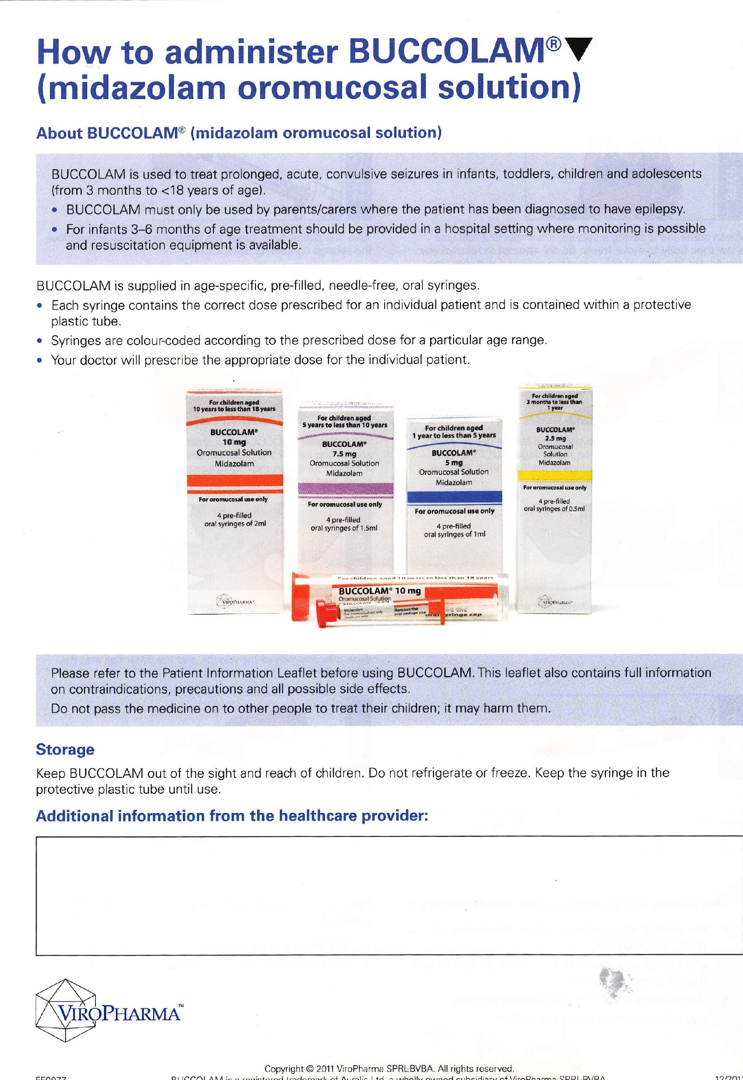
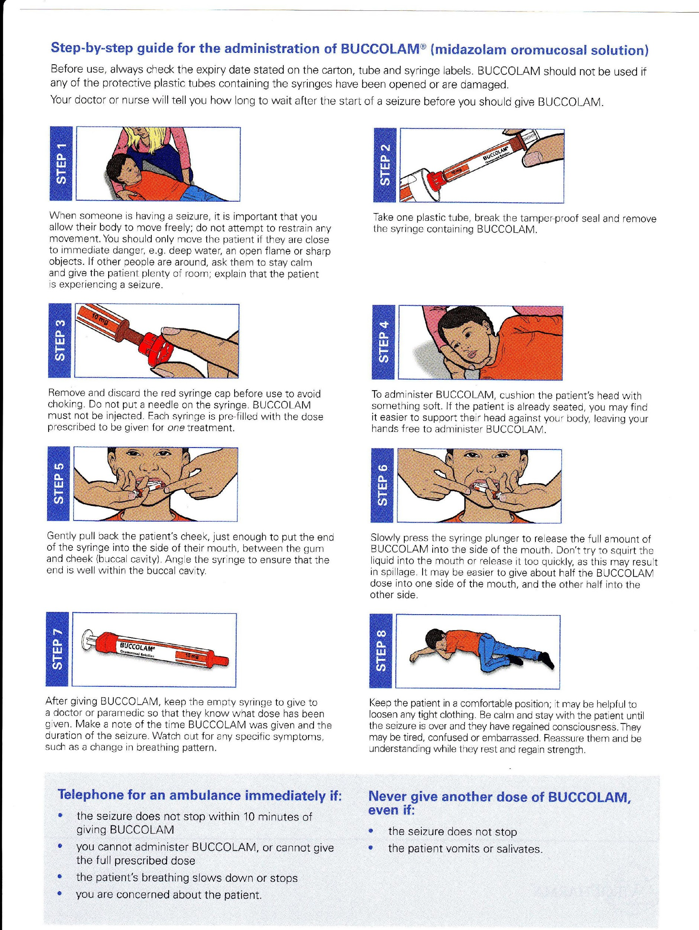

How do I give the Rectal Diazepam?
- Take the tube out of the foil wrapping and remove the safety cap.
- Place the CYP in a suitable position, for example on their side.
- Insert the nozzle of the tube into their bottom (rectum) up to the end of the tube.
- Whilst inserted, squeeze contents of tube and keep squeezing whilst you withdraw the tube.
- Hold the CYP's buttocks together for approximately five minutes.
- If the CYP opens their bowel after you have given the Diazepam, do not repeat the dose straight away, as it will be difficult to know how much has already been absorbed.
- If the seizure continues, call an ambulance and explain what has happened or seek medical advice (Please see the section headed ‘Contact details’).
Does the Rectal Diazepam work immediately?
It can take 5 – 10 minutes for the medicine to be absorbed into
the bloodstream.
Do I need to call an ambulance?
It is advisable to call an ambulance as well as giving the Rectal Diazepam if:
- Stated in the IHP.
- The CYP appears to be having difficulty breathing.
- This is the first time Rectal Diazepam has been used on the CYP.
- The seizure has not stopped 10 minutes after using Rectal Diazepam.
- If you think the CYP has been injured during their seizure.

© Copyright to Central Manchester University Hospitals NHS Foundation Trust

Guidance for school on the use of emergency Salbutamol inhalers

Primary and secondary school/ early years settings now have the option of keeping a Salbutamol (Ventolin) inhaler for emergency use.

This is not a formal requirement; school can decide whether they wish to implement this option and should establish a process for the storage and use of the emergency inhaler (See Medical Conditions in School policy on Office on Line on the link below).
https://scwd.stockport.gov.uk/cypd/content/Forms/forms.aspx?bid=95

School processes should be based on the guidance which can be found at
https://www.gov.uk/government/uploads/system/uploads/attachment_data/file/360585/guidance_on_use_of_emergency_inhalers_in_school_October_2014.pdf

Parental responsibility
It is important to note that existing policies and procedures are not affected by this additional option. The provision of a full and in date inhaler and spacer is still the parents/carers responsibility.

Use of the emergency inhaler
The emergency Salbutamol inhaler should only be used by CYP who have either been diagnosed with asthma and prescribed a Salbutamol inhaler or who have been prescribed a Salbutamol inhaler as reliever medication.
The inhaler can be used if the pupil’s prescribed inhaler is not available (for example because it is broken or empty).

Important – new guidance on overuse of reliever inhalers from Asthma UK
Staff should be made aware that a CYP using their reliever (usually blue) inhaler more than three times a week or suddenly using their reliever inhaler more than they normally do has asthma that may not be under control and may be at greater risk of having an asthma attack. Should this be observed, immediate action should be taken to alert the parents/carers and staff should record any actions or discussions.

Benefits of an emergency inhaler
Keeping an inhaler for emergency use will have many benefits. It could prevent an unnecessary and traumatic trip to hospital for a CYP and potentially save their life. Parents/carers are likely to have greater peace of mind about sending their CYP to school/ early years setting. Having a protocol that sets out how and when the inhaler should be used will also protect staff by ensuring they know what to do in the event of a CYP having an asthma attack.

Purchasing inhalers and spacers
We recommend you contact your local pharmacist to discuss your requirements; staff may also be required to present formal identification at the point of purchase.

Further support and training
Asthma awareness training is available free of charge from your school nurse.

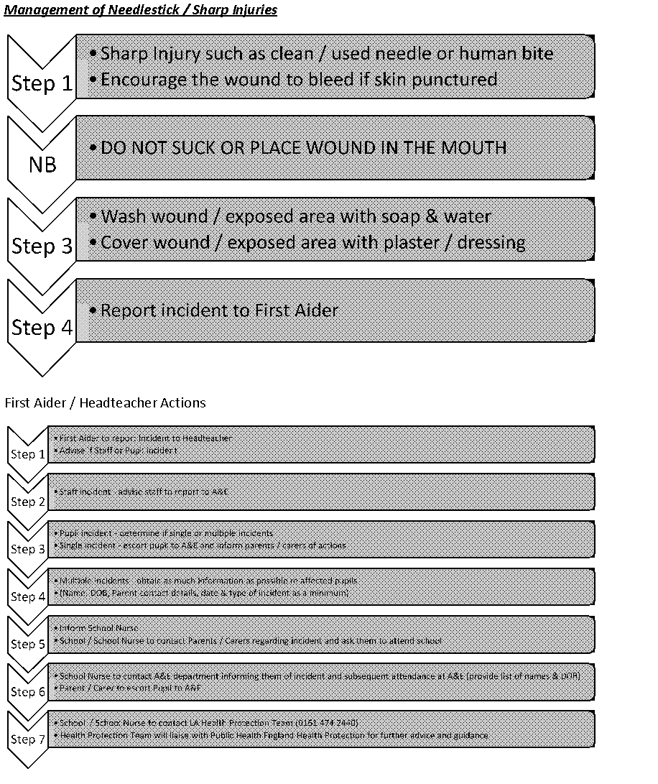

List of medications that may require an Individual Health Plan

Health Condition | Type of treatments | Names of drugs | Effects of condition / medication
Inflammatory Bowel Disease (Crohn’s / Ulcerative Colitis) | 5-ASAs | Sulfsalazine  Mesalazine | Can lower immune system, predisposing to infection  Can suppress bone marrow, resulting in easy bleeding / bruising or anaemia  Steroids if stopped abruptly can cause Addisonian crisis (low BP, circulatory collapse)
 | Steroids | Prednisolone  Hydrocortisone  Budesonide
 | Immunosuppression | Azathioprine  Methotrexate
 | Biologic treatments | Infliximab  Adalimumab (Humira)
Cardiac conditions (Long QT / Brugada / SVT) | Antiarrhythmics | Amiodarone  Sotalol  Flecainide  Digoxin | Reduction in blood pressure / pulse rate  Anticoagulants can predispose to bleeding / bruising
 | Anticoagulants | Warfarin
Respiratory Conditions (Asthma / CF) | Inhalers
 | Nebulisers (incl antibiotics)
Epilepsy | Anti-epileptics | Sodium Valproate (Epilim)  Lamotrigine (Lamictal)  Levetiracetam (Keppra)  Carbamazapine (Tegretol)  Clobazam
 | Rescue meds | Rectal Diazepam  Buccal Midazolam
Diabetes | Insulin
 | Medication to manage hypoglycaemia | Oral glucose gel  Glucagon
Other endocrine conditions (e.g. Addisons) | Steroids | Prednisolone  Hydrocortisone  Budesonide | Steroids if stopped abruptly can cause Addisonian crisis (low BP, circulatory collapse)
Cancer | Chemotherapy | Various | Can lower immune system, predisposing to infection  Can suppress bone marrow, resulting in easy bleeding / bruising or anaemia
Rheumatological conditions (e.g. JIA) | Steroids | Prednisolone  Hydrocortisone  Budesonide | Can lower immune system, predisposing to infection  Can suppress bone marrow, resulting in easy bleeding / bruising or anaemia  Steroids if stopped abruptly can cause Addisonian crisis (low BP, circulatory collapse)
 | Immunosuppression | Methotrexate
 | Biologic treatments | Etanercept  Anakinra  Tocilizumab  Rituximab

Asthma Emergency Procedures

+ coughing
+ shortness of breath
+ wheezing
+ feeling tight in the chest
+ being unusually quiet
+ difficulty speaking in full sentences
+ difficulty walking
+ sometimes younger children express feeling tight in the chest and a tummy ache.

Do . . .
- Encourage the pupil to sit up straight- try to keep calm
- Get the pupil to take one puff of their reliever inhaler (usually blue) through the spacer every 60 seconds up to 10 puffs.
- If the pupil feels worse at any point OR doesn’t feel better after 10 puffs call 999 for an ambulance.
- Repeat step 2 while waiting for an ambulance

999
Call an ambulance urgently if any of the following:
+ the pupil’s symptoms do not improve after 10 puffs
+ the pupil is too breathless or exhausted to talk
+ the pupil’s lips are blue
+ you are in any doubt.

After a minor asthma attack
+ Minor attacks should not interrupt the involvement of a pupil with asthma in school/ early years setting.
When the pupil feels better they can return to school/ early years setting activities.
+ The parents/carers must always be told if their CYP has had an asthma attack.

Important things to remember in an asthma attack

+ Never leave a pupil having an asthma attack.
+ If the pupil does not have their inhaler and/or spacer with them, send another teacher or pupil to their classroom or assigned room to get their spare inhaler and/or spacer.
+ In an emergency situation school staff are required under common law, duty of care, to act like any reasonably prudent parent.
+ Reliever medicine is very safe. During an asthma attack do not worry about a pupil overdosing.
+ Send a pupil to get another teacher/adult if an ambulance needs to be called.
+ Contact the pupil’s parents/carers immediately after calling the ambulance.
+ A member of staff should always accompany a pupil taken to hospital by ambulance and stay with them until their parent arrives.
+ Generally, staff should not take pupils to hospital in their own car.

Do not cancel an ambulance once called, even if the pupil’s condition appears to have improved.

Anaphylaxis Emergency Procedures

Anaphylaxis has a whole range of symptoms

Any of the following may be present, although most pupils with anaphylaxis would not necessarily experience all of these:

+ generalised flushing of the skin anywhere on the body
+ nettle rash (hives) anywhere on the body
+ difficulty in swallowing or speaking
+ swelling of throat and mouth
+ alterations in heart rate
+ signs of breathlessness and/or severe asthma symptoms (see asthma section for more details)
+ abdominal pain, nausea and vomiting
+ sense of impending doom
+ sudden feeling of weakness (due to a drop in blood pressure)
+ collapse and unconsciousness

Do
If a pupil with allergies shows any possible symptoms of a reaction, immediately seek help from a member of staff trained in anaphylaxis emergency procedures. Ensure all members of staff know who is trained.

The trained member of staff should:
+ Follow the pupil’s emergency procedure closely. These instructions will have been given by the paediatrician/healthcare professional during the staff training session and/or the protocol written by the pupil’s doctor
+ Try to ensure the pupil remains as still as possible
+ Lie the pupil down UNLESS they have breathing difficulties. If they are feeling dizzy, weak or appear pale and sweating their legs should be raised
+ If there are also signs of vomiting, lay the pupil on their side to avoid choking
+ Administer appropriate medication in line with perceived symptoms
+ If symptoms are potentially life-threatening, give the pupil their adrenaline injector into the outer aspect of their thigh. Make sure the used injector is made safe before giving it to the ambulance crew. Either put it in a rigid container or follow the instructions given at the anaphylaxis training.
+ Make a note of the time the adrenaline is given in case a second dose is required and also to notify the ambulance crew.

999 and say ANAPHYLAXIS (anna-fill-axis)
If you consider that the pupil’s symptoms are cause for concern, call for an ambulance

State:
+ The name and age of the pupil
+ That you believe them to be suffering from anaphylaxis
+ The cause or trigger (if known)
+ The name, address and telephone number of the school/ early years setting
+ Give precise and clear directions to the emergency operator
+ Call the pupil’s parents/carers.

While awaiting medical assistance the designated trained staff should:
+ Continue to assess the pupil’s condition
+ Position the pupil in the most suitable position according to their symptoms.
+ If the person’s condition deteriorates after making the initial 999 call, a second call to the emergency services should be made to ensure an ambulance has been dispatched.
+ If adrenaline has been given and there has been no improvement after 5 minutes, a second dose can be given if they have been prescribed a second dose.

Do
+ On the arrival of the paramedics or ambulance crew the staff member in charge should inform them of the time and type of medicines given. All used adrenaline injectors must be handed to the ambulance crew.
+ If the child has been prescribed an EpiPen, in cases of doubt it is better to give the adrenalin injection then to hold back.

After the emergency
+ After the incident carry out a debriefing session with all members of staff involved.
+ Parents/carers are responsible for replacing any used medication.

Do not cancel an ambulance once called, even if the pupil’s condition appears to have improved.

Diabetes Emergency Procedures

Hyperglycaemia
If a pupil’s blood glucose level is high (over 10mmol/l) and stays high.

Common symptoms:
+ thirst
+ frequent urination
+ tiredness
+ dry skin
+ nausea
+ blurred vision.

Do . . .
Call the pupil’s parents/carers who may request that extra insulin be given.
The pupil may feel confident to give extra insulin.

999
If the following symptoms are present, then call the emergency services:
+ deep and rapid breathing (over-breathing)
+ vomiting
+ breath smelling of nail polish remover

Hypoglycaemia

What causes a hypo?
+ too much insulin
+ a delayed or missed meal or snack
+ not enough food, especially carbohydrate
+ unplanned or strenuous exercise
+ drinking large quantities of alcohol or alcohol without food
+ no obvious cause.

Watch out for:
+ hunger
+ trembling or shakiness
+ sweating
+ anxiety or irritability
+ fast pulse or palpitations
+ tingling

+ glazed eyes
+ pallor
+ mood change, especially angry or aggressive behaviour
+ lack of concentration
+ vagueness
+ drowsiness.

Do
Immediately give something sugary, a quick-acting carbohydrate such as one of the following:

+ administer a glass of a sugary drink such as full sugar coke. Remember that low sugar drinks (e.g. diet coke, coke zero etc) will not work
+ three or more glucose tablets
+ a glass of fruit juice
+ five sweets, e.g. jelly babies
+ GlucoGel.

The exact amount needed will vary from person to person and will depend on individual needs and circumstances.

After 10 – 15 minutes recheck the blood sugar again. If it is below 5.6 give another sugary quick acting carbohydrate. Re-check the blood sugar in 20-30 minutes to make sure it remains within normal range.

If the pupil still feels hypo after 15 minutes, something sugary should again be given.

999

If the pupil is unconscious or having a seizure do not give them anything to eat or drink; call for an ambulance and contact their parents/carers and put them in the recovery position. Stay with the pupil.

Epilepsy Emergency Procedures

First aid for seizures is quite simple and can help prevent a CYP from being harmed by a seizure. First aid will depend on the individual CYP’s epilepsy and the type of seizure they are having. Some general guidance is given below, but most of all it is important to keep calm and know where to find help.

Tonic-clonic seizures

Symptoms:
+ the person loses consciousness, the body stiffens, then falls to the ground
+ this is followed by jerking movements
+ a blue tinge around the mouth is likely, due to irregular breathing
+ loss of bladder and/or bowel control may occur
+ after a minute or two the jerking movements should stop and consciousness slowly returns.

Do . . .
+ protect the person from injury – (remove harmful objects from nearby)
+ cushion their head
+ look for an epilepsy identity card or identity jewellery. These may give more information about a pupil’s condition, what to do in an emergency, or a phone number for advice on how to help
+ Time how long the jerking lasts
+ once the seizure has finished, gently place them in the recovery position to aid breathing
+ keep calm and reassure the person
+ stay with the person until recovery is complete.

Don’t . . .
+ restrain the pupil
+ put anything in the pupil’s mouth
+ try to move the pupil unless they are in danger
+ give the pupil anything to eat or drink until they are fully recovered.
+ attempt to bring them round.

999
Call for an ambulance if . . .
+ you believe it to be the pupil’s first seizure
+ the seizure continues for more than five minutes
+ one tonic-clonic seizure follows another without the person regaining consciousness between seizures
+ the pupil is injured during the seizure
+ you believe the pupil needs urgent medical attention.

Focal seizures
You may also hear this type of seizure called a partial seizure. Someone having a focal seizure may not be aware of their surroundings or what they are doing. They may have unusual movements and behaviour such as plucking at their clothes, smacking their lips, swallowing repeatedly or wandering around.
Do. . .
+ Guide them away from danger (such as roads or open water)
+ Stay with them until recovery is complete
+ Be calmly reassuring
+ Explain anything that they may have missed

Don’t . . .
+ Don't restrain them
+ Don't act in a way that could frighten them, such as making abrupt movements or shouting at them
+ Don't assume they are aware of what is happening, or what has happened
+ Don't give them anything to eat or drink until they are fully recovered
+ Don't attempt to bring them round

999
Call for an ambulance if . . .
+ You know it is their first seizure or
+ The seizure continues for more than five minutes or
+ They are injured during the seizure or
+ You believe they need urgent medical attention

Do not cancel an ambulance once called, even if the pupil’s condition appears to have improved.

Seizures in a Wheelchair

Do . . .
+ Put the brakes on, to stop the chair from moving
+ Let them remain seated in the chair during the seizure (unless they have an IHP which says to move them)
+ If they have a seatbelt or harness on, leave it fastened
+ If they don’t have a seatbelt or harness, support them gently, so they don’t fall out of the chair
+ Cushion their head and support it gently. A head rest, cushion or rolled up coat can be helpful

Don’t . . .
+ Don’t restrain their movements
+ Don’t put anything in their mouth
+ Don’t give them anything to eat until they are fully recovered
+ Don’t attempt to bring them round

