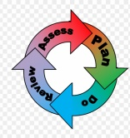 | How is the Graduated System of Special Needs supported in school?

The Code of Practice sets out a graduated response. The first category is known as Special Educational Needs (SEN) Support. Early identification of special needs is a priority for us. If your child has needs which go beyond our universal provision and ‘quality first’ teaching, then we will identify what support they need that is ‘different from and additional to’ the adaptive teaching that we have in place. We will work with you to create a support plan which will be reviewed termly.
A child who is recognised as having more complex needs may need an Education, Health and Care Plan (EHCP). If the school think that this may be the case they will work with parents to complete a referral for an Education, Health and Care Needs Assessment (EHCNA). If and when an EHCP is issued, it is a legal document which describes a child or young person's special educational needs, the support they need, and the outcomes they would like to achieve.

