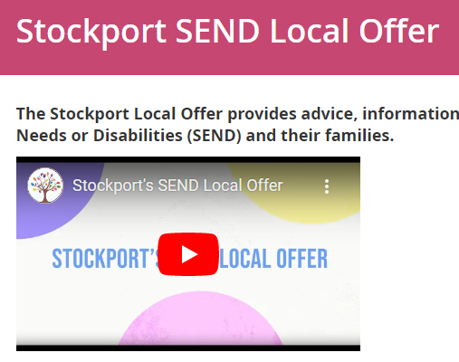 | Stockport Local Offer

The Local Offer was first introduced in the Green Paper (March 2011) as a local offer of all services available to support disabled children and children with SEN and their families. This easy to understand information will set out what is normally available in schools to help children with lower-level SEN as well as the options available to support families who need additional help to care for their child. This will be available on the Stockport Local Offer website.
https://stockport.fsd.org.uk/kb5/stockport/fsd/localoffer.page
This website brings together a range of support services and information for children and young people aged 0-25, with Special Educational Needs and Disabilities (SEND).
Some of the services are part of Stockport Family - such as the Autism Team, SEN, Aiming High and the Children with Disabilities Social Care team. You will also find information and advice from other specialist health/Therapy services, all working together to support children and families with Special Educational Needs and/or Disabilities (SEND).

