Monday 9th October 2023
Dear Parents / Carers,
Halloween Disco
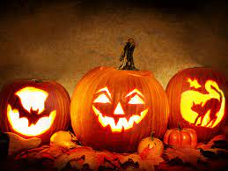
School will be hosting some Halloween Discos on Thursday 2nd November to raise school funds. Children are invited to wear Halloween costumes or whatever they like!
Reception, Year 1 and Year 2 4.30pm – 5.15pm
(Parents or carers must stay with their child/ren for the whole of the disco for Reception / Year 1 / Year 2)
Year 3 and Year 4 5.30pm – 6.15pm
Year 5 and Year 6 6.30pm – 7.30pm

Each child will need a ticket. These will cost £1.50 for 1 child and then £1 for brothers and sisters.
This will include:
- a drink
- a slice of pizza or a hot dog
- a ‘glow in the dark’ band
Additional sweets and cakes will also be on sale for a small charge. Tickets will be on sale on the playground from Tuesday 10th October at the end of the school day.
If you are able to help with the disco in any way, please let school know:
schooladmin@calegreen.stockport.sch.uk
Kind regards,
Mrs Sarah McHugh

