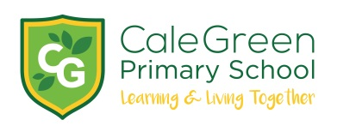
Thursday 23rd November

Dear Parents/ Carers,

Cale Green Christmas Raffle

It’s that time of year again- The Cale Green Christmas Raffle! FROcGs and members of staff have once again kindly donated lots of prizes for our annual Christmas raffle to raise much needed funds for school.

Tickets are priced at £1.00 for a strip or £5 for 6 strips and will be on sale from Monday 27th November.

ALL children will receive a strip of tickets for FREE.

There will be 2 ways tickets can be purchased:

- Parent Pay

or

- Children may bring in the correct money in a sealed envelope (no change will be given)

The draw will take place during the Family Assembly on Friday 22nd December.

Yours sincerely,

Mrs Sarah McHugh

