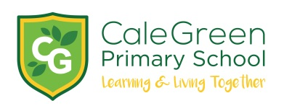
Tuesday 12TH December 2023
Dear Parents / Carers,

Christmas Activities- ANOTHER UPDATE!

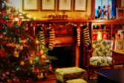

There has been so much going on throughout the festive period in school, we thought it might be helpful to send a further update. Still to come…

Lower Key Stage 2 Christmas Performances

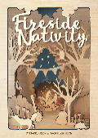

Children in Holly, Hazel and Hawthorn will be performing to parents and carers on 2 days. These will be taking place in the school hall on Wednesday 13th December at 6pm and Thursday 14th December at 1.45pm. Details about tickets for this event have been sent out to all Year 3 / 4 families.

Christmas Story Time

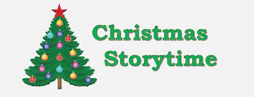

We would like to invite the children to come to school in their pyjamas (or cozy clothes) on Monday 18th December and to bring their favourite cuddly soft-toy.

During the afternoon, we will be having Christmas story time sessions with festive cookies.

- Early Years 1.30pm – 2pm (This will take place the Early Years Hub area)

- Key Stage 1 1.45pm – 2.15pm

- Lower Key Stage 2 2.15pm – 2.45pm

- Upper Key Stage 2 2.45pm – 3.15pm (normal end to the school day!)

Christmas Parties

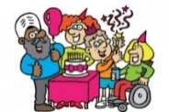

Children are invited to come to school in their own party clothes on Tuesday 19th December. Mr. Hall, ex-pupil’s Imogen and Libby’s dad who is a DJ, has kindly agreed to host 4 separate party discos throughout the day. Children will have some party food and drink which school will provide. (Please keep us informed of any specific dietary needs.)

Early Years 9.15am – 10.15am

Key Stage 1 10.15am – 11.15am

Lower Key Stage 2 1.30pm – 2.30pm

Upper Key Stage 2 2.30pm – 3.30pm (a slightly later end to their school day!)

Key Stage 2 Choir singing at Walthew House

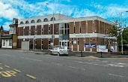

The Key Stage 2 choir have been invited to sing to Walthew House service users before they have their Christmas dinner on Tuesday 19th December. This will take place during the morning and they will return to school for normal school dinner time. Further details to follow.

Travelling Pantomime

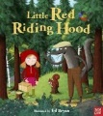

We have a travelling theatre company who will be joining us during the morning on Thursday 21st December. They will be performing the well-known pantomime, ‘Little Red Riding Hood’ to our Early Years, Key Stage 1 and Lower Key Stage 2 children.

Christmas Raffle

The ‘Friends of Cale Green’ (FROGs) and members of staff have once again kindly donated prizes for our annual Christmas raffle to raise much needed funds for school.

Tickets are priced at £1.00 for a strip or £5.00 for 6 strips.
As part of our commitment to poverty proofing, ALL children will receive some FREE raffle tickets.

Children can bring in the correct money in a sealed envelope (no change will be given) or pay on Parent Pay.
Christmas Carol Concert and Raffle

Our whole-school Carol Concert will take place at 9.15am on Friday 22nd December. All parents, carers and grandparents are welcome but once we’re full, we will not be able to admit any more. There will be a short break after the Carol Concert before we draw our Christmas Raffle where you will be able to get light refreshments.

As you can see, we still have lots of lovely events to enjoy in December. If you have any questions please don’t hesitate to email school schooladmin@calegreen.stockport.sch.uk

Yours sincerely,

Mrs Sarah McHugh

