Friday 15th December 2023

Dear Parents / Carers,
Choir Concert – Walthew House

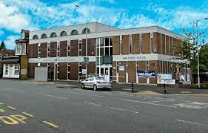

On the morning of Tuesday 19th December, we will be taking the Key Stage 2 choir to sing at Walthew House before their visitors Christmas lunch. This is always a lovely morning and an opportunity for the choir to meet people in our local community.

The children will walk to Walthew House and return for their normal school dinner.

Please can you give permission for your child to attend this event.

Thank you for all your continued support this year and Merry Christmas!

Yours sincerely,

Mrs Lewis, Miss Latimer and Mrs Buckley

