Tuesday 9th January 2024

Dear Parents / Carers,

NSPCC Number Day

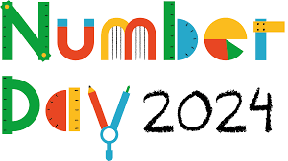
This year we will be taking part in NSPCC Number Day on Friday 2nd February 2024.

During the day, children will be taking part in a range of fun maths activities within their classes and we hope to have a whole school game of bingo!

During February, we will also be learning about the important work the NSPCC does to keep children safe and making connections with maths and our PSHE work.

To raise money for NSPCC and the vital work they do with ChildLine, the children will be asked to donate in order to “Dress up for Digits”. Children will be able to come to school wearing their own clothes but they must try and include a number somewhere on their outfit.

They could wear a football shirt with a number on the back, a birthday badge or be a little more creative! How could you dress as a pair, a double or even pi?

If you have any questions please do not hesitate to contact school:
schooladmin@calegreen.stockport.sch.uk

Yours sincerely,

Mrs M Cronshaw
Maths Subject Lead

