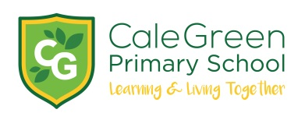

Thursday 22nd February 2024

Dear Parents / Carers,

Stockport Children’s Poetry Festival

As part of a series of English poetry lessons, your child was chosen to submit their poem to the Stockport Children’s Poetry Festival. As a result of this, along with other schools in Stockport, Cale Green has been allocated a number of seats at the festival.

The event takes place on Wednesday 20th March at the Guild Hall. The children will be having an early lunch and leaving school at 12:00pm to arrive at the event for 12:30pm. The children will be walking to the Guild Hall on a route which has been risk assessed with Mrs McHugh and Ms Ingham.

The festival will be attended this year by Michael Rosen, one of the best-known poets and authors in the children's book world, he is renowned for his work as a poet and performer, and he will be available for signing books. If children would like to bring a small amount of money to purchase a book they may but school will also be buying some books for school too.

If you have any queries please do not hesitate to contact school: schooladmin@calegreen.stockport.sch.uk

Yours sincerely,

Ms S Ingham

