 | Theme 1 | Theme 2 | Theme 3 | Theme 4
MODERN BRITISH VALUES  SCHOOL VALUES  LINKS TO UNRC ARTICLES | Mutual Respect  (PSHE week- week 1 Parliament week November)  Article 28 and 29 Right to and goals of Education.  Article 7 Right to name, Nationality  Article 8 Identity  Article 24 Health and Health services | Democracy  The Rule of Law  (Anti-bullying week / Road Safety week )  Article 24 Health and Health services  Article 38 War and armed conflict  Article 12 Respect the views of the child  Article 30 minority groups  Article 14 Freedom of thought | Individual Liberty  Tolerance of those of different faiths and beliefs  (Internet-Safety Week)  Article 17 Access to Media  Article 12 Respect the views of the child  Article 14 Freedom of thought  Article 33 Drug abuse | Keeping Healthy and safe  Moving on  Article 19 – Violence, abuse and neglect  Article 24 Health and Health services  Article 33 Drug abuse
RSE Taught in a combination of composite classes and single year - group lessons as appropriate to age and stage of learning.
HEALTHY RELATIONSHIPS AND SEX EDUCATION  (RSE) | RSE  Y1 Spiral - Feelings / Abuse:  Activity 1: Feelings  Activity 2: Skills and Feelings  Activity 3: Feelings  Activity 3a: When do you feel hurt?  Y2 Spiral - Friendship and feelings:  Activity 1: Managing feelings  Activity 2: Making Choices  Activity 2a: Hiding Feelings  LGBT+  Read ‘Giraffes Can’s Dance’ By Giles Andreae Celebrating difference.  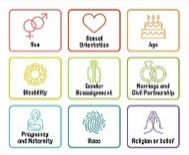 | RSE  Y1 Spiral - Friends:  Activity 4 Friends  Activity 5: Losing friends  Activity 6/6: Good Friends  Y2 Spiral - Friends and family:  Activity 3: Special People  Activity 4/5: Different types of family  ANTI BULLYING: ABCD Curriculum Generic Year !. Links to Anti-bullying week theme. | RSE  Y1Spiral - Growing up:  Activity 8: Belonging  Activity 9: Growing from young to old  Activity 10: Parts of the body  Activity 11: The needs of babies  Activity 12: Boys / girls  Activity 13/14: Being unique  Y2 Spiral – Growing up:  Activity 6: Growing up  Activity 7: Animals reproduce  Activity 8: Equality  LGBT+  Rainbow classroom – Geography lesson Where we Live  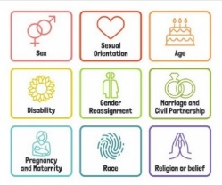  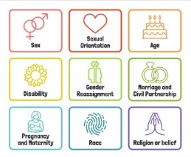 | RSE  Y1 Spiral - Safety / Domestic Abuse:  Activity 15: Safety – secrets  Activity 16: Saying no / asking for help  Activity 16a: When do you not feel safe?  Y2 Spiral - Safety / Domestic Abuse:  Activity 9: Safe Touches (NSPCC – Pants rule)  Activity 9a: How to get help  ANTI BULLYING: ABCD Homophobia and race Year 1 Text - Something Else By Kathryn Cave.
HEALTH AND WELLBEING  DRUGS EDUCATION (DATE)  HEALTHY LIFESTYLE | DATE: Year 1 Activities 1-3 Making simple choices about health and well- being.  Emotional Regulation circle time | DATE: Year 1 Activity 2. Peer relationships and friendships  HEALTHY LIFESTYLES:: Road Safety activities – Keeping safe on dark nights Road Safety week/ Bonfire Night | DATE: Year 1 Activity 4 Understand about harmful medicines and what can be found in a household.  Children’s Mental Health Week | DATE: Year 1 activities 5 and 6 Using medicines safely / Where can we keep medicines.  HEALTHY LIFESTYLES Healthy eating and lifestyle choices – The Light House Keepers Lunch, hand washing, dental hygiene, NSPCC.
E-SAFETY | Computing links - 1 /2 To agree and follow sensible e-Safety rules.  1 / 2 To talk about why it is important to be kind and polite online and in real life.  1 /2 To know that not everyone is who they say they are on the Internet. | Computing links - 1 To keep my password private.  1 To understand what personal information is.  1 To tell an adult when I see something online that is unexpected.  2 To explain why I need to keep my password private.  2 To describe the things that happen online that I must tell an adult about. | Internet Safety Week – Work linked to that year’s theme. | Computing links - 1 To recognise an age appropriate website  2 To talk about why I should only go online for a short amount of time.
LIVING IN THE WIDER WORLD  MODERN BRITISH VALUES  SCHOOL VALUES  TRANSITION  FINANCIAL CAPABILITY  Circle times | Class Charter Rights and Responsibilities  British Values circle times mutual respect  Setting ground rules; Cale green Code; Class Vision Statement; In this class we speak poster. School council election speeches  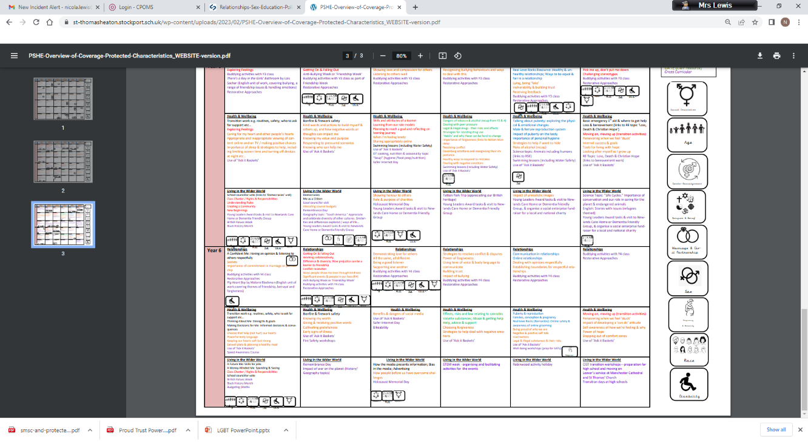  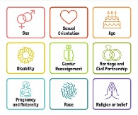  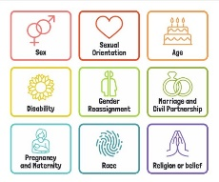  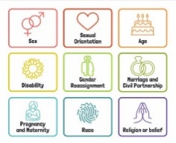  Welcome to our class  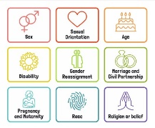  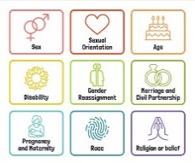  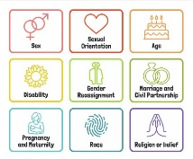 | Black History Month  Remembrance Day  Democracy / The Rule of Law.  Links to Parliament week.  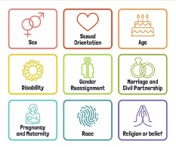 | Individual Liberty / Tolerance of those with different faiths and beliefs.  Science week / STEM activities linked to wider world of work  FINANCIAL: Natwest resources – Why is it important to save money? | FINANCIAL: Natwest Resources – Where can I keep my money?
 |  |  |  | Links to DT - Know about a range of fresh and processed ingredients appropriate for their product, and whether they are grown, reared or caught.
Whole School Activities | Peer Massage  Special Friends table  Play Leaders  Water Safety Swimming  Visit From GMP  Bonfire Night Safety  Fire Safety  Restorative approaches  Ask-it baskets  Water safety lesson using materials from Canals and Waterways Trust  Unicef Rights Respect school – Steering stars  Article of the month
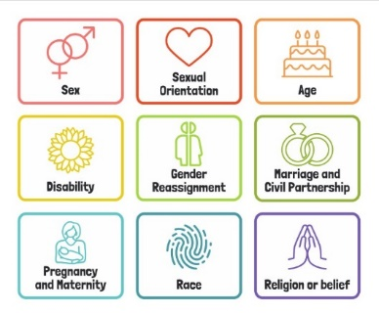
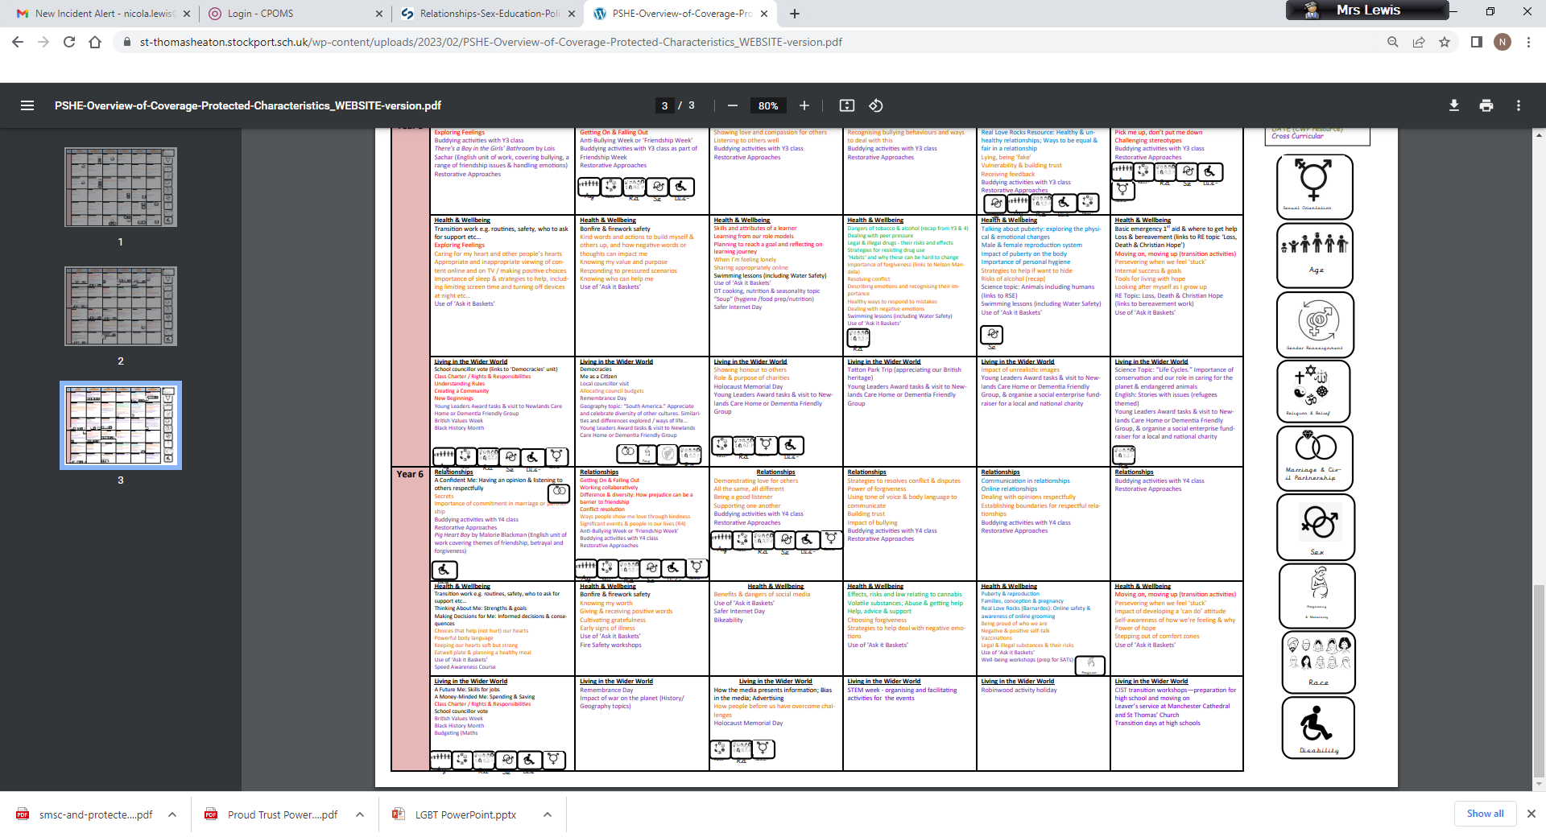
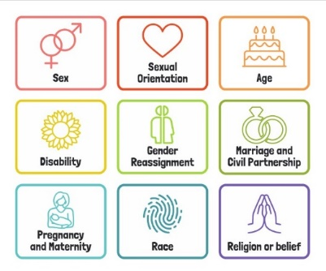
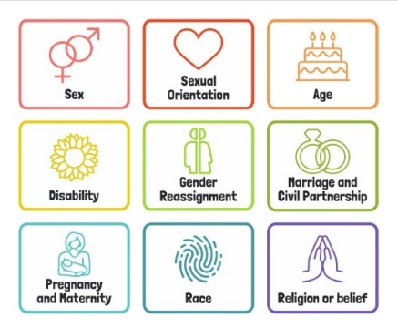
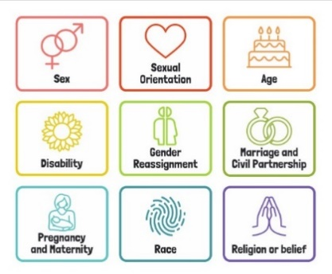
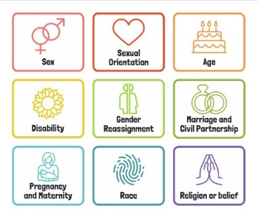
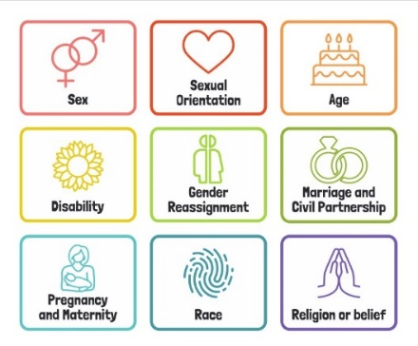
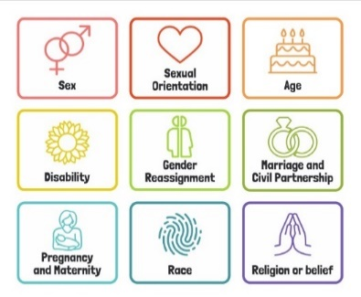
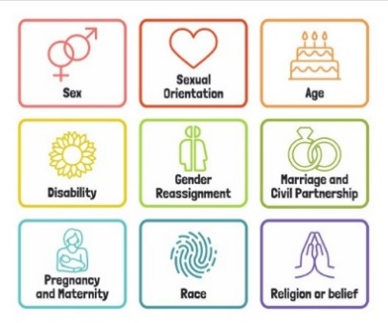

Useful Websites
http://www.preventforschools.org
http://www.impsweb.co.uk/schools/
http://www.anti-bullyingalliance.org.uk/anti-bullying-week/
https://www.thinkuknow.co.uk/5_7/
http://www.psheassociation.co.uk
http://www.digital-literacy.org.uk/Home.aspx
http://www.bbc.co.uk/education/topics/zy77hyc/
https://campaignresources.phe.gov.uk/schools/topics/being-active/overview
http://www.foodafactoflife.org.uk/section.aspx?t=0&siteId=20&sectionId=124
http://whatworkswell.schoolfoodplan.com/articles/category/3/learning-about-food
http://www.childrensfoodtrust.org.uk/lets-get-cooking/
http://www.foodforlife.org.uk/schools

