 | Theme 1 | Theme 2 | Theme 3 | Theme 4
MODERN BRITISH VALUES  SCHOOL VALUES  LINKS TO UNRC ARTICLES | Mutual Respect  (PSHE week- week 1 Parliament week November)  Article 28 and 29 Right to and goals of Education.  Article 7 Right to name, Nationality  Article 8 Identity  Article 24 Health and Health services  Article 14 Freedom of thought  Article 33 Drug abuse | Democracy  The Rule of Law  (Anti-bullying week / Road Safety week )  Article 24 Health and Health services  Article 12 Respect the views of the child  Article 30 minority groups  Article 14 Freedom of thought  Article 38 War and conflict | Individual Liberty  Tolerance of those of different faiths and beliefs  (Internet-Safety Week)  Article 17 Access to Media  Article 12 Respect the views of the child  Article 14 Freedom of thought  Article 33 Drug abuse Article 24 Health and Health services | Keeping Healthy and safe  Moving on  Article 19 – Violence, abuse and neglect  Article 24 Health and Health services  Article 33 Drug abuse Article 17 Access to Media
RSE Taught in a combination of composite classes and single year - group lessons as appropriate to age and stage of learning.
HEALTHY RELATIONSHIPS AND SEX EDUCATION  (RSE) | Y5 Spiral - Feelings / Abuse / Families:  Activity 1 /2: Feelings –controlling your behaviour  Activity 3a: Feelings / abuse  Activity 4: The importance of family  Activity 5: The Responsibilities in families  Activity 6: Seeing things from a different point of view  Y6 Spiral – Feelings:  Activity 1: Emotions / feelings  Activity 2: Body language  Activity 3: Qualities of a friend  LGBT+  Activity 4: Diverse nature of families +  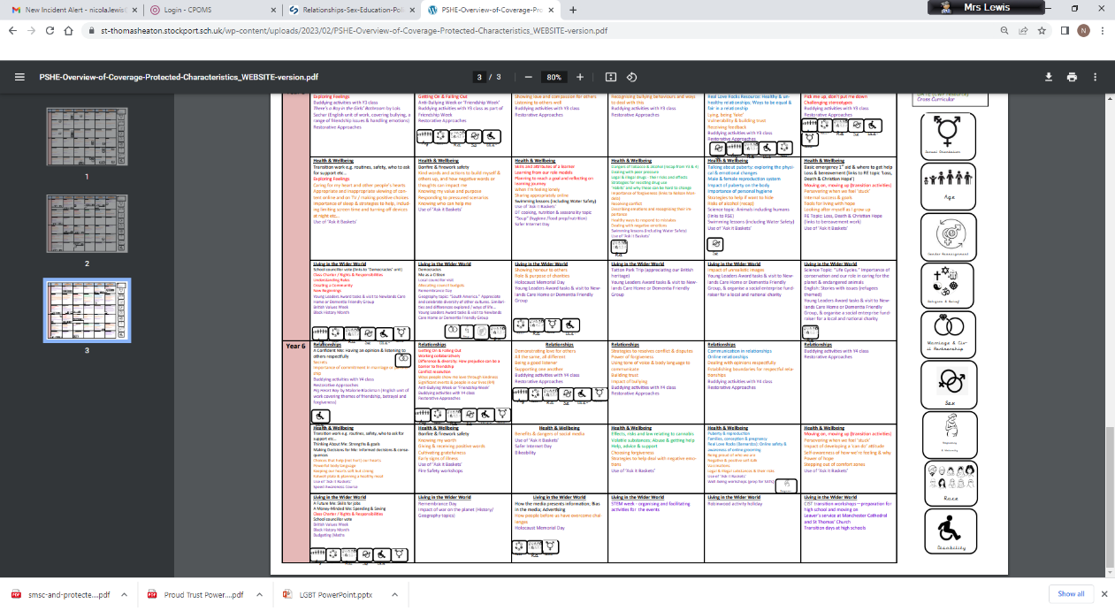  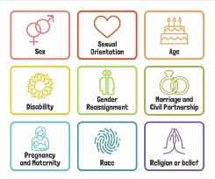  Stonewall text He’s My Mom!  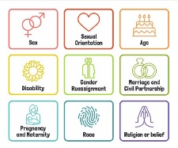  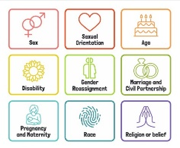  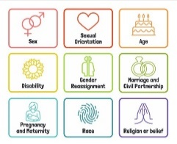  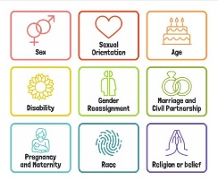 | Y5 Spiral - Friendships / Relationships:  Activity 7: Good Friends  Activity 8: Peer Pressure  Y6 Spiral - Friendships and Relationships:  Activity5: Appreciating different view points  Activity 6: Attraction / love  Activity 7: Marriage / Civil Partnerships (Sensitivity needed)  ANTI BULLYING: ABCD Curriculum pg 52 Generic. Links to anti-bullying theme.  LGBT+  Rainbow Classroom – KS2 Geography map skills.  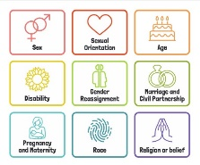 | Y5 Spiral - Growing up:  Activity 9: Growing up – Body changes  Activity 10: Naming and understanding function of male / female sex organs  Activity 11: Body changes at puberty  Activity 12: Menstruation  Christopher Winters Teaching SRE with confidence: Mix and match Puberty lessons as teacher thinks.  .Y6 Spiral - Growing up:  Activity 8: Puberty  Activity 10: Help / Support  Activity 16: understand that there are laws to protect children and why they are necessary | Y5 Spiral – Safety:  Activities 13 / 14 / 15: Risk judgements  Y6 Spiral -Stereotypes / The Role of the Media / Safety:  Career related learning strategy  Activity 20 / 21 Recognising Stereotypes  Activity 22 /23 /24: The Role of the media  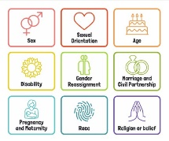  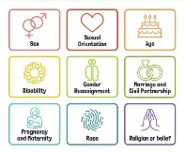  LGBT+  Proud Trust ‘Alien Nation’ – 3 lessons  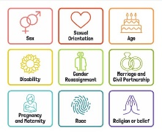
Additional, optional Y6 content from Y4 / 6
Spiral Curriculum
* Activity 9 A New Life Begins
*Activity 11: Intercourse and Love
*Activity 13: Conception / Having a new baby
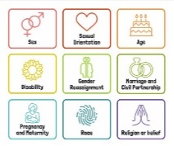
Activity 16 understand that there are laws to protect children and why they are necessary

LGBT +
Proud Trust ‘Alien Nation’ – 2 lessons

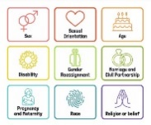
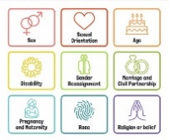
HEALTH AND WELLBEING  DRUGS EDUCATION  HEALTHY LIFESTYLE | Drug Use / Misuse in society.  Using ask-it baskets  Emotional Regulation circle time | Peer Pressure / Role models (Link to Anti-bullying week) and DATE work.  DATE peer pressure- activity 3 Year 5 diamond 9 – what pupils wish to learn about Drug education.  DATE Activities Year 5: 1 Drug Use, 2 Peer pressure and Risks, 4 Role Models and 5 Legal or Not? *Include Vapes and e-cigarettes in work. Activity 7 How many units? | .  Spiral Curriculum Activity 9: Personal Hygiene  D and T link To understand and apply principles of a varied diet. To understand seasonality and how ingredients are grown, reared and processed.  Children’s Mental Health Week | Basic first aid.  St. John’s ambulance:  Bleeding  Calling for Help  Sports Day  Freddie Fit
E-SAFETY | Computing links - 5 / 6 To explain why I need to protect myself and my friends online and the best way to do this.  5 To understand that anything I post online can be seen, used and may affect others.  5 To explain the importance of communicating kindly and respectfully online.  6 To explain the consequences to myself and others of not communicating kindly and respectfully online. | Computing links - 5 To choose a secure password and appropriate screen name.  5 / 6 To protect my password and other personal information.  6 to explain the consequences of sharing too much information about myself online. | Internet Safety Day work linked to this year’s theme. Keeping safe on line – personal information to yourself ABCD Curriculum E-Safety Year 5. | 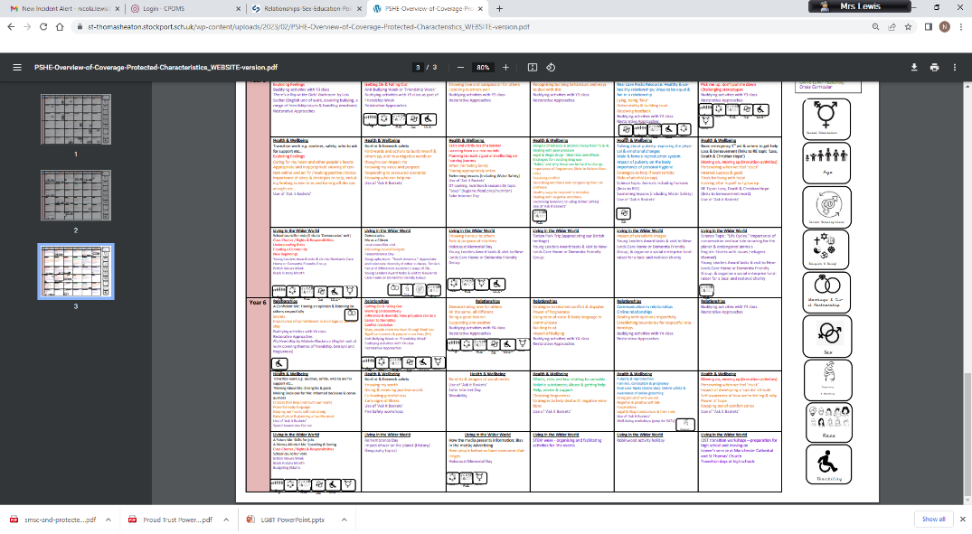  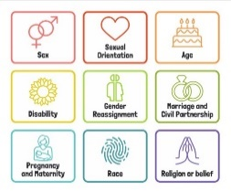  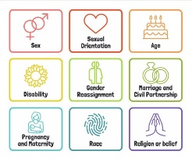  ABCD Curriculum – Homophobia and Race Year 5. Links to KOSSW.  Computing links - 5 To talk about the dangers of spending too much time online.  5 To discuss the importance of choosing age appropriate websites, apps or games.  6 To explain the consequences of spending too much time online or on a game.
LIVING IN THE WIDER WORLD  MODERN BRITISH VALUES  SCHOOL VALUES  TRANSITION  FINANCIAL CAPABILITY  Circle times | Class Charter Rights and Responsibilities  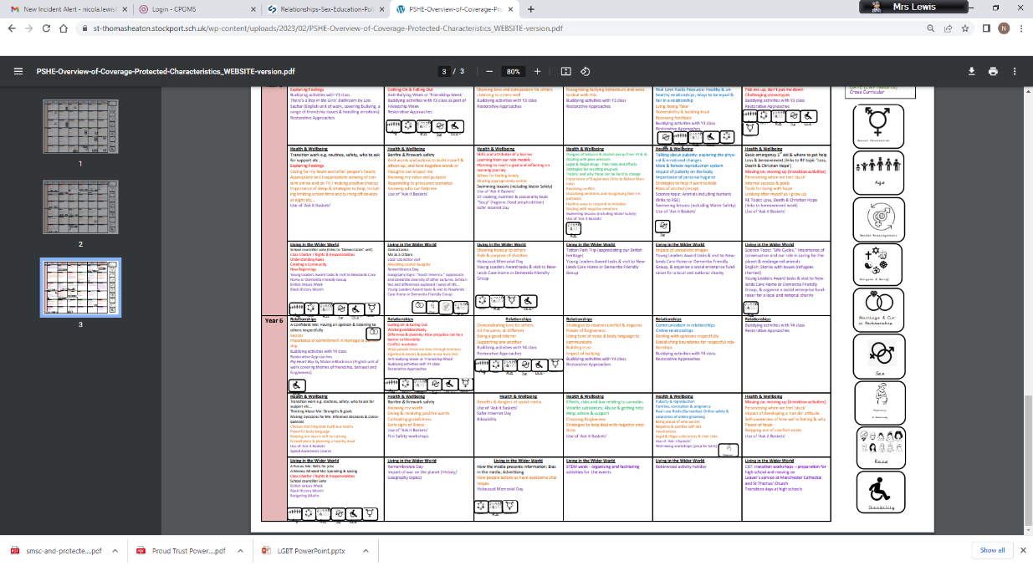  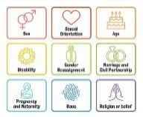  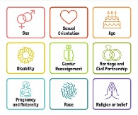  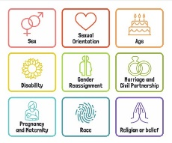  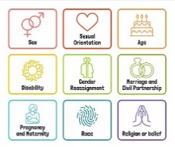  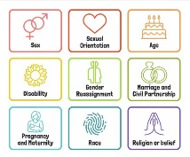  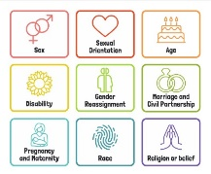  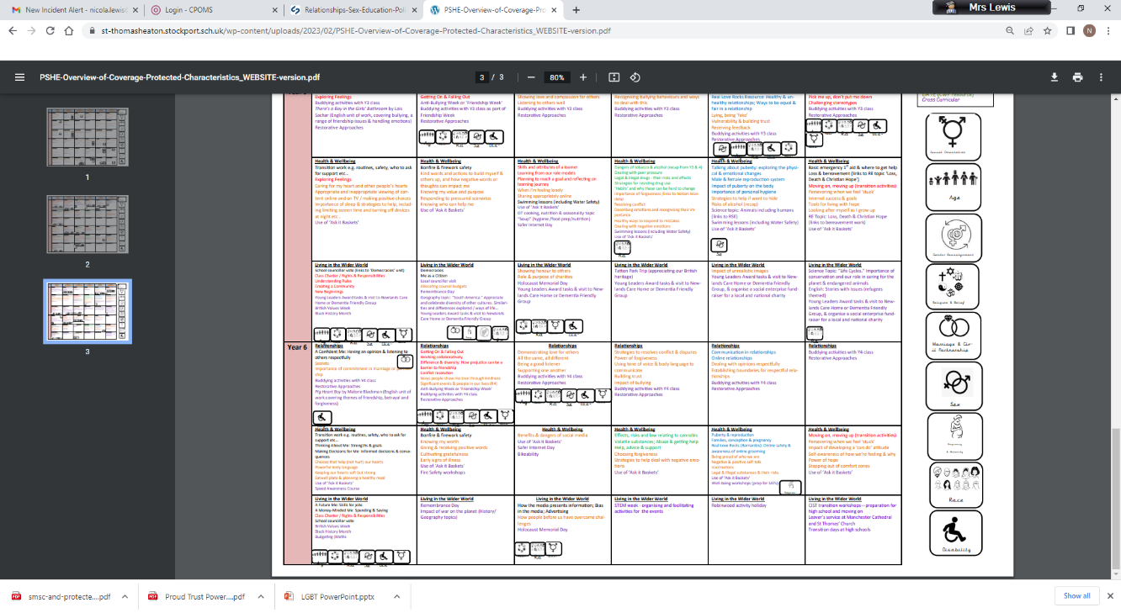  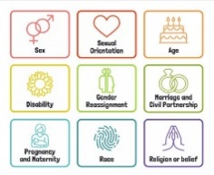  British Values circle times Mutual respect  Speed Awareness Course (Y6)  Setting ground rules; Cale green Code; Class Vision Statement; In this class we speak poster. School council election speeches | FINANCIAL: Natwest resources – What are the links between jobs and money?  Black History Month  Remembrance Day Visit to cenotaph  Democracy / The Rule of Law.  Links to Parliament week.  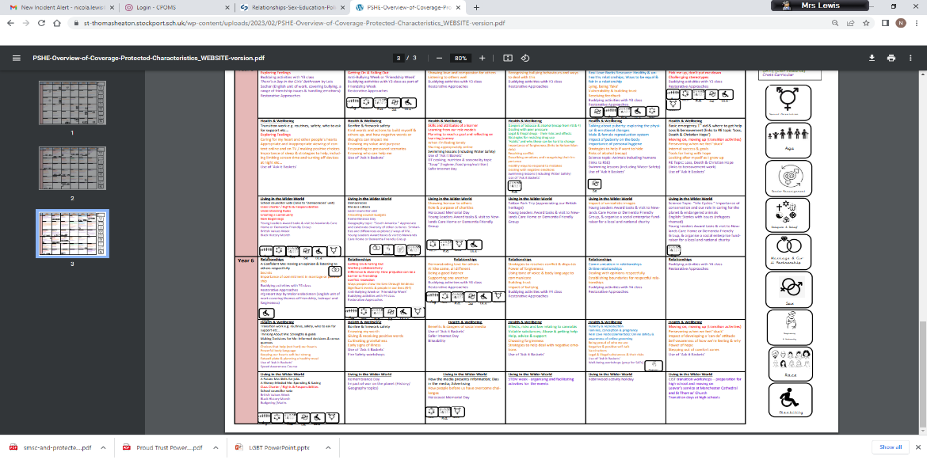  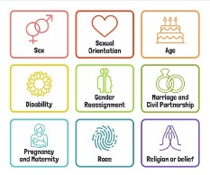 | 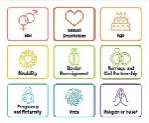  Individual Liberty / Tolerance of those with different faiths and beliefs.  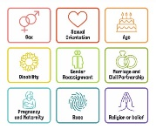  Science week / STEM activities linked to wider world of work  FINANCIAL: Natwest resources – How do I plan a simple budget? | Careers fair / aspirations week / World of work day Cv’s / interview skills.  Year 6:10 week Chameleon Project; care wheel; school questionnaire; transition day.  How do we keep healthy and safe?  Moving on; Growing up. Transition to next class.  (Year 6 Chameleon Project)  Y6 Residential holiday
Whole School Activities | Peer Massage  Special Friends table  Play Leaders  Water Safety Swimming  Visit From GMP  Bonfire Night Safety  Fire Safety  Restorative approaches  Ask-it baskets  Water safety lesson using materials from Canals and Waterways Trust  Unicef Rights Respect school – Steering stars  Article of the month  Bikeability Being a safe cyclist (Cycling Proficiency and road safety  Water Safety Swimming
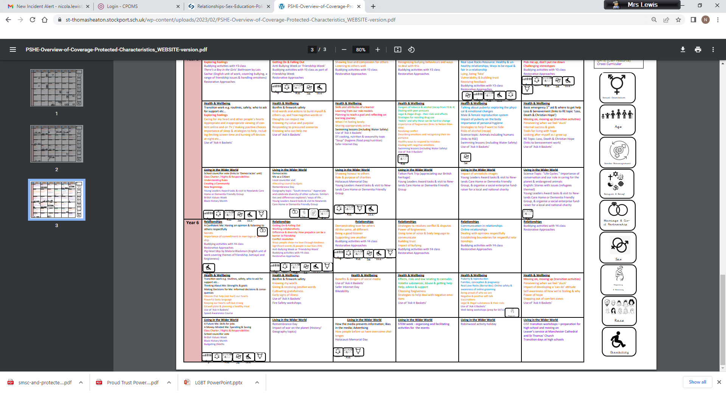
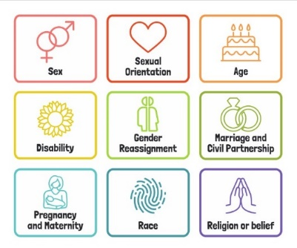
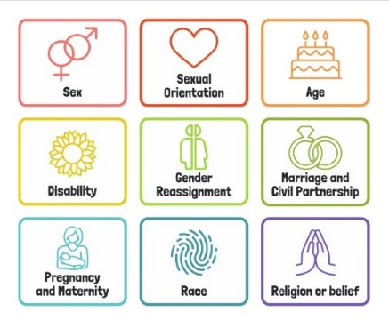
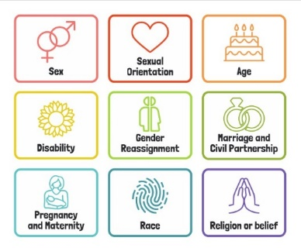
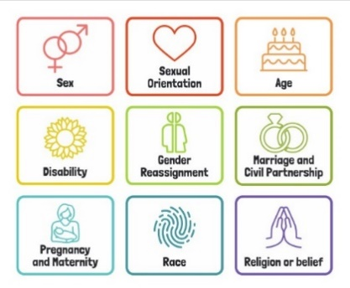
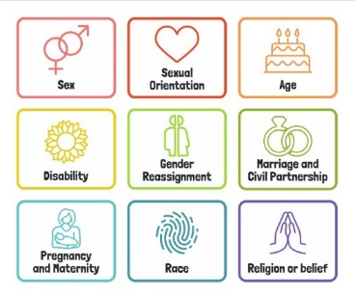
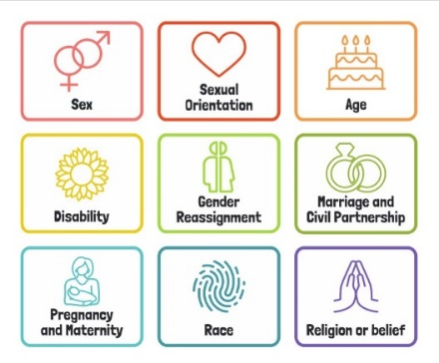
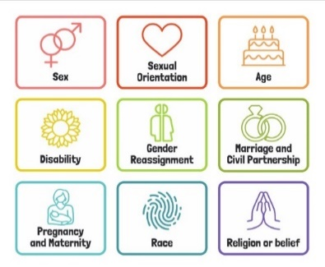
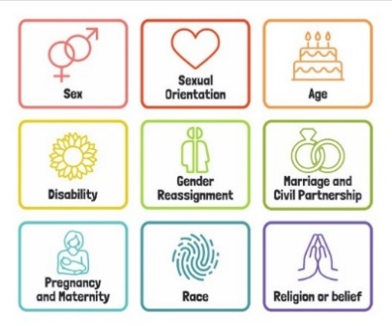
*Lessons parents will have the option to opt out from

Useful Websites
http://www.preventforschools.org
http://www.impsweb.co.uk/schools/
http://www.anti-bullyingalliance.org.uk/anti-bullying-week/
https://www.thinkuknow.co.uk/5_7/
http://www.psheassociation.co.uk
http://www.digital-literacy.org.uk/Home.aspx
http://www.bbc.co.uk/education/topics/zy77hyc/
https://campaignresources.phe.gov.uk/schools/topics/being-active/overview
http://www.foodafactoflife.org.uk/section.aspx?t=0&siteId=20&sectionId=124
http://whatworkswell.schoolfoodplan.com/articles/category/3/learning-about-food
http://www.childrensfoodtrust.org.uk/lets-get-cooking/
http://www.foodforlife.org.uk/schools

Information to consider
Monday assembly by Head teacher linked to same MBV as theme.
Emphasis on baseline activities- Quality not Quantity
End of ‘theme’ pupil feedback – two children selected for pupil voice at the end of each theme.
If you find new resources, populate the matrix above so that people are aware of resources that can be used and we can share good practice

