 | Theme 1 | Theme 2 | Theme 3 | Theme 4
MODERN BRITISH VALUES  SCHOOL VALUES  LINKS TO UNRC ARTICLES | Mutual Respect  (PSHE week- week 1 Parliament week November)  Article 28 and 29 Right to and goals of Education.  Article 7 Right to name, Nationality  Article 8 Identity  Article 24 Health and Health services Article 38 War and armed conflict  Article 14 Freedom of thought | Democracy  The Rule of Law  (Anti-bullying week / Road Safety week )  Article 24 Health and Health services  Article 12 Respect the views of the child  Article 30 minority groups  Article 14 Freedom of thought | Individual Liberty  Tolerance of those of different faiths and beliefs  (Internet-Safety Week)  Article 17 Access to Media  Article 12 Respect the views of the child  Article 14 Freedom of thought  Article 33 Drug abuse | Keeping Healthy and safe  Moving on  Article 19 – Violence, abuse and neglect  Article 24 Health and Health services
RSE Taught in a combination of composite classes and single year - group lessons as appropriate to age and stage of learning.
HEALTHY RELATIONSHIPS AND SEX EDUCATION  (RSE) | Understand that everybody feels a range of emotions at different times  -Identify when I feel an emotion, not a physical illness  -Be able to link physical synonyms to emotions  -Be able to articulate which emotion I am feeling using synonyms other than ‘happy, ‘sad’ etc  -Be able to articulate why I feel this way  -Be able to identify these signs in others  -Develop a set of coping strategies for when I feel different emotions in order to better manage my actions at the time  LGBT+  Stonewall Book list – ABC of Equality. Discussion of words used.  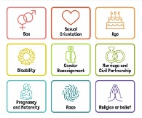  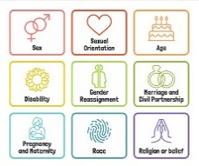  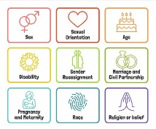  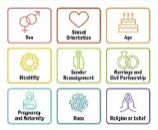  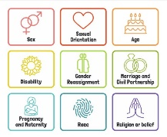  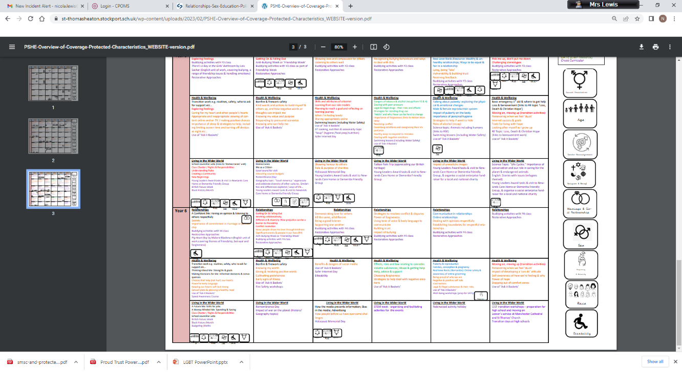  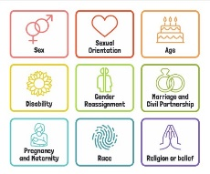 | Y3 – Spiral – friends:  Activity 7: What makes a good friend?  Activity 8 Best Friends  Y4 – Spiral –Friends:  Activity 2: Friendships  Activity 3/ 4 Conflict in friendships  Activity 5: Restoring Friendships  ANTI BULLYING:  What is a bully? When might bullying occur? What to do if you witness bullying? ABCD Curriculum Generic Year 3. Links to Anti-bullying week theme. | Y3- Spiral - Growing up / families:  Activity 9: Human Variation (Science links)  Activity 10: Similarities and differences  Activity 11: What might make us feel frightened or angry? (Saying no)  Activity 12 / 13/ 14: Families  Activity 15: Naming Body parts  Y4 Spiral – Growing up:  Activity 6 / 7 What is a grown up?  Y4 Christopher Winters Teaching SRE with confidence:  Activity 9: A new life begins  *Activity 10: Having a baby  *Activity 11: What does it mean? (Vocabulary)  ANTI BULLYING / LGBT+: ABCD Curriculum Year 3 Homophobia 1 and Race (Text – Space Girl Pukes). | Y3 – Spiral – Safety / Abuse:  Activity 16: Feeling safe / abuse  Activity 17: Understanding rights of your own body and other peoples.  Activity 18: Personal Space  Y4 – Spiral – Safety:  Activity 1b: Domestic Abuse  Activity 12/13: Safety Saying no / Who to ask for help?  Activity 13a: Domestic Abuse  LGBT+  Stonewall Book List A Day of Pride.  Rainbow Classroom KS2 Art and Design – We are all Welcome.
HEALTH AND WELLBEING  DRUGS EDUCATION  HEALTHY LIFESTYLE | Emotional Regulation circle time | Road Safety week/ Bonfire Night | St. John’s Ambulance: Calling for Help  Bites and Stings  Peer relationships / Safety  D and T link healthy and varied diet, preparing food. To understand seasonality and how ingredients are grown . reared.  Children’s Mental Health Week | Sports Day  Freddie Fit  Physical and mental effects of exercise (link to science)  Oral hygiene and prevention of spreading germs- link to science (year 3/4 talk with Anne Jepson)  DATE: Activity 1 Year 3 Draw and Write to ascertain children’s current understanding.  Peer relationships / Safety Year 3 activity 2/3  Medicines and Drugs can have positive and Negative effect Year 3 Activity 4/5.  Identifying Dangers (links to KOSSW) Year 3 activity 6
E-SAFETY | ABCD booklet- pg 17)  Computing links - 3/4 To use the safety features of websites as well as reporting concerns to an adult.  3 To post positive comments online.  4 To know that anything I share online can be seen by others. | Computing links - 3 / 4 To discuss what makes a secure password and why they are important.  3 To protect my personal information when I do things online.  4 To discuss the ways I can protect myself and my friends from harm online. | Internet Safety Day work linked to this year’s theme. Cyberbullying  Things for Sale (Digital Literacy) things that children can buy online- use of real life websites- show children how to remain safe online | Computing links - 3 / 4 To recognise and choose games and websites that are appropriate to my age.  3 / 4 To make good choices about how long I spend online.  3 / 4 To ask an adult before downloading files and games on the internet.  4 To talk about why I need to ask a trusted adult before downloading files or games online.
LIVING IN THE WIDER WORLD  MODERN BRITISH VALUES  SCHOOL VALUES  TRANSITION  FINANCIAL CAPABILITY  Circle times | Class Charter Rights and Responsibilities  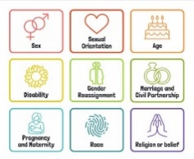  British Values circle times mutual respect  Setting ground rules; Cale green Code; Class Vision Statement; In this class we speak poster. School council election speeches  Welcome to our class | Black History Month  Remembrance Day  Democracy / The Rule of Law.  Links to Parliament week.  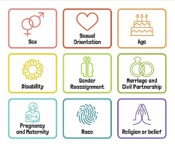 | Individual Liberty / Tolerance of those with different faiths and beliefs.  Science week / STEM activities linked to wider world of work  FINANCIAL: Natwest resources – How are payments changing? | FINANCIAL: Natwest Resources – How Can I Pay for things?
Whole School Activities | Peer Massage  Special Friends table  Play Leaders  Water Safety Swimming  Visit From GMP  Bonfire Night Safety  Fire Safety  Restorative approaches  Ask-it baskets  Water safety lesson using materials from Canals and Waterways Trust  Unicef Rights Respect school – Steering stars  Article of the month
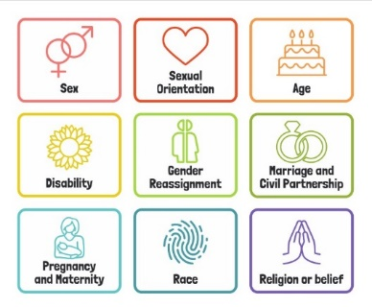
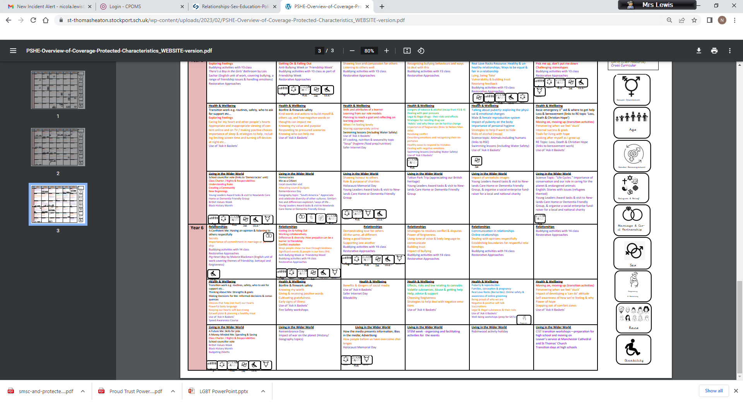
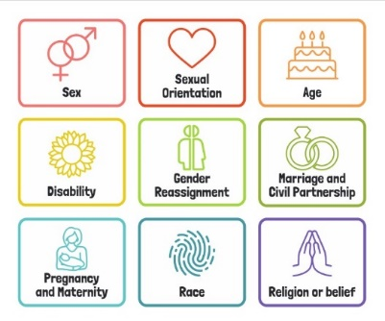
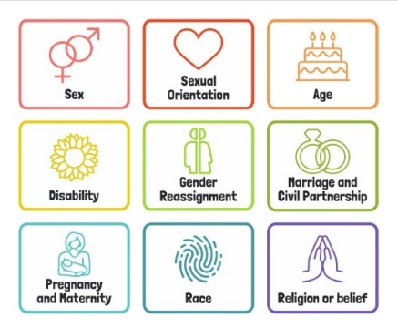
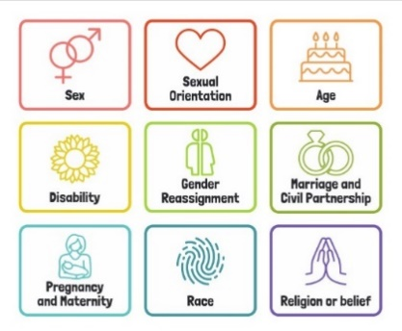
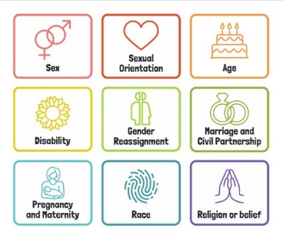
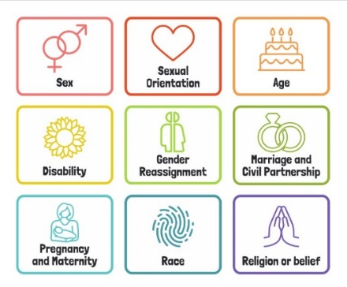
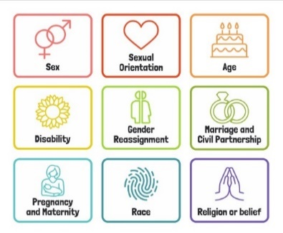
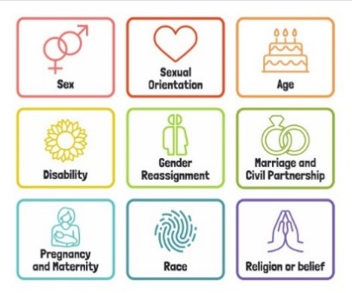

Useful Websites
http://www.preventforschools.org
http://www.impsweb.co.uk/schools/
http://www.anti-bullyingalliance.org.uk/anti-bullying-week/
https://www.thinkuknow.co.uk/5_7/
http://www.psheassociation.co.uk
http://www.digital-literacy.org.uk/Home.aspx
http://www.bbc.co.uk/education/topics/zy77hyc/
https://campaignresources.phe.gov.uk/schools/topics/being-active/overview
http://www.foodafactoflife.org.uk/section.aspx?t=0&siteId=20&sectionId=124
http://whatworkswell.schoolfoodplan.com/articles/category/3/learning-about-food
http://www.childrensfoodtrust.org.uk/lets-get-cooking/
http://www.foodforlife.org.uk/schools

