 | Theme 1 | Theme 2 | Theme 3 | Theme 4
MODERN BRITISH VALUES  SCHOOL VALUES  LINKS TO UNRC ARTICLES | Mutual Respect  (PSHE week- week 1 Parliament week November)  Article 28 and 29 Right to and goals of Education.  Article 7 Right to name, Nationality  Article 8 Identity  Article 24 Health and Health services | Democracy  The Rule of Law  (Anti-bullying week / Road Safety week)  Article 24 Health and Health services  Article 38 War and armed conflict  Article 12 Respect the views of the child  Article 30 minority groups  Article 14 Freedom of thought | Individual Liberty  Tolerance of those of different faiths and beliefs  (Internet-Safety Week)  Article 17 Access to Media  Article 12 Respect the views of the child  Article 14 Freedom of thought  Article 33 Drug abuse  Article 24 Health and Health services | Keeping Healthy and safe  Moving on  Article 19 – Violence, abuse and neglect  Article 24 Health and Health services  Article 33 Drug abuse
RSE Taught in a combination of composite classes and single year - group lessons as appropriate to age and stage of learning.
HEALTHY RELATIONSHIPS AND SEX EDUCATION  (RSE) | RSE  Y1 Spiral - Feelings / Abuse:  Activity 1: Feelings  Activity 2: Skills and Feelings  Activity 3: Feelings  Activity 3a: When do you feel hurt?  Y2 Spiral - Friendship and feelings:  Activity 1: Managing feelings  Activity 2: Making Choices  Activity 2a: Hiding Feelings  LGBT+  Rainbow classroom – RE lesson Noah’s Ark  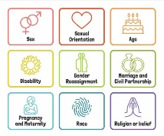  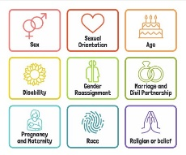 | RSE  Y1 Spiral - Friends:  Activity 4 Friends  Activity 5: Losing friends  Activity 6/6: Good Friends  Y2 Spiral - Friends and family:  Activity 3: Special People  Activity 4/5: Different types of family  ANTI BULLYING: ABCD Curriculum Generic Year 2 . Links to Anti-bullying week theme. | RSE  Y1Spiral - Growing up:  Activity 8: Belonging  Activity 9: Growing from young to old  Activity 10: Parts of the body  Activity 11: The needs of babies  Activity 12: Boys / girls  Activity 13/14: Being unique  Y2 Spiral – Growing up:  Activity 6: Growing up  Activity 7: Animals reproduce  Activity 8: Equality  LGBT+  Rainbow classroom - Hanging Mobiles D and T lesson | RSE  Y1 Spiral - Safety / Domestic Abuse:  Activity 15: Safety – secrets  Activity 16: Saying no / asking for help  Activity 16a: When do you not feel safe?  Y2 Spiral - Safety / Domestic Abuse:  Activity 9: Safe Touches (NSPCC – Pants rule)  Activity 9a: How to get help  ANTI BULLYING:  ABCD Homophobia and race 1 Year 2 (Stonewall Posters).  LGBT+  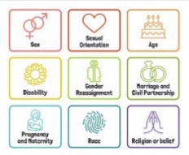  Read ‘Tyrannosaurus Drip’ By Julia Donaldson Celebrating Difference
HEALTH AND WELLBEING  DRUGS EDUCATION (DATE)  HEALTHY LIFESTYLE | DATE: Year 2 Activity 2 Peer Relationships.  HEALTHY LIFESTYLES:  Settling in and making new friends.  Emotional Regulation circle time | DATE: Year 2 Activity 3 Safety.  HEALTHY LIFESTYLES:: Road Safety activities – Keeping safe on dark nights Road Safety week/ Bonfire Night | DATE: Year 2 Activities: 4 Medicines as Drugs. 5 Positive and Negative Effects – use online stories rather than newspaper / magazine articles if more appropriate.  Children’s Mental Health Week | DATE: Year 2 Activity 6 Identifying Dangers.  HEALTHY LIFESTYLES Healthy eating and lifestyle choices – The Light House Keepers Lunch, hand washing, dental hygiene, NSPCC.
E-SAFETY | Computing links - 1 /2 To agree and follow sensible e-Safety rules.  1 / 2 To talk about why it is important to be kind and polite online and in real life.  1 /2 To know that not everyone is who they say they are on the Internet. | Computing links - 1 To keep my password private.  1 To understand what personal information is.  1 To tell an adult when I see something online that is unexpected.  2 To explain why I need to keep my password private.  2 To describe the things that happen online that I must tell an adult about | Internet Safety Week – work linked to this year’s theme | Computing links - 1 To recognise an age appropriate website  2 To talk about why I should only go online for a short amount of time.
LIVING IN THE WIDER WORLD  MODERN BRITISH VALUES  SCHOOL VALUES  TRANSITION  FINANCIAL CAPABILITY  Circle times | Class Charter Rights and Responsibilities  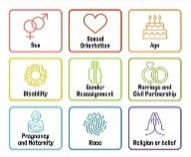  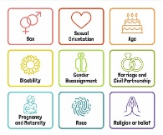  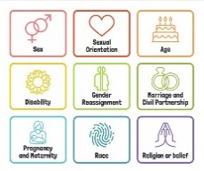  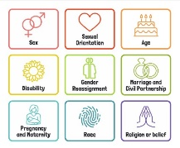  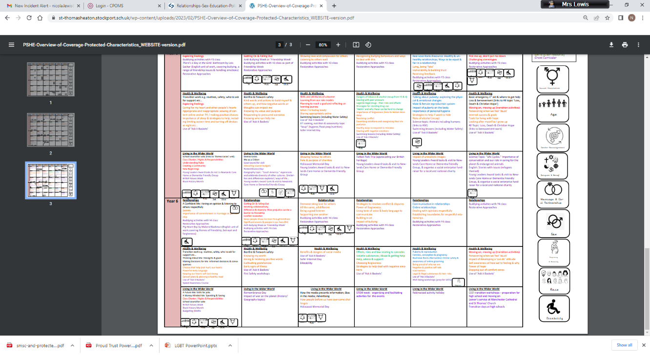  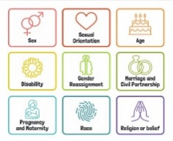  British Values circle times Mutual Respect  Setting ground rules; Cale green Code; Class Vision Statement; In this class we speak poster. School council election speeches  School Linking Network Resources Welcome to our class. | Black History Month  Remembrance Day  Democracy / The Rule of Law.  Links to Parliament week.  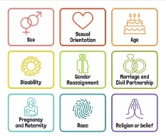 | Individual Liberty / Tolerance of those with different faiths and beliefs.  Science week / STEM activities linked to wider world of work  FINANCIAL: Natwest resources – Where does money come from? | FINANCIAL: Natwest resources – Things we need and things we want
 |  |  |  | Links to DT - Know about a range of fresh and processed ingredients appropriate for their product, and whether they are grown, reared or caught.
Whole School Activities | Peer Massage  Special Friends table  Play Leaders  Water Safety Swimming  Visit From GMP  Bonfire Night Safety  Fire Safety  Restorative approaches  Ask-it baskets  Water safety lesson using materials from Canals and Waterways Trust  Unicef Rights Respect school – Steering stars  Article of the month
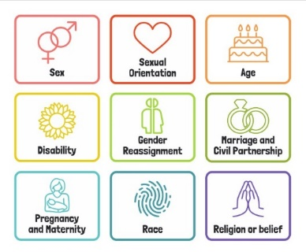
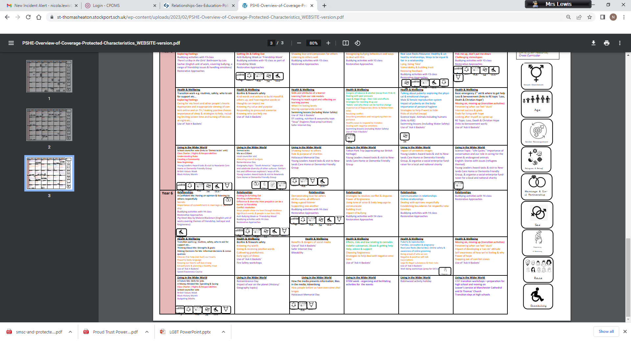
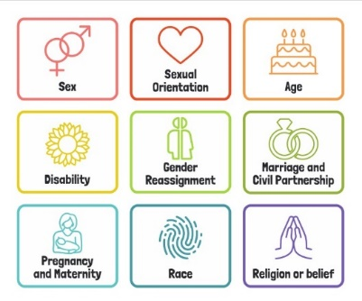
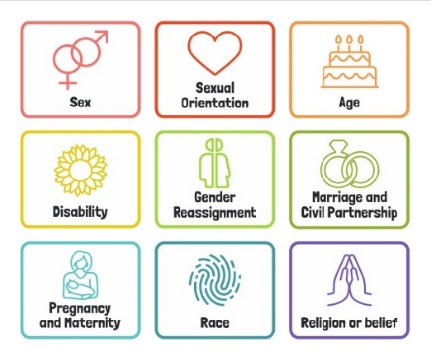
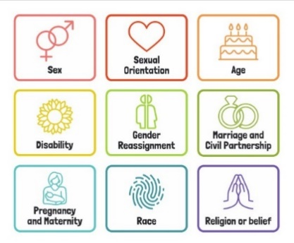
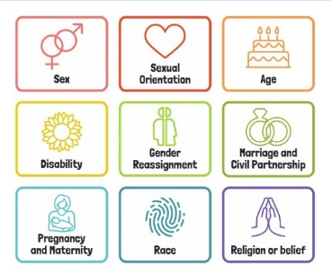
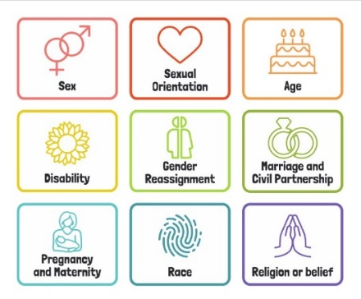
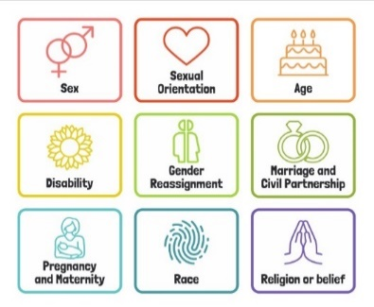
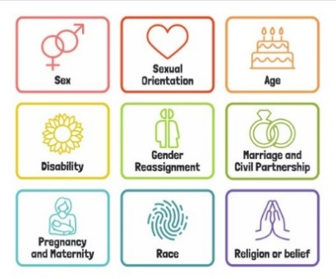

Useful Websites
http://www.preventforschools.org
http://www.impsweb.co.uk/schools/
http://www.anti-bullyingalliance.org.uk/anti-bullying-week/
https://www.thinkuknow.co.uk/5_7/
http://www.psheassociation.co.uk
http://www.digital-literacy.org.uk/Home.aspx
http://www.bbc.co.uk/education/topics/zy77hyc/
https://campaignresources.phe.gov.uk/schools/topics/being-active/overview
http://www.foodafactoflife.org.uk/section.aspx?t=0&siteId=20&sectionId=124
http://whatworkswell.schoolfoodplan.com/articles/category/3/learning-about-food
http://www.childrensfoodtrust.org.uk/lets-get-cooking/
http://www.foodforlife.org.uk/schools

