 | Autumn 1 | Autumn 2 | Spring 1 | Spring 2 | Summer 1 | Summer 2
MODERN BRITISH VALUES  SCHOOL VALUES  LINKS TO UNRC ARTICLES | MBV - Mutual Respect  (PSHE week- week 1)  Article 28 and 29 Right to and goals of Education.  Article 7 Right to name, Nationality  Article 8 Identity | MBV’s - Democracy  The Rule of Law  (Parliament week November / Anti-bullying week / Road Safety week )  Article 38 War and armed conflict  Article 12 Respect the views of the child  Article 30 minority groups  Article 14 Freedom of thought | MBV’s - Individual Liberty  Article 17 Access to Media  Article 12 Respect the views of the child | MBV - Tolerance of those of different faiths and beliefs  Article 12 Respect the views of the child  Article 14 Freedom of thought and beliefs | Keeping Healthy and safe  Moving on  Article 24 Health and Health services | Keeping Healthy and safe  Moving on  Article 24 Health and Health services
LIVING IN THE WIDER WORLD  MODERN BRITISH VALUES  SCHOOL VALUES  TRANSITION | Circles: Mutual Respect  Setting ground rules; Cale green Code; Class charter; School Values; In this class we speak poster.  Celebrating difference Marvellous Me story – Think Equal  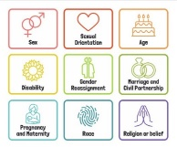  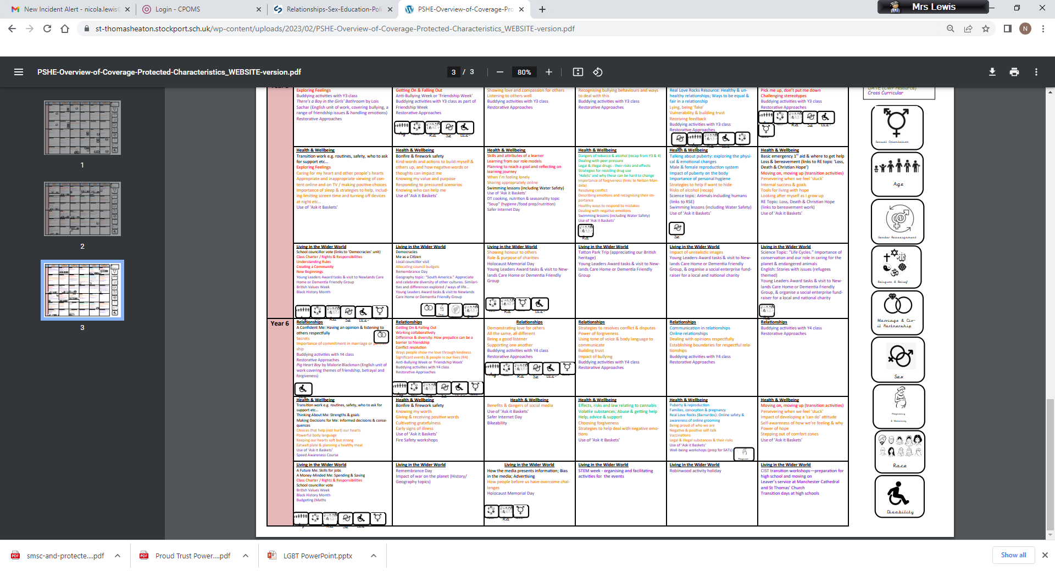  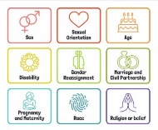  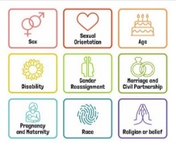  Francisco’s Family  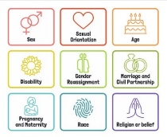 | Circles: Democracy / The Rule of Law. Links to Parliament week. Road safety / anti bullying  Remembrance Day  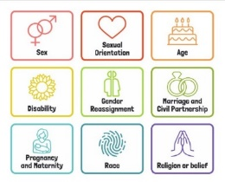  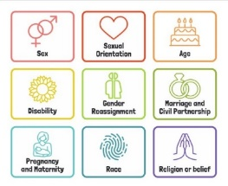  Celebrating difference – ‘My Hair’ Book Hannah Lee | Circles: Individual Liberty. Internet Safety week.  Celebrating Difference - Aah Spider By Lydia Monks. | Circles: Tolerance of those of different faiths and beliefs.  Scaling.  Celebrating Difference –  It’s okay to be different By Todd Carr | Circles: How do we keep healthy and safe?  Celebrating difference –  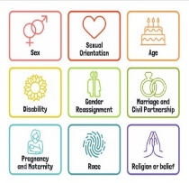  Yoshi is different – Think Equal | Circles: Moving on; Growing up. Transition to next class.  Celebrating difference –  The Smeds and The Smoos By Julia Donaldson  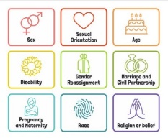
HEALTHY RELATIONSHIPS AND SEX EDUCATION  (RSE) | New beginnings - settling in and making friends. Learning names. | RSE:  Good friends / Bad friends. Being a kind friend  Modelling being kind friends. | RSE:  Mood Monsters, exploring different feelings. Matching feelings to scenarios.  Children’s Mental Health Week | RSE:  Worry Box / Huge bag of worries, scaling. | Handwashing, healthy eating and living, dental nurse visit, road safety | Changes / transition
 | Other resources :Games – Bug in a rug, rolling ball naming children etc. | Other resources: Twinkl resource Kind friend / not kind friend | Other resources: Smartie the Penguin (Internet safety)  Twinkl Mood Monsters – PowerPoint, fans, making in playdough. | Other resources: Introduce scaling. Link mood monsters to numbers on scale. Scaling using expressions and scenarios.  Sign in with scaling. | Other resources:  Twinkl Keeping healthy PowerPoint.  Sorting healthy / unhealthy foods. | Other resources:  Writing to new teacher. Worries / what we are looking forward to in new class. The Cautious Caterpillar.

