 | Theme 1 | Theme 2 | Theme 3 | Theme 4
MODERN BRITISH VALUES  SCHOOL VALUES  LINKS TO UNRC ARTICLES | Mutual Respect  (PSHE week- week 1 Parliament week November)  Article 28 and 29 Right to and goals of Education.  Article 7 Right to name, Nationality  Article 8 Identity  Article 24 Health and Health services  Article 14 Freedom of thought  Article 33 Drug abuse | Democracy  The Rule of Law  (Anti-bullying week / Road Safety week )  Article 12 Respect the views of the child  Article 30 minority groups  Article 14 Freedom of thought  Article 38 War and conflict | Individual Liberty  Tolerance of those of different faiths and beliefs  (Internet-Safety Week)  Article 17 Access to Media  Article 12 Respect the views of the child  Article 14 Freedom of thought  Article 33 Drug abuse Article 24 Health and Health services | Keeping Healthy and safe  Moving on  Article 19 – Violence, abuse and neglect  Article 24 Health and Health services  Article 33 Drug abuse Article 17 Access to Media
RSE Taught in a combination of composite classes and single year - group lessons as appropriate to age and stage of learning.
HEALTHY RELATIONSHIPS AND SEX EDUCATION  (RSE) | Y5 Spiral - Feelings / Abuse / Families:  Activity 1 /2: Feelings –controlling your behaviour  Activity 3a: Feelings / abuse  Activity 4: The importance of family  Activity 5: The Responsibilities in families  Activity 6: Seeing things from a different point of view  Y6 Spiral – Feelings:  Activity 1: Emotions / feelings  Activity 2: Body language  Activity 3: Qualities of a friend  LGBT+  Activity 4: Diverse nature of families +  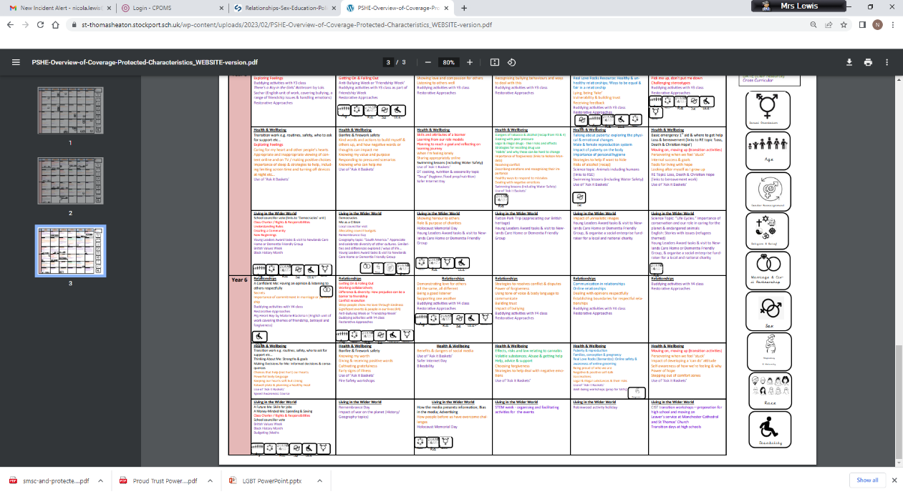  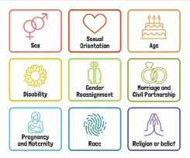  Stonewall Book The Great Big Book of Families.  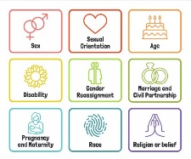  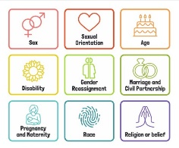  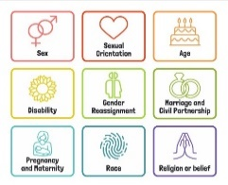  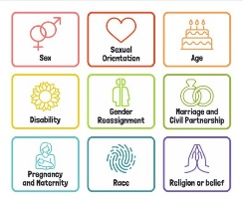 | Y5 Spiral - Friendships / Relationships:  Activity 7: Good Friends  Activity 8: Peer Pressure  Y6 Spiral - Friendships and Relationships:  Activity5: Appreciating different view points  Activity 6: Attraction / love  Activity 7: Marriage / Civil Partnerships (Sensitivity needed)  ANTI BULLYING: ABCD Curriculum pg 52 Generic. Links to anti-bullying theme.  LGBT+  Rainbow resource – KS2 Music Film Scores.  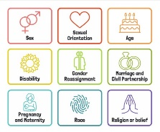 | Y5 Spiral - Growing up:  Activity 9: Growing up – Body changes  Activity 10: Naming and understanding function of male / female sex organs  Activity 11: Body changes at puberty  Activity 12: Menstruation  Christopher Winters Teaching SRE with confidence: Mix and match Puberty lessons as teacher thinks.  .Y6 Spiral - Growing up:  Activity 8: Puberty  Activity 10: Help / Support  Activity 16: understand that there are laws to protect children and why they are necessary | Y5 Spiral – Safety:  Activities 13 / 14 / 15: Risk judgements  Y6 Spiral -Stereotypes / The Role of the Media / Safety:  Career related learning strategy  Activity 20 / 21 Recognising Stereotypes  Activity 22 /23 /24: The Role of the media  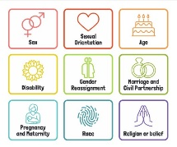  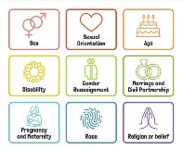  LGBT+  Y5 / 6 Proud Trust – King and King Play LGBT – 3 x 1hour lessons.  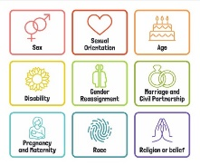
Additional, optional Y6 content from Y4 / 6
Spiral Curriculum
* Activity 9 A New Life Begins
*Activity 11: Intercourse and Love
*Activity 13: Conception / Having a new baby
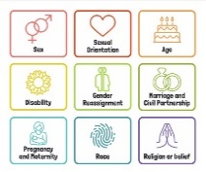
Activity 16 understand that there are laws to protect children and why they are necessary

LGBT+
Y5 / 6 Proud Trust – King and King Play LGBT – 2 x 1hour lessons.

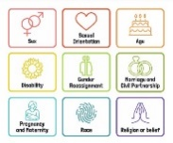
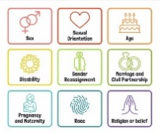
HEALTH AND WELLBEING  DRUGS EDUCATION  HEALTHY LIFESTYLE | Emotional Regulation circle time | Peer Pressure / Role models (Link to Anti-bullying week)  DATE Year 6: Activities: 1 For Better or Worse? 2 Attitudes and Beliefs. 3 Personal Safety,. 4 Peer Pressure and Making the Right Decision. 5 Making the Right Decision. 6 Dingo! Drug Bingo.  Alcohol misuse.  Twinkl- resources on alcohol and drugs | Confidently express own views & listen to & respect others.  Activity 9: Personal Hygiene  Children’s Mental Health Week | Basic first aid.  St. John’s Ambulance:  Choking  Head Injuries  Basic Life support  Sports Day  Freddie Fit
E-SAFETY | E SAFETY:  Talking safely online.  Computing links - 5 / 6 To explain why I need to protect myself and my friends online and the best way to do this.  5 To understand that anything I post online can be seen, used and may affect others.  5 To explain the importance of communicating kindly and respectfully online.  6 To explain the consequences to myself and others of not communicating kindly and respectfully online. | Computing links - 5 To choose a secure password and appropriate screen name.  5 / 6 To protect my password and other personal information.  6 to explain the consequences of sharing too much information about myself online. | Internet Safety Day work on this year’s theme. Cyberbullying – Real Love Rocks – Keeping Safe on Line. | 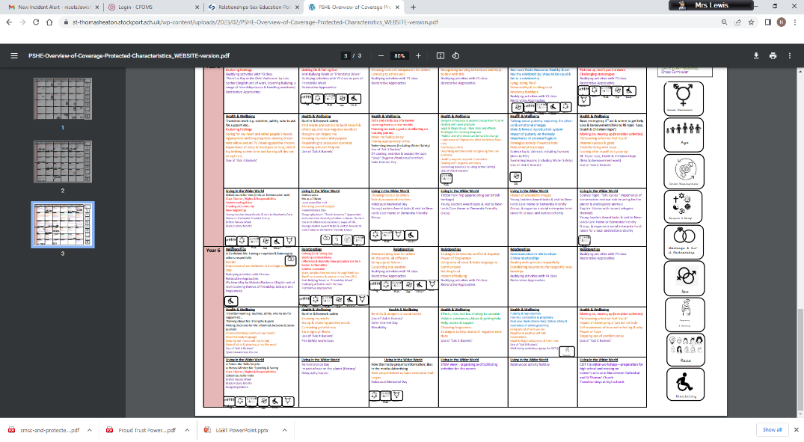  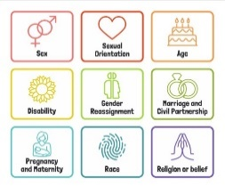  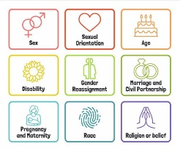  ABCD Curriculum – : ABCD Curriculum Homophobia and Race  Links to KOSSW.  Computing links - 5 To talk about the dangers of spending too much time online.  5 To discuss the importance of choosing age appropriate websites, apps or games.  6 To explain the consequences of spending too much time online or on a game.
LIVING IN THE WIDER WORLD  MODERN BRITISH VALUES  SCHOOL VALUES  TRANSITION  FINANCIAL CAPABILITY  Circle times | Class Charter Rights and Responsibilities  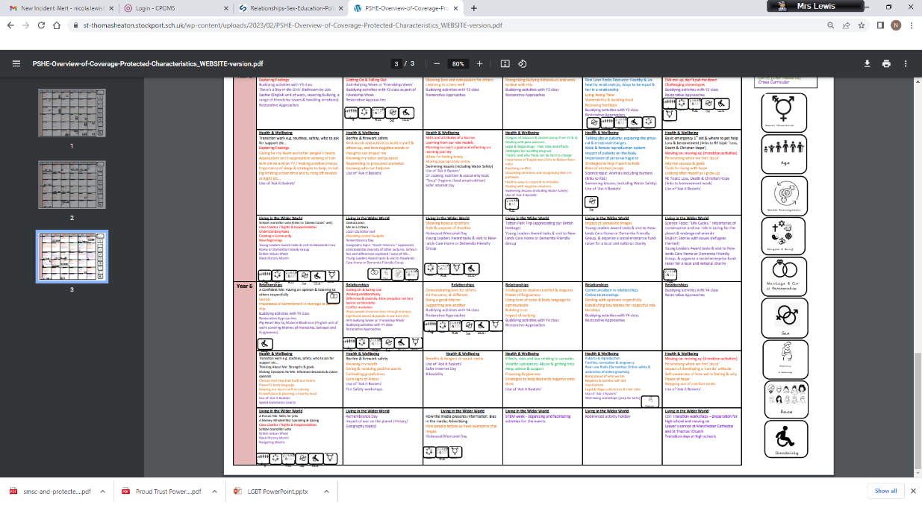  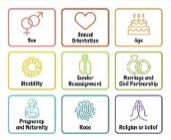  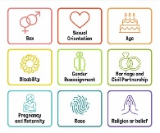  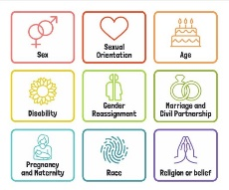  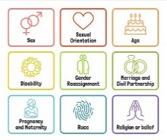  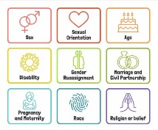  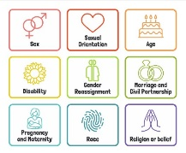  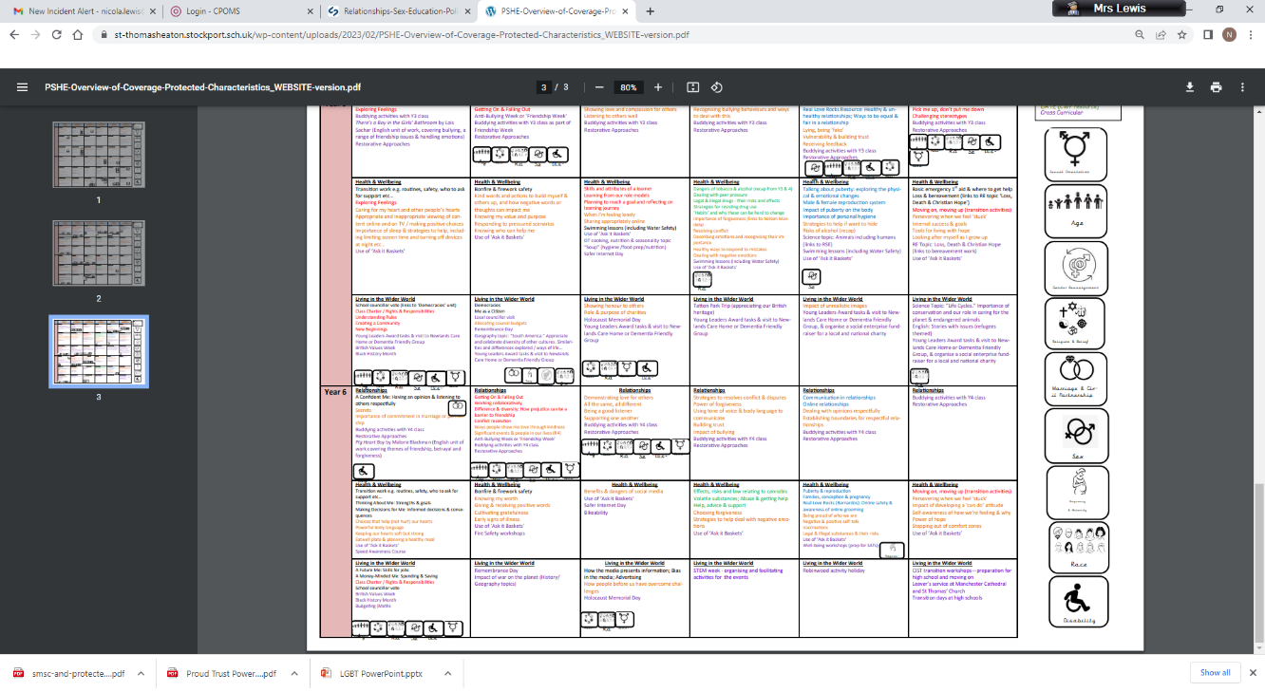  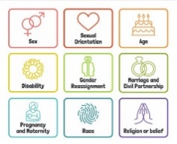  British Values circle times Mutual respect  Speed Awareness Course (Y6)  Setting ground rules; Cale green Code; Class Vision Statement; In this class we speak poster. School council election speeches  Mutual Tolerance and Respect – We are Britain. | FINANCIAL: Natwest resources – How Can I keep my money safe?  Black History Month  Remembrance Day Visit to cenotaph  Democracy / The Rule of Law.  Links to Parliament week.  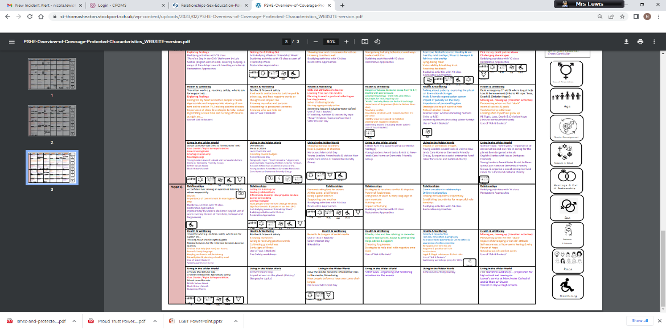  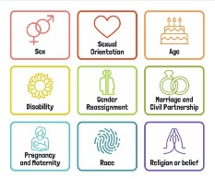 | 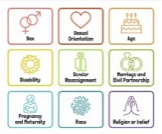  Individual Liberty / Tolerance of those with different faiths and beliefs.  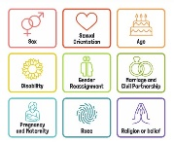  Science week / STEM activities linked to wider world of work  FINANCIAL - Natwest resources – What affects my choices about money? | Careers fair / aspirations week / World of work day Cv’s / interview skills.  Year 6:10 week Chameleon Project; care wheel; school questionnaire; transition day.  How do we keep healthy and safe?  Moving on; Growing up. Transition to next class.  (Year 6 Chameleon Project)  Y6 Residential holiday
Whole School Activities | Peer Massage  Special Friends table  Play Leaders  Water Safety Swimming  Visit From GMP  Bonfire Night Safety  Fire Safety  Restorative approaches  Ask-it baskets  Water safety lesson using materials from Canals and Waterways Trust  Unicef Rights Respect school – Steering stars  Article of the month  Bikeability Being a safe cyclist (Cycling Proficiency and road safety  Water Safety Swimming  Water safety lesson using materials from Canals and Waterways Trust  Bikeability Being a safe cyclist (Cycling Proficiency and road safety  Water Safety Swimming
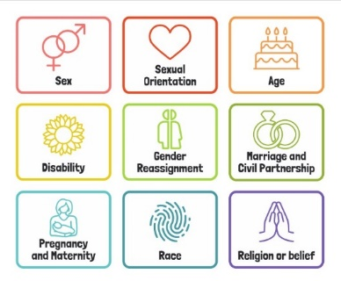
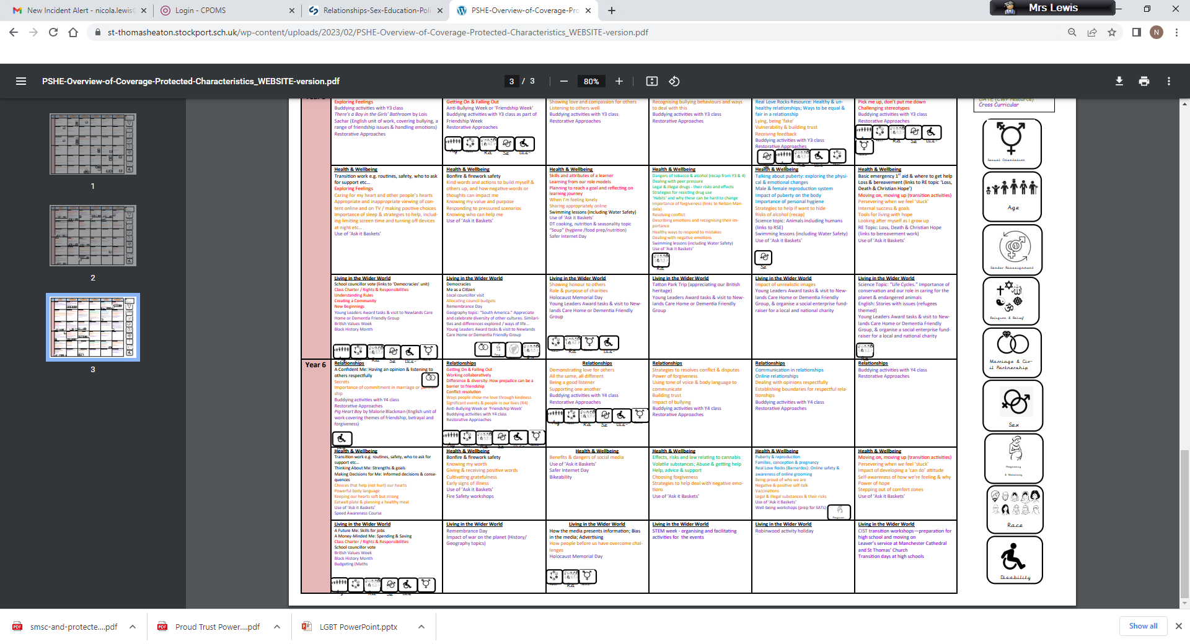
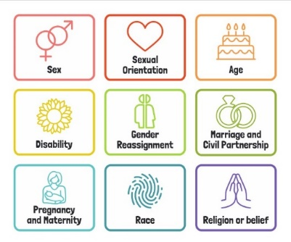
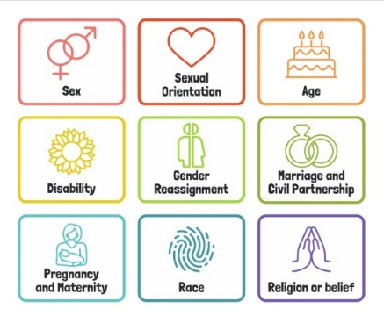
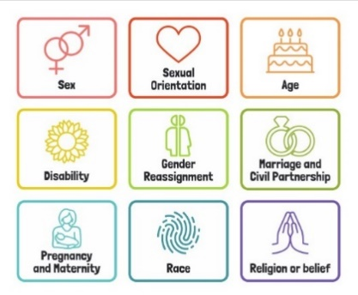
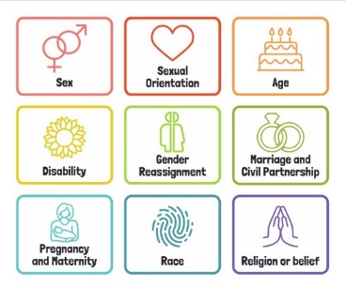
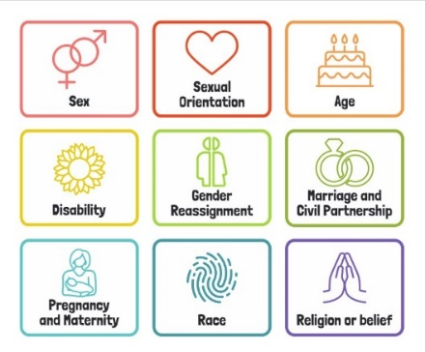
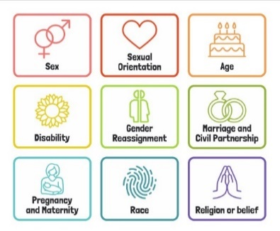
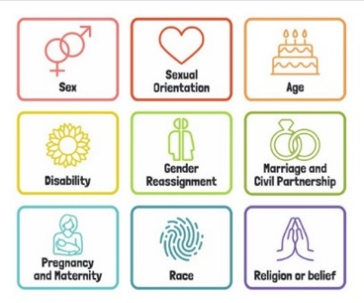

Useful Websites
http://www.preventforschools.org
http://www.impsweb.co.uk/schools/
http://www.anti-bullyingalliance.org.uk/anti-bullying-week/
https://www.thinkuknow.co.uk/5_7/
http://www.psheassociation.co.uk
http://www.digital-literacy.org.uk/Home.aspx
http://www.bbc.co.uk/education/topics/zy77hyc/
https://campaignresources.phe.gov.uk/schools/topics/being-active/overview
http://www.foodafactoflife.org.uk/section.aspx?t=0&siteId=20&sectionId=124
http://whatworkswell.schoolfoodplan.com/articles/category/3/learning-about-food
http://www.childrensfoodtrust.org.uk/lets-get-cooking/
http://www.foodforlife.org.uk/schools

