

Friday 14th June 2024

Dear Parents and Carers,

**Year 3/4 Cricket Festival at Cheadle Hulme School**

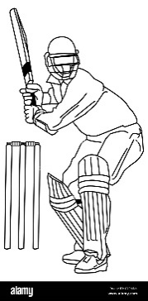

On Thursday 20th June, some children from Year 3 and 4 have been invited to take part in a Cricket Festival at Cheadle Hulme School. During their time there, they will receive coaching and the opportunity to take part in small sided matches - I’m sure it will be great fun.

Cheadle Hulme School is providing the transport so there is no cost for families. Your child will need to wear school PE kit and they should also bring a waterproof coat and a water bottle.

We will leave school after registration and will be back in time for lunch.

Kind regards,

Mrs Harding

Deputy Head

**Year 3/4 Cricket Festival at Cheadle Hulme School**

Name of Child:

I give permission for my child to attend the Multi-Sports Festival