Monday 8th July 2024

Dear Parents / Carers,

**Year 6 Pool Fun Session**

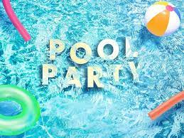

On Tuesday 16th July during the afternoon, we will be taking the Year 6 children to Grand Central Swimming Pool for a ‘fun session’ as an end-of year treat - the cost of which will be fully subsidised by school.

The session will be fully supervised by lifeguards, swimming coaches and school staff and will be held in a separate area of the pool to the general public. The water will be at a depth where all children will be able to touch the floor.

Your child will need:

* swimming costume / trunks (no baggy shorts please)
* a swimming cap
* towel.
* arm bands will be provided if this is necessary.

Please sign permission on School Spider.

Thank you for your support.

Yours sincerely,

Mrs Lewis, Mrs Harding, Miss Foster and Mrs Powell-Gill