

**Modern Foreign Languages (MFL) Policy**

**Spring 2025**

**Content and Rationale**

This policy outlines the aims and management of Modern Foreign Languages (MFL) at Cale Green Primary School. The implementation of the policy is the responsibility of the governors, the headteacher and all the teaching staff. This policy has been written to provide staff with guidance and support for the teaching and assessment of French and exemplifies the teaching strategies and approaches to be used throughout the school.

**Aims and Objectives**

**Our Core Values:**

• We are a learning community where everyone has the highest aspirations for ALL of the children of Cale Green.

• We are a strong and resilient school community where kindness and thought for others is at the heart of everything we do.

• We are a school at the heart of its community with happy children ‘learning and living together’.

At Cale Green, we believe that learning a foreign language is a fundamental part of a child’s education, offering opportunities for personal growth, cultural awareness, and the development of essential communication skills. French, as one of the most widely spoken languages in the world, offers students a gateway to understanding different cultures and engaging with the wider global community, which underpins our school values of ‘Learning and Living Together’.

Learning a foreign language also supports the development of important life skills, such as collaboration and perseverance. It encourages students to take risks in their learning, develop a sense of achievement and cultivate a lifelong love of language and culture.

# Legislation and guidance

This policy reflects the requirements of the [National Curriculum programmes of study](https://www.gov.uk/government/collections/national-curriculum), which all maintained schools in England must teach.

It also reflects requirements for inclusion and equality as set out in the [Special Educational Needs and Disability Code of Practice 2014](https://www.gov.uk/government/publications/send-code-of-practice-0-to-25) and [Equality Act 2010](http://www.legislation.gov.uk/ukpga/2010/15/part/6/chapter/1), and refers to curriculum-related expectations of governing boards set out in the Department for Education’s [Governance Handbook](https://www.gov.uk/government/publications/governance-handbook).

In addition, this policy acknowledges the requirements for promoting the learning and development of children set out in the [Early Years Foundation Stage (EYFS) statutory framework](https://www.gov.uk/government/publications/early-years-foundation-stage-framework--2).

# Roles and responsibilities

The governing board

The governing board will monitor the effectiveness of this policy and hold the headteacher to account for its implementation.

The governing board will also ensure that:

* A robust framework is in place for setting curriculum priorities and aspirational targets
* Enough teaching time is provided for pupils to cover the National Curriculum and other statutory requirements
* Provision is made for pupils with different abilities and needs, including children with special educational needs (SEN)
* The school implements the relevant statutory assessment arrangements
* It participates actively in decision-making about the breadth and balance of the curriculum
* It fulfils its role in processes to disapply pupils from all or part of the National Curriculum, where appropriate, and in any subsequent appeals

Headteacher

The headteacher is responsible for ensuring that this policy is adhered to, and that:

* All required elements of the curriculum, and those subjects which the school chooses to offer, have aims and objectives which reflect the aims of the school and indicate how the needs of individual pupils will be met
* The amount of time provided for teaching the required elements of the curriculum is adequate and is reviewed by the governing board
* Where appropriate, the individual needs of some pupils are met by permanent or temporary disapplication from all or part of the National Curriculum
* They manage requests to withdraw children from curriculum subjects, where appropriate
* The school’s procedures for assessment meet all legal requirements
* The governing board is fully involved in decision-making processes that relate to the breadth and balance of the curriculum
* The governing board is advised on whole-school targets in order to make informed decisions
* Proper provision is in place for pupils with different abilities and needs, including children with SEN

Subject Leader

The subject leader will:

* Read, understand and interpret the National Curriculum for MFL
* Review and keep up to date the MFL policy and scheme of work
* Attend relevant training and feedback to staff.
* Provide teachers with practical ideas and resources to incorporate into MFL teaching.
* Monitor the teaching of MFL through the use of lesson observations, work scrutiny and pupil interviews.
* Analyse progress and attainment in MFL across Key Stage 2 and provide a breakdown of the percentage of children in each year group achieving Emerging, Developing, Secure or Mastered.
* Identify any underperforming groups and strategies to tackle this. Share this information with all staff.
* Update action plans to address areas for development for the following year.
* Take responsibility for MFL resources.

**Curriculum Design – Organisation and Planning**

In Key Stage 2 at Cale Green, all pupils are taught French as our chosen ‘modern foreign language’, in accordance with the national curriculum. The national curriculum for languages aims to ensure that all pupils:

* understand and respond to spoken and written language from a variety of authentic sources.
* speak with increasing confidence, fluency and spontaneity, finding ways of communicating what they want to say, including through discussion and asking questions, and continually improving the accuracy of their pronunciation and intonation.
* can write at varying length, for different purposes and audiences, using the variety of grammatical structures that they have learnt.
* discover and develop an appreciation of a range of writing in the language studied.

Our French scheme of work has been designed based on a suggested two-year rolling programme from Culturetheque. The following images outline the topics covered:

**Years 3 and 4:**

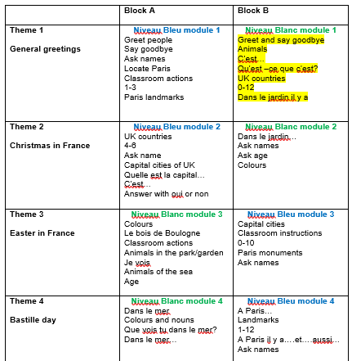

**Years 5 and 6:**

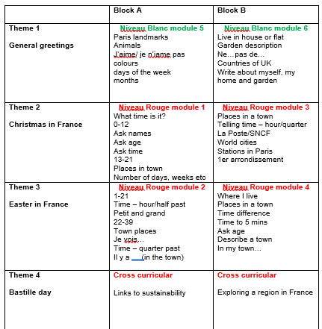

This scheme also utilises French stories, songs and finger rhymes to support work across the modules and to meet the National Curriculum objective; *appreciate songs, stories, poems and rhymes in the language*.

Our curriculum is designed to ensure that all students, regardless of their starting point, have access to high-quality language learning throughout their primary school years. By providing a structured, progressive approach to French, we aim to foster a love of languages and prepare our students with the skills they need for their future education and beyond.

**I****mpact – Assessment and Inclusion**

The pupils’ progress in French is monitored continuously. Assessment takes place both informally during the lessons to evaluate what the children have learned and at the end of a unit of work. Assessment of MFL is in four key areas:

* listening and responding;
* speaking;
* reading and responding;
* writing

At Cale Green, we aim to deliver an inclusive curriculum, whilst maintaining high expectations for every pupil. This continuous assessment allows teachers to set ambitious targets, set suitable challenges and respond to the diverse learning needs of every pupil, including:

* more able pupils
* pupils with low prior attainment
* pupils from disadvantaged backgrounds
* pupils with SEND
* pupils with English as an additional language (EAL)

Further information can be found in our statement of equality information and objectives, and in our SEND policy and information report.

# Links with other policies

This policy links to the following policies and procedures:

* EYFS policy
* Assessment policy
* SEN policy
* Equality information and objectives
* Anti-Racism policy

Hannah Powell-Gill

Spring 2025

To be reviewed spring 2025