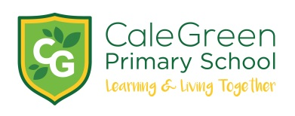
Art & Design policy
Spring 2025

Curriculum aims
Art & Design at Cale Green Primary school allows the children to explore and express their lived experiences, thoughts and ideas in a range of exciting and creative ways. Our children have the opportunity to develop their potential through learning the skills, and gaining an understanding of, Art & Design as a discrete practice within a broad and balanced, rich and relevant curriculum.
Our curriculum aims / intends to:
- Promote creativity and exploration of Art & Design based activities, starting at the beginning of school life with our youngest children in the EYFS setting.
- Enable pupils to develop knowledge, vocabulary, technical skills and provide them with opportunities to express their individual interests and ideas.
- Provide pupils with varied range of high-quality art experiences.
- Support pupils, as artists, with reflective and evaluative skills.
- Provide every pupil with the opportunity to be inspired and achieve success through Art & Design
- Nurture artistic talent and support pupils with the knowledge and cultural capital they need to succeed in life.
- Use Art & Deign as a contribution to the emotional, social, cultural and intellectual development.
- Promote Art & Design as a staple part of a broad and balanced curriculum.
- Ensure equal access to learning for all pupils, with high expectations for every pupil and appropriate levels of challenge and support

Legislation and guidance
This policy reflects the requirements of the National Curriculum programmes of study, which all maintained schools in England must teach.
It also reflects requirements for inclusion and equality as set out in the Special Educational Needs and Disability Code of Practice 2014 and Equality Act 2010, and refers to curriculum-related expectations of governing boards set out in the Department for Education’s Governance Handbook.
In addition, this policy acknowledges the requirements for promoting the learning and development of children set out in the Early Years Foundation Stage (EYFS) statutory framework.

Roles and responsibilities
The governing board
The governing board will monitor the effectiveness of this policy and hold the headteacher to account for its implementation.

The governing board will also ensure that:
- a robust framework is in place for setting curriculum priorities and aspirational targets
- enough teaching time is provided for pupils to cover the National Curriculum and other statutory requirements
- provision is made for pupils with different abilities and needs, including children with special educational needs (SEN)
- the school implements the relevant statutory assessment arrangements
- it participates actively in decision-making about the breadth and balance of the curriculum
- it fulfils its role in processes to disapply pupils from all or part of the National Curriculum, where appropriate, and in any subsequent appeals
Headteacher
The headteacher is responsible for ensuring that this policy is adhered to, and that:
- all required elements of the curriculum, and those subjects which the school chooses to offer, have aims and objectives which reflect the aims of the school and indicate how the needs of individual pupils will be met
- the amount of time provided for teaching the required elements of the curriculum is adequate and is reviewed by the governing board
- where appropriate, the individual needs of some pupils are met by permanent or temporary disapplication from all or part of the National Curriculum
- they manage requests to withdraw children from curriculum subjects, where appropriate
- the school’s procedures for assessment meet all legal requirements
- the governing board is fully involved in decision-making processes that relate to the breadth and balance of the curriculum
- the governing board is advised on whole-school targets in order to make informed decisions
- proper provision is in place for pupils with different abilities and needs, including children with SEN

Organisation and planning
Our Art & Design curriculum has been designed and sequenced in a way that allows children to develop skills within drawing, painting, collage, and sculpture throughout their time at Cale Green. Alongside traditional art processes and techniques, digital art using iPad apps are used, which prepares children for contemporary Art & Design careers. We encourage the children to be ambitious in their choices and experiment with a wide variety of media alongside teaching them an understanding of the elements of art; value, colour, line, form, shape, space, texture and medium/media. Giving children the vocabulary to discuss theirs and others’ art work forms a key part of our Art & Design curriculum.
At Cale Green, we follow our two-yearly rolling curriculum plan. This ensures that children can access all of the strands in Art & Design, whilst being in that phase to establish progression.
Example of objective progression in the drawing strand:
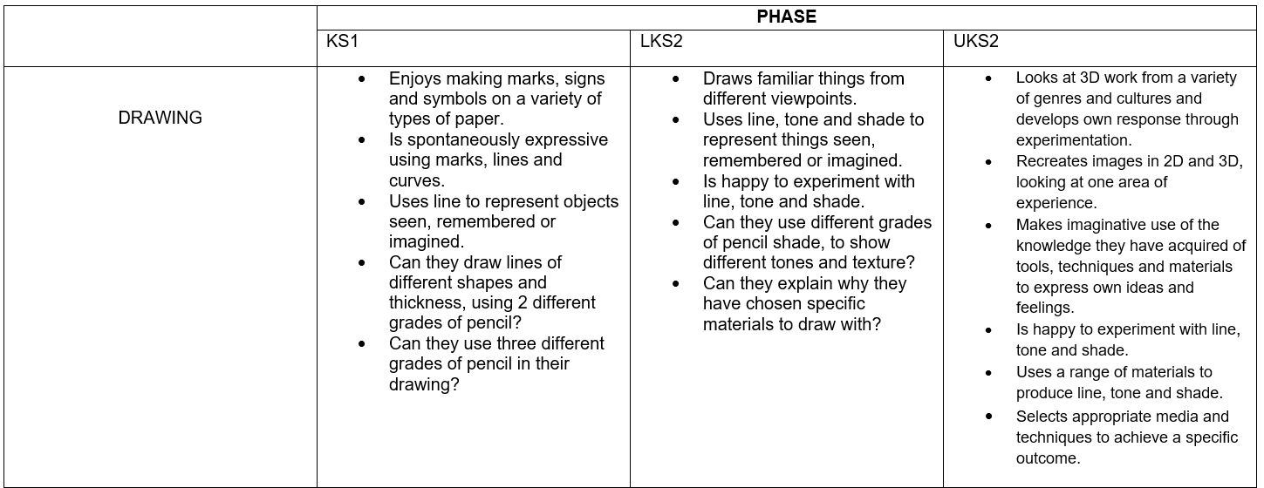
As well as exploring Art & Design in the classroom, we provide the children with opportunities to work with local artists and within local art spaces such as Stockport Art Gallery, the Lowry art gallery. This allows us to enrich the children’s experiences to further their understanding of Art & Design within a wider context, and progresses their personal development in creativity, independence, judgement and self-reflection.
The wide range of diverse artists and designers that we learn about and explore reflects the comprehensive and diverse nature of our school; all of which prepares them for life in Britain and beyond.
Teachers are given an element of freedom in their choices of artists and designers within a discipline to allow their own skills and knowledge to shine in their planning and delivery of lessons.
See our EYFS policy for information on how our early years curriculum is delivered.

Assessment
In the classroom, art assessment typically involves a combination of formative and summative methods, often including observation, sketchbook analysis, and feedback through verbal comments. A child’s sketchbook is part of their creative space and will not be marked in a traditional way as in other subjects.
Teachers assess student progress against learning objectives and track skills development, using a progression of skills document. Formative assessment, which is ongoing and provides feedback during the learning process, is crucial for guiding student learning.

Inclusion
Teachers set high expectations for all pupils. They will use appropriate assessment to set ambitious targets and plan challenging work for all groups, including:
- more able pupils
- pupils with low prior attainment
- pupils from disadvantaged backgrounds
- pupils with SEN
- pupils with English as an additional language (EAL)

Teachers will plan lessons so that pupils with SEN and/or disabilities can study every National Curriculum subject, wherever possible, and ensure that there are no barriers to every pupil achieving.
Teachers will also take account of the needs of pupils whose first language is not English. Lessons will be planned so that teaching opportunities help pupils to develop their English, and to support pupils to take part in all subjects.
Further information can be found in our statement of equality information and objectives, and in our SEN policy and information report.

Monitoring arrangements
Governors monitor coverage of National Curriculum subjects and compliance with other statutory requirements through:
- Subject Leaders monitor the way their subject is taught throughout the school by:
- Lesson observations
- Voice of the child
- Planning and sketchbook looks

Links with other policies
This policy links to the following policies and procedures:
- EYFS policy
- Assessment policy
- SEN policy
- Equality information and objectives
- Anti-Racism policy

Miss Ellie Brown
Summer 2025
To be reviewed summer 2026

