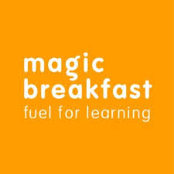

Friday 22nd March 2019

Dear Parents/Carers
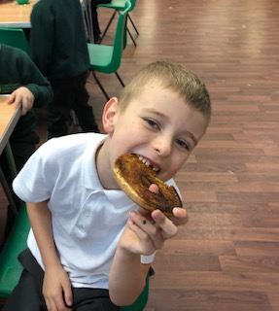

Breakfast Club - National School Breakfast Programme

Our Breakfast Club has become increasingly popular. About 45 – 50 children attend regularly with over 100 registered, all enjoying a healthy breakfast and fun activities. Breakfast is served every day from 7.45am.

There is always a range of healthy food on offer such as cereal, fruit, bagels, toast and ‘overnight oats’, which give the children a flying start to the school day.

The cost is £1.00 and children who are eligible for free school meals do not have to pay for Breakfast Club. No child is ever turned away! Parents are always welcome to attend and often stay for breakfast too.

For those children who don’t make it into Breakfast Club, and who haven’t had any breakfast, bagels are available up until break time.

To further improve our Breakfast Club we have joined the government’s National School Breakfast Programme (NSBP), which is being delivered by the charities Family Action and Magic Breakfast. This means that a healthy school breakfast is available to all, ensuring that the children are settled and ready to learn at the start of the school day.

We are proud to be a National School Breakfast Programme school and we would welcome your child to join us for a great start to the day.

If you would like your child to come along then all you have to do is complete a short registration form on their first day.

If you require any further information then please contact Mrs Horrabin in the school office.

Yours sincerely,

D.Marshall
Headteacher

