Thursday 2nd May 2019
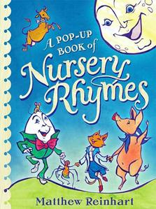
Dear Parents / Carers,

We are very excited to announce that the children in Reception will be taking part in the Nursery Rhyme Day at Stockport Town Hall this year.

This will take place on Thursday 9th May from 1.30pm-2.30pm.

The children will be getting a coach to and from the Town Hall and will have lunch as usual first.

We hope you agree this will be lots of fun and it will be a wonderful learning experience for the children as they will perform ‘Ring a Roses’ for other schools!

If you are free to come along and watch us, we would appreciate the support.

There will be no charge for this activity.

Yours sincerely,

Mrs Phillips and Mrs Cartwright

Name of Child:

I give permission for my child to attend the Nursery Rhyme Day at Stockport Town Hall on Thursday 9th May 2019.

Emergency Contact Numbers:

Relevant Medical Details:

Signed: Parent / Carer

