Monday 17th September 2018
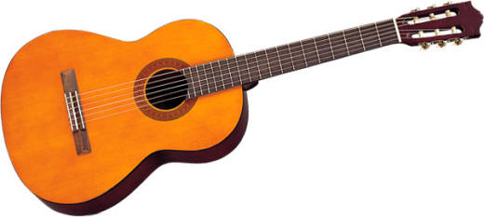
Dear Parents / Carers,

GUITAR TUITION AT KS2

This week your child will be starting guitar lessons. These will take place on a fortnightly basis. We are extremely pleased to inform you that all instruments and tuition are provided FREE OF CHARGE for the year. This is a fantastic offer from school and will greatly develop your child’s understanding of music, notation and confidence through being part of whole-class group performances.

As part of the guitar tuition we expect children to practice at home. This is considered as part of their normal homework. All children should do this at least once a week.

Lessons will be on Thursdays and your child will have their first lesson on Thursday, 20th September. They will need to bring their guitar into school every Thursday after this date as there will also be an opportunity to practice in class.

Yours sincerely,

Mrs N. Lewis
Music Coordinator

Name of Child: Class:

I would like my child to be able to practice at home and accept responsibility for the safe keeping of the above instrument and bag during the time it is away from the school premises.

I understand that should the instrument or bag be lost or damaged I am responsible for the full replacement or repair costs (which will not exceed £30.00).

Signed: Parent / Carer

Print name:

