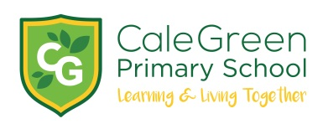
Wednesday 19th September 2018
Dear Parents and Carers,
Lauren Child – author visit – Friday 5th October
The children in Year 5 have the fantastic opportunity to meet Lauren Child, the author of CHARLIE AND LOLA and the Children’s Laureate in 2017.
We will be taking the children to St Michael’s Church in Bramhall on Friday 5th October. We will leave school at 9.30am to take the bus to the church and will return to school in time for normal school dinner time.
Lauren will be talking about her new book which features Hubert Horatio who is an exceptionally intelligent and sensible child who has to sort out the grown-ups in his life!
There are two different options:
Option 1:
Ticket - £4.00
Option 2:
Ticket and signed First Edition book - £10.00
Payment can be made by ParentPay or by sending in cash. All money must be paid by Wednesday 26th September.
Kind regards,
Mrs. Sarah McHugh
English Subject Leader
_________________________________________________________________________________
Author Visit to see Lauren Child– Friday 5th October
Name of Child:

I give permission for my child to take part in the author visit at St Michael’s Church in Bramhall.

We will be taking: Option 1: ______ and enclose £4.00

or

Option 2: ______ and enclose £10.00

2 Emergency Contact Numbers:

Medical Conditions:

Signed: Parent / Carer

