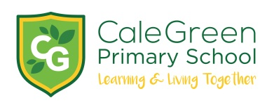
Tuesday 29th January 2019

Dear Parents / Carers
50 Stars - Simply Books Visit

Congratulations!

As a reward for gaining 50 starts on the Cale Green Star Chart your child has been invited to Simply Books in Bramhall to choose a special book prize and to have a drink / biscuit.

If you are happy for your child to attend Simply Books then please sign and return the reply slip.

As this is such a fantastic achievement your child’s chosen book will be presented to them during the next Family Assembly. They will also get a mention in the next school newsletter under the ‘Special Achievement’ section!

A full risk assessment for this activity has been completed.

If you have any questions please dot hesitate to contact me.

Yours sincerely,

D.Marshall
Headteacher

Simply Books Visit -

I give/ do not give permission for my child to attend the Simply Books visit on

Childs Name:

Relevant Medical Concerns / Allergies:

Emergency Contact Numbers:

Signed: Parent / Carer

