Tuesday 11th June 2019
Dear Parents,
Year 2 Local Environment Visit - Wednesday 19th June
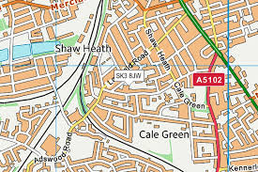
As part of our ‘Keeping Ourselves Safe Week’ we will be taking the children on a walk around the local area to experience learning beyond the classroom and deepen their geography field work skills.
Both Elder and Elm class will be going on Wednesday 19th June at 1.30pm.
Prior to this visit, the children will have discussed places within the local community where they feel safe/unsafe and shared their reasons for this (this could include the speed of traffic along roads, no safe crossing areas for children to use and so on).
One of the main objectives is that the children become active citizens who care for and are engaged in the community they live in. We will be encouraging the children to think about how they can have a positive impact upon their local environment. The children will use maps of the local area to locate the different places identified and will then use these to support them when navigating around.
Please can you ensure that on the day your child is wearing appropriate footwear as well as having a coat in school?
We will need some parent helpers to assist with this visit. If you are able to help during this time, please come and speak to myself or Ms. Ingham.
If you have any questions, please do not hesitate to speak to us on the playground after school.
Our visit has been fully risk-assessed.
Many thanks for your continued support
Miss Best
Mrs Ingham
Year 2 Local Environment Visit – Wednesday 19th June
Name of child:
I give my permission for my child to walk around the local area at 1.30pm on Wednesday 12th June.
Medical conditions:
Emergency contact numbers:
Signed: Parent / carer

