Tuesday 18th June 2019

Dear Parent / Carer
August - Summer Holiday Swimming Courses over for Non Swimmers - £5.00 – Book now!

We are committed to providing an opportunity for every child at Cale Green Primary School to learn to swim safely. Along with Stockport Metro we are supporting RLSS UK’s Drowning Prevention Week Campaign, running from 14-24 June, to help put water safety at the forefront of everyone’s mind in the lead up to summer, a high-risk time of year for drowning.

Lessons are only £1.00 per ½ hour lesson and will take place for 5 consecutive days (£5 for the week).

This offer is available during August at Life Leisure Grand Central, Life Leisure Avondale and Life Leisure Cheadle. Places are limited to one week per child. To access this opportunity parents/carers need to:

Choose your preferred week:

- 29th July – 2nd August
- 5th August - 9th August
- 12th August – 16th August
- 19th August – 23rd August
- 27th August – 30th August (4 days)

Contact your preferred centre:

- Life Leisure Grand Central 0161 474 7766
- Life Leisure Avondale 0161 477 4242
- Life Leisure Cheadle 0161 428 3216

Book and pay during National Drowning Prevention week (14th – 24th June) to secure a place:

- Payments can be made in centre or over the phone
- Places are offered on a first come, first served basis and are therefore subject to availability

To be eligible for these courses your child must not be a ble to swim 5 metres unaided.

For further information about drowning prevention please use this link:

https://www.rlss.org.uk/drowning-prevention-week

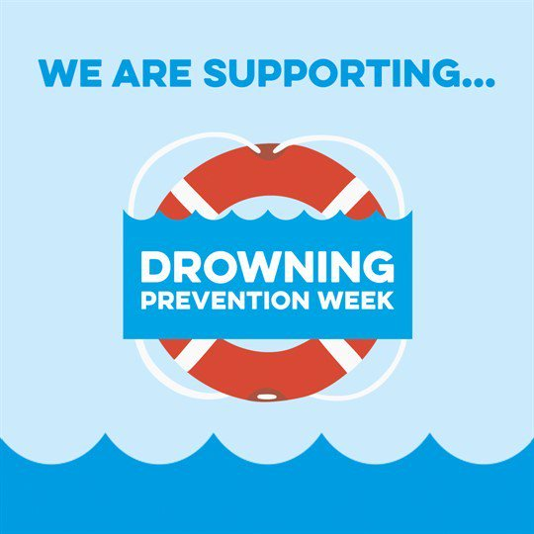

Yours sincerely

Ms S Ingham
PE Subject Leader

