Wednesday 4th September 2019

Dear Parents and Carers,

Bike to School Week
Monday 23rd – Friday 27thSeptember
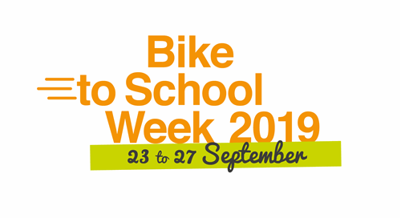

As part of Sustrans ‘Bike to School Week’ we will be offering a variety of cycling based activities for the children and families of Cale Green:

- Bike-it Breakfast - Monday 23rd September 2019:
Any child or family member who cycles or scoots to school can get a free breakfast from 7:45am-8:20am in our Breakfast Club.

- Bling Your Bike Competition - Tuesday 24th September 2019:
This is a chance to get creative – fancy dress for your bike or scooter! Let your imagination run wild, decorate your bike or scooter, bring it to school on Tuesday and there will be prizes awarded for the most creative designs!

- Dr. Bike - Thursday 26th September 2019:
Dr Bike will be available from 8am-9am to do a safety check on any bikes brought into school. Tyres flat? Not a problem. Loose brakes? These can be fixed too!

- Family Assembly - Friday 27th September 2019:
All prizes for the week will be awarded during assembly.

There will also be a prize for the class who make the most journeys to school by bike or scooter as well as many other activities - so please keep an eye out for posters around school!

For a free family guide please follow this link:

https://www.sustrans.org.uk/sign-up-to-receive-your-free-family-guide/

Kind regards,
Mrs Walsh
Cycle Champion!

