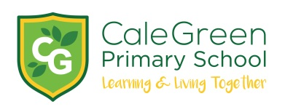
Tuesday 19th November 2019

Dear Parent / Carer,

Edgeley Library Visit

There has been a change of dates for both Chestnut (Miss Best) and Cherry class (Miss Bayley) visits to Edgeley library this term.

Chestnut class will visit on Monday 25th November
Cherry class will visit on Wednesday 4th December

Each class will leave school at 9:15am and return at 11:30am.

If you are available to help on the trip then please let a member of staff know.

If you have any questions about this visit please don’t hesitate to ask.

Kind regards,

Mr. Marshall

KS1 Edgeley Library Visit

Name of Child:

I give permission for my child to visit Edgeley Library.

Emergency Contact Numbers:

Medical Conditions:

Signed: Parent/ Carer

