Dear Parents and Carers,

Drama Club – Romeo and Juliet – Lowry Theatre

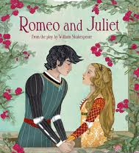

A Drama Club for children in Key Stage 2 will begin on Thursday 27th February from 3.15pm - 4.15pm and will run until Thursday 25th June.

For the past 4 years, children in different classes in Key Stage 2 have studied a different Shakespeare play which they have then performed as part of the Stockport Children’s Shakespeare Festival.

This year, the Drama Club will be working on ‘Romeo and Juliet’ which will lead up to a final performance at the Lowry Theatre.

To take part at the Lowry Theatre the children must attend the Drama Club on a regular basis.

Kind regards,

Mrs Sarah McHugh,
Deputy Head teacher

Drama Club – Thursdays 3.15pm - 4.15pm until Thursday 25th June.

Name of Child:

I give permission for my child to attend Drama Club.

Relevant Medical Concerns:

Emergency Contact Number:

Signed: Parent / Carer

