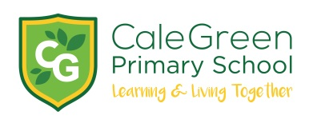

Thursday 27th February 2020

Dear Parents and Carers,

Onjali Q Rauf Author Visit- Friday 6th March

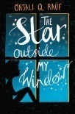

To celebrate World Book Day we’d like to take Juniper, Jasmine and Oak classes to a very special book launch event with Onjali Q Rauf the award winning author of ‘The Boy at the Back of Class’. The event is being hosted by Hursthead Junior School in Cheadle Hulme. It’s the story of a 9 year old refugee called Ahmet, who has fled the war in Syria. When the children in his class find out he is separated from his family, they come up with a plan to help. Her latest book is ‘The Star Outside my Window’ which deals with domestic abuse in the same very sensitive way.

Onjali will speak to the children first followed by a book signing. She will be signing copies of both her books which children will be able to buy. (See details below)

We will be getting the bus to Hursthead Junior School on Friday 6th March at 12.30pm and will be back in time for the end of the school day.

TICKETS

Option 1      Admission Only Ticket   £3 (bus fare and ticket)

Option 2      Book & Ticket                £10 includes The Star Outside my Window the second book in the series

Option 3     SPECIAL TWO BOOK DEAL & TICKET £15 includes both books

***Payment should be made by Parent Pay. All money must be paid by Thursday 5th March.***

Kind regards,

Mrs. Sarah McHugh

English Subject Leader

 ____________________________________________________________________________________________

Author Visit to see Onjali Q Rauf – Friday 6th March 2020

Name of Child:

I give permission for my child to take part in the author visit

We will be taking: Option 1: ______ Option 2: ______ Option 3: ______

Emergency Contact Numbers:

Medical Conditions:

Signed: