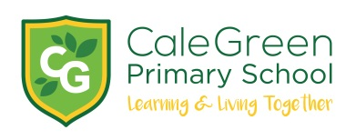
Wednesday 8th January 2020

Family Learning – ‘Reading for Pleasure’ – Free Course

Dear Parents / Carers

Please find details attached to this letter of a new reading opportunity for parents at of children at Cale Green.

We feel that there is no greater pleasure than sharing the experience of reading together with your child and we know that children who have the opportunity to do this generally do better than expected at school!

Working alongside Stockport and Trafford colleges we will be delivering a free 4 week programme on Tuesday afternoons from 1.30pm – 3.00pm. This will take place at Walthew House (on Shaw Heath – a two minute walk from school) and will be supported by our new Child and Family Support Worker, Gill Rogers.

We need a minimum of 8 parents but would like many more!

You will need to attend all 4 sessions. These will take place on Tuesday 21st January / Tuesday 28th January, Tuesday 4th February and Tuesday 11th February from 1.30-3.00pm.

All those parents who complete the 4 weeks will be invited to go to Simply Books in Bramhall together with their child / children on Friday 14th February where they can choose a book to share at home!

Please complete the reply slip below and return it to school no later than Tuesday 14th January. If you would like to sign up in person or have more information about this activity then please come along to school on Tuesday 14th January at 2.45pm.

If you require any further information please do not hesitate to contact us at school.

Yours sincerely

D.Marshall Gill Rogers
Headteacher Child and Family Support Worker

Name of Child:

Name of Parent:

I would like to attend the Reading for Pleasure Family Learning course and commit to attending all 4 sessions at Walthew House on Tuesdays from 1.30pm – 3.00pm.

Signed: Parent / Carer

